COPIAR EN EL CUADERNO
October, 23th
Reading Comprehension: Read the text on page 106 and do activities 1, 2 and 3
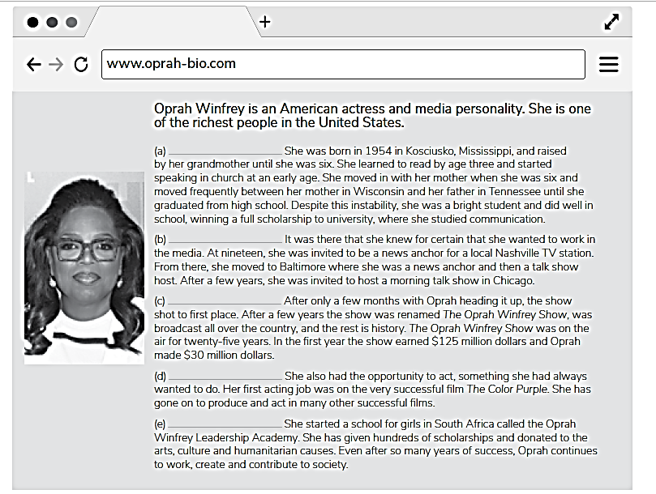

Se controlará próxima clase.

