Plan de contingencia 23/10/24: Inglés
Wednesday, 23rd October 3rd year “A” and “B”
Teachers: Laura Chavez and Guadalupe Benavidez

Review of Unit 6: Social Responsability
- Read the clues and write the correct word.

racism - famine - war - flooding - bullying - loneliness / abandonment –
poverty - disease - illiteracy - ill-treatment of animals

What are these problems called?
a. It’s related to no food for people. ______________________
b. It’s related to different races. ______________________
c. It’s related to nuclear armament. ______________________
d. It’s related to solitude. ______________________
e. It’s related to physical and psychological aggression. ______________________
f. It’s related to reading. ______________________
g. It’s related to having no money. ______________________
h. It’s related to aggression to animals. ______________________

- Read the grammar box and complete the sentences with since or for.
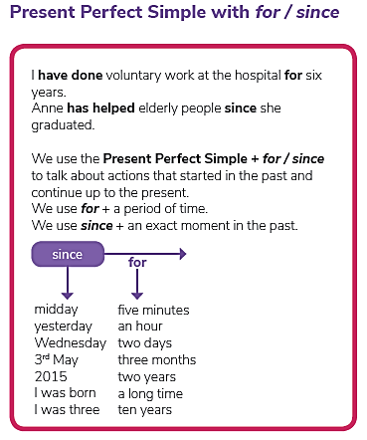
a. I’ve been here ___________ 8 this morning. I haven’t moved ____________ two hours.
b. She’s lived in this house _____________ a very long time.
c. I haven’t seen him ___________ yesterday.
d. She has worked ___________ she finished school.
e. I’ve had this __________ January

- Order the words into questions and answer them in two different forms, using since and for.

- studied / teacher / how / your / English / has / long
_______________________________________________?
________________________________________________ .
- jeans / long / you / had / your / how / have / favourite
_____________________________________________?
_________________________________________________ .
- family / how / has / your / lived / in / long / your / home
_______________________________________________?
________________________________________________ .
- student / long / a / been / how / you / have
_______________________________________________?
________________________________________________ .

