INGLÉS ACTIVIDADES 30/10
- MATCH THE PICTURES TO THE SENTENCES.
- SHE HASN’T DONE THE SHOPPING YET.
- SHE HAS JUST SPILLED MILK.
- HE HAS ALREADY RUN A MARATHON.
- HE HAS ALREADY FINISHED HIS HOMEWORK.
- SHE HASN’T TIDIED HER BEDROOM YET.

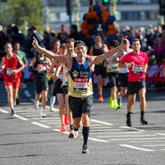

- JOIN THE VERBS TO THEIR PAST PARTICIPLES.

GO SAW

EAT HAD

HAVE GONE

SEE WON

WIN EATEN

