TRABAJO INTEGRADOR INGLÉS
- LISTEN TO THE SONG “MARY HAD A LITLE LAMB” AND MATCH THE WORDS TO THE PHOTOS.

LAMB
SNOW
SCHOOL
LAUGH
TEACHER
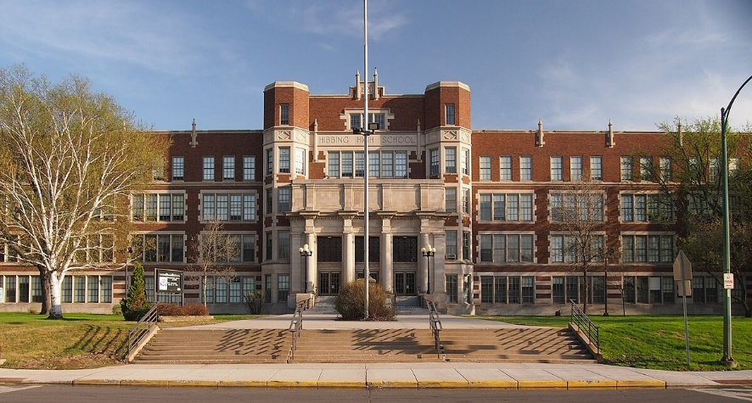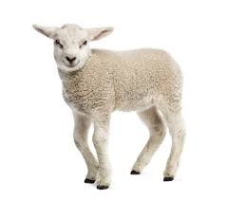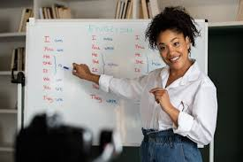
- LISTEN TO THE SONG AGAIN AND WRITE THE PAST SIMPLE FORM OF THESE VERBS:
- GO:
- BE:
- FOLLOW:
- MAKE:
- TURN:
- LINGER:

