Recuperación de la material inglés- Instancia de diciembre 2024
Colegio María Auxiliadora
Profesora: María Gabriela Perona
Grado: 6°B
Alumno (Nombre y Apellido): ____________________________________________

Unit 4: What time is it?
- Write what time it is.
9:10
________________________________________________________
6:00
________________________________________________________
12:30
________________________________________________________
1:15
________________________________________________________

- Write about a normal day in your life.
Use: in the morning, in the afternoon, in the evening, at night, get up, have breakfast, go to school by, go home, do homework, go to bed.
_________________________________________________________________________________________________________________________________________________________________________________________________________________________________________________________________________________________________________________________________________________________________________________________________________________________________________________________________________________________________________________________________________________________________________________________________________________________________________________________________________________________.

Unit 5: ¡Sports are so fun!
- Write the sports in the correct place.
Ballet-Skiing-Judo-Jogging-Rugby-Baseball-Ping Pong-Skateboarding
PLAY | GO | DO

- Look and write the correct sport name.

He can´t_____________________________ but he can_____________________________
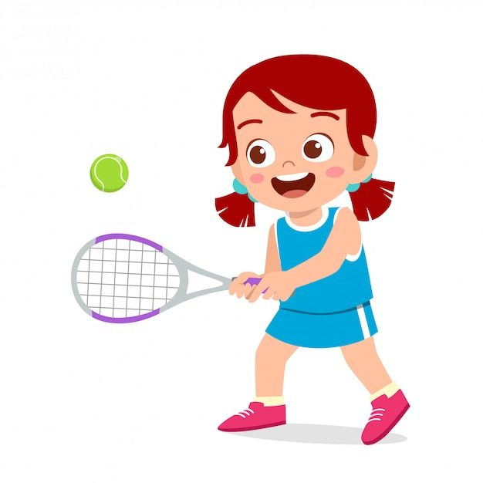
She can ____________________________but she can´t____________________________
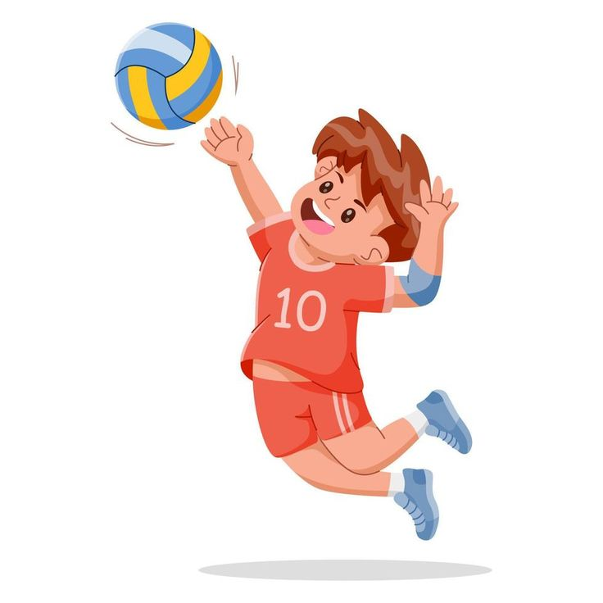
He can ______________________________but he can’t___________________________

Unit 6: ¡Yummy, delicious!
- Write what food you and your friend like and don’t like.

- I like__________________, ___________________ and___________________. But, I don´t like_________________ or__________________.
- My friend likes______________, ________________ and __________________.
But He/She doesn´t like________________ or _________________.

- Complete the sentences with the correct form of the verb like.

- I____________ (+) French fries and ice cream.
- He_______________ (-) tomato soup or garden salad.
- ¿______ Nico and Max_________ nuggets?
- They______________(-) onion rings or Mexican tacos.
- ¿_______she________ cupcakes?
- Angie__________ (+) chicken soup.
- Tom and Mary_______________ (+) soda and lemonade.
- My sister______________(-) pizza.
- My mom and dad__________________(+) cookies and cupcakes.
- He___________(+) Hot dogs and burgers.


- Make questions (How much…?) and answer.

$10.50
$5.90

How much____________________________? How much______________________?
It’s __________________________________. It’s____________________________.


$4,20
$7.25
__________________________________? _____________________________________?
__________________________________. _____________________________________.

