
COLEGIO MODELO 4° AÑO “A”
WRITTEN TEST
CRITERIOS DE EVALUACION: COHERENCIA Y COHESION, GRAMATICA Y ORTOGRAFIA, PRESENTACION GENERAL

NAME:
- Look at Hanna’s plans, write sentences in Present Continuous(6)
MONDAY | TUESDAY | WEDNESDAY | THURSDAY | FRIDAY | SATURDAY
Meet Peter | Visit the dentist | Go to grandma’s house | Buy a new T-shirt | Go to Math classes | Play tennis with Susan

- Write your plans for the future in four sentences using going to (4)
- Look at Ben’s to-do list and complete the dialogue. Write sentences using the Present Perfect and already or yet. (6)
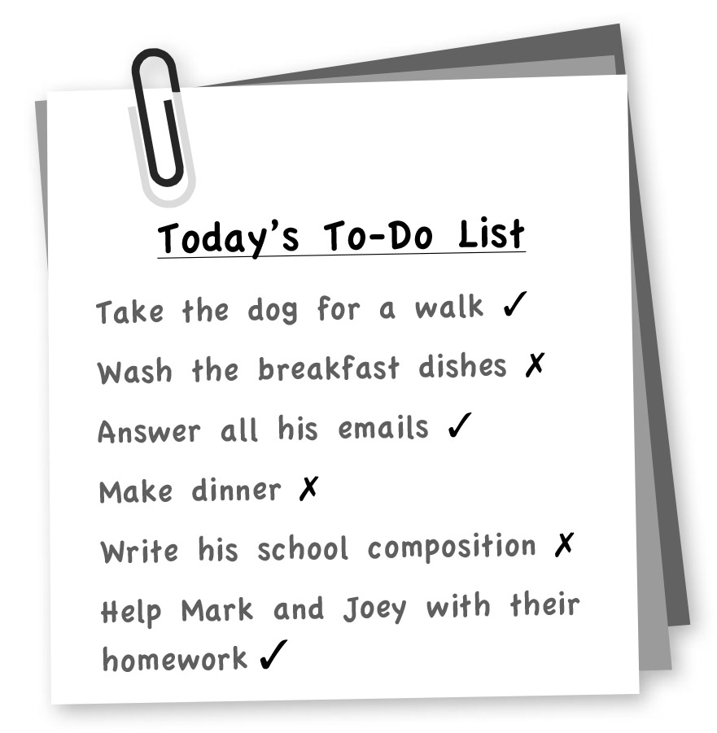

- Look at the bubbles and write sentences about Sarah’s life experiences.
Use the Present Perfect and never when necessary. (5)
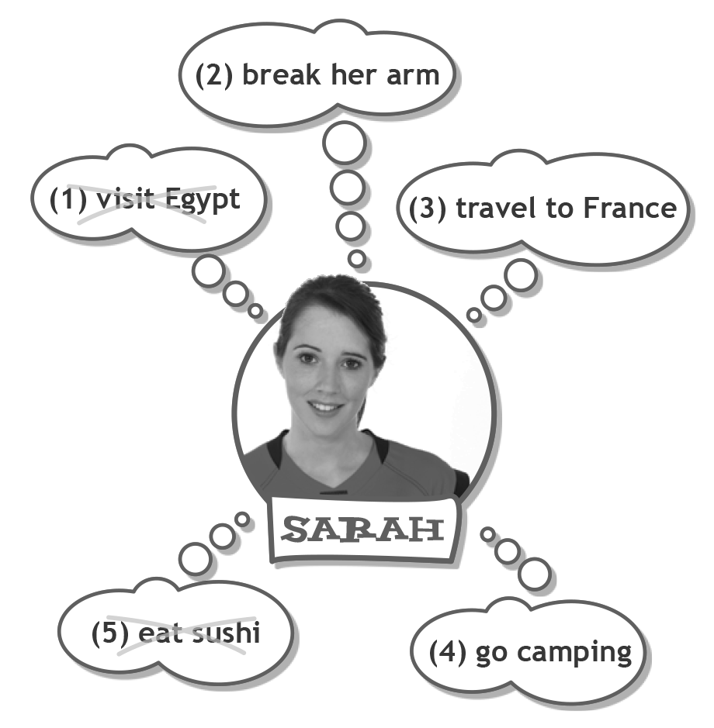

_______________________________________
_________________________________________________
_______________________________________
_______________________________________
_______________________________________
_______________________________________
_______________________________________

TOTAL MARKS _____/21

