COLEGIO SANTA ROSA DE LIMA

“Embracing our history, we boldly build new paths of humanization."

Materia: Lengua Extranjera Ingles Año: 2025
Profesor: López Belén
Alumno: _emiliana López_

INTRODUCTION
Welcome students! It`s a pleasure to be your teacher again. For the ones who I meet for the first time my name is Belen Lopez and we are going to work together so as apart from learning English you can enjoy and love this process of learning.
I have prepared an activity which is going to be finished on Wednesday,5th. We are going to share it in class so I can know more about you, your goals for this year, etc.
Then, you are going to work on a review that must be uploaded and prepared for Wednesday,5th.

GET TO KNOW ACTIVITY
- Look at the picture and answer: “What is in my jar?” Write on the hearts in the jar:
- 3 things you have learnt last year
- 3 things you want to achieve this year
- 3 things you expect this year from the subject, your teacher, your classmates, or about yourself.
Note: Your jar must be on your notebooks for Wednesday,5th.

- *speak more fluently
- *talk about environmental pollution
- 3 things you want to achieve this year
- Have better English pronunciation
- Write better in English
- Learn more things
- • 3 things you expect this year from the subject, your teacher, your classmates, or about yourself
- That he doesn’t demand so much from us
- That my colleagues behave
- I have more patience
REVIEW
- Answer the following questions.
- Which things have you learnt in this s ubject last year?
The things I learned from the subject last year were about the environment and how to take care of it. That’s what I remember most from last year.
- Which things from the ones you learnt did you like the most?
What I liked the most and was interested in was the environment and talking about pollution
- Which things were difficult to learn? What did you do to go through those difficulties?
What I found most difficult was writing and what I did to make it easier was to practice writing.
- What new things do you want us to start doing this year?
The truth is that I don’t know what things are, but I would like to have more conversations in English.

- Choose 3 topics from the ones you learnt last year and write 2 motivational phrases.
Note: Write these phrases on a different piece of paper. You can decorate it as you want. Try to WRITE YOUR OWN motivational phrase.

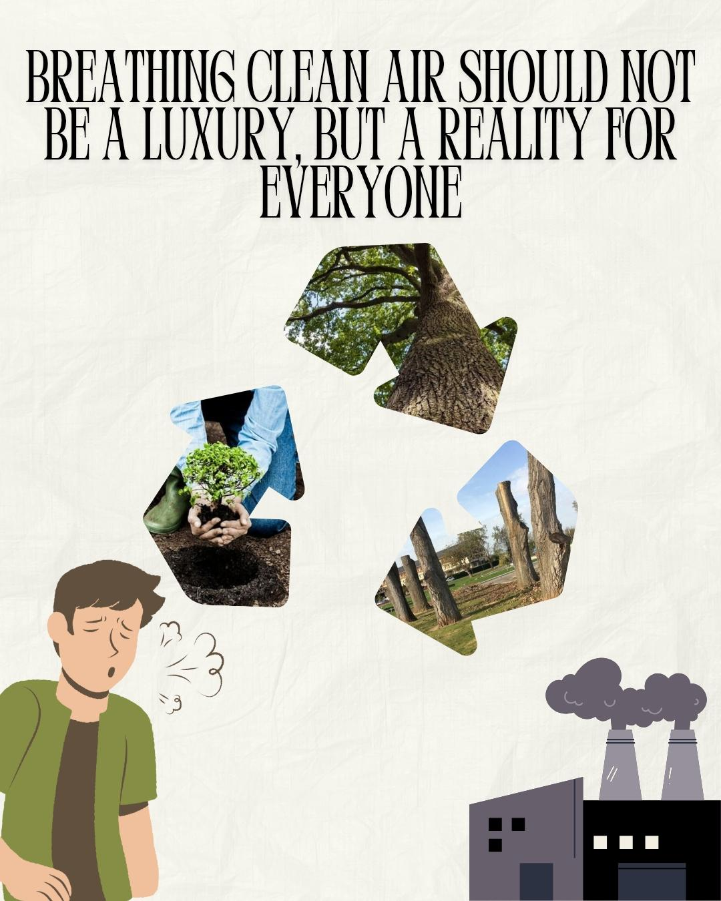


Example: this is a motivational phrase that encourages us to never give up. We use in this phrase zero conditional.


