COLEGIO SANTA ROSA DE LIMA

“Embracing our history, we boldly build new paths of humanization."

Materia: Lengua Extranjera Ingles Año: 2025
Profesor: López Belén
Alumno: __________________

INTRODUCTION
Welcome students! It`s a pleasure to meet you and tell you that I am going to be your teacher this year. My name is Belen Lopez and we are going to work together so as apart from learning English you can enjoy and love this process of learning.
To know you I have prepared an activity which is going to be finished on Wednesday,5th. We are going to share it in class so I can know more about you.
Then, you are going to work on a review that must be uploaded and prepared for Wednesday,5th.

GET TO KNOW ACTIVITY
- Look at the picture and answer the questions:
- What can you see in the picture? What is it?
- Is it the title related to the picture? In what ways?
- What things apart from our fingerprint do you think make us unique?


- Write on your fingerprint the things that define you, things that make you unique and different from others. You can write on it with different colours.
Try to include:
- Things you like/ dislike
- Things that you enjoy doing in your free time
- Personal information (favourite food, colour, etc)
- Adjectives that describe who you are
- Hobbies,etc.
Note: Your fingerprint must be on your notebooks.

REVIEW
- Think about all the things you learnt last year and complete the chart.
Things I learnt | Things I love doing last year | Things I have some difficulties with

- Choose a topic from ones you write on the chart and prepare a short explanation about it to share with all the class. You can make a mind map that helps you to remember the topic and the most important things about it.
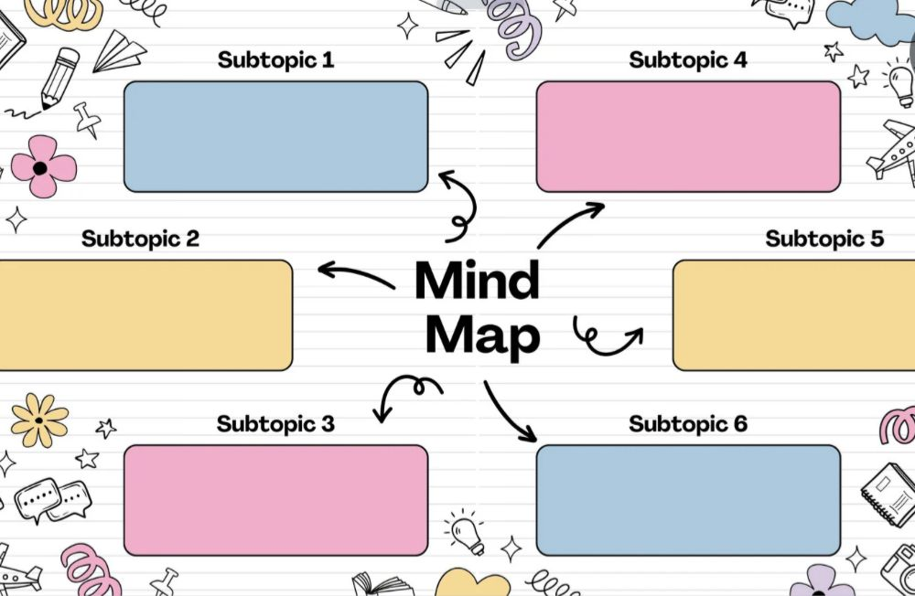
Note: You can also include questions you want to ask to your partners about this topic.

