COLEGIO SANTA ROSA DE LIMA

“Embracing our history, we boldly build new paths of humanization."

Materia: Lengua Extranjera Ingles Año: 2025
Profesor: López Belén
Alumno: Delfina Castro

INTRODUCTION
Welcome students! It`s a pleasure to be your teacher again. For the ones who I meet for the first time my name is Belen Lopez and we are going to work together so as apart from learning English you can enjoy and love this process of learning.
I have prepared an activity which is going to be finished on Wednesday,5th. We are going to share it in class so I can know more about you, your goals for this year, etc.
Then, you are going to work on a review that must be uploaded and prepared for Wednesday,5th.

GET TO KNOW ACTIVITY
- Look at the picture and answer: “What is in my jar?” Write on the hearts in the jar:
- 3 things you have learnt last year
- 3 things you want to achieve this year
- 3 things you expect this year from the subject, your teacher, your classmates, or about yourself.
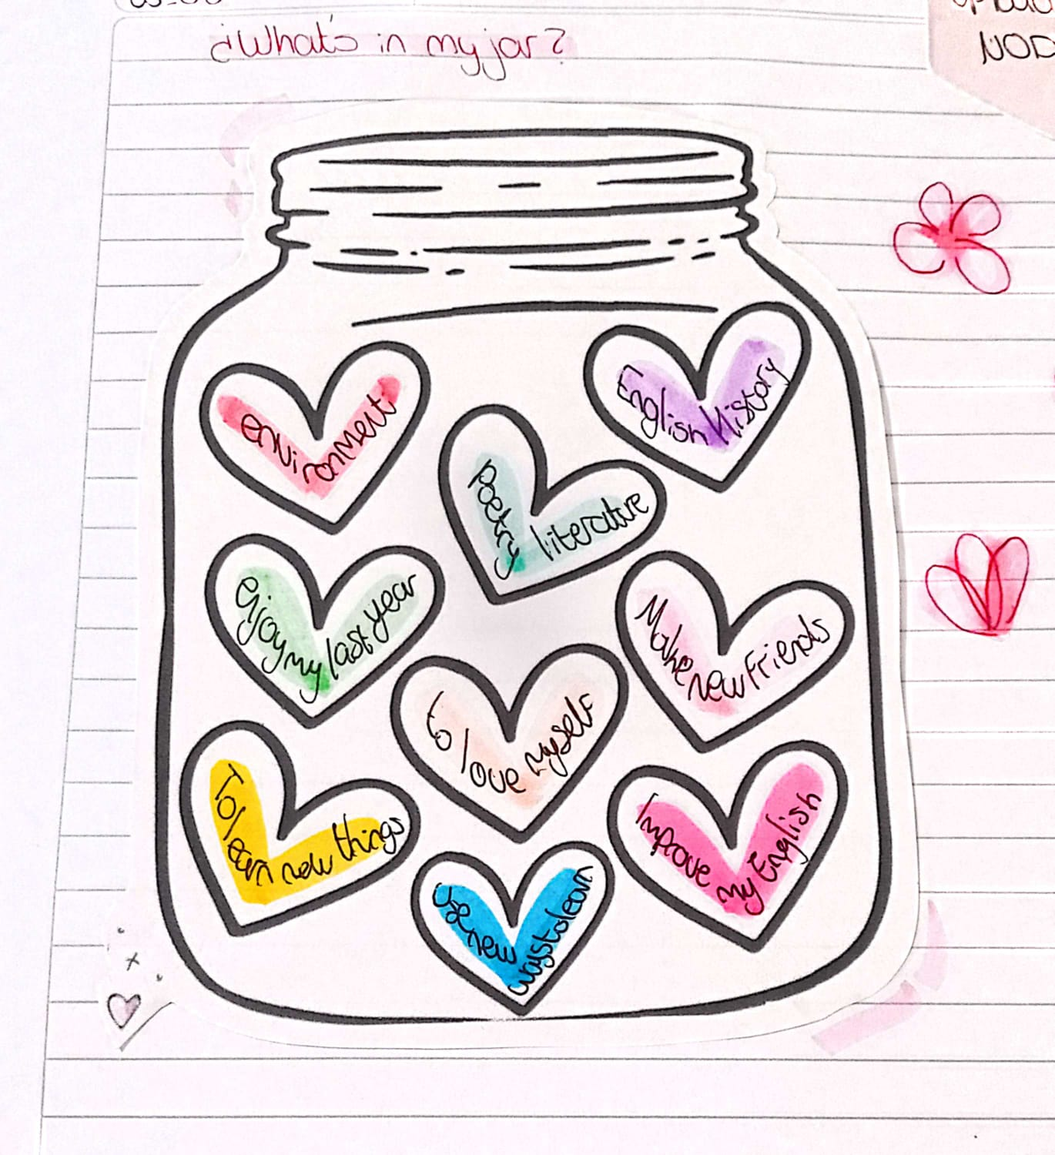
Note: Your jar must be on your notebooks for Wednesday,5th.

REVIEW
- Answer the following questions.
- Which things have you learnt in this subject last year?
We learned about different writers, also about environment vocabulary, transports and clothing
- Which things from the ones you learnt did you like the most?
I liked to do different hand-made games or flyers
- Which things were difficult to learn? What did you do to go through those difficulties?
I didn’t have any rough difficulties
- What new things do you want us to start doing this year?
I´d like to see movies o listening to music to learn new vocabulary

- Choose 3 topics from the ones you learnt last year and write 2 motivational phrases.
Note: Write these phrases on a different piece of paper. You can decorate it as you want. Try to WRITE YOUR OWN motivational phrase.
Example: this is a motivational phrase that encourages us to never give up. We use in this phrase zero conditional.


“The only way to fail is to quit"
"The best is yet to come"
“You just have to trust the process”

