COLEGIO SANTA ROSA DE LIMA

“Embracing our history, we boldly build new paths of humanization."

INTRODUCTION
Welcome students! It`s a pleasure to be your teacher again. I have prepared an activity which is going to be finished on Wednesday,2nd. You have to upload it before that day.
I want to know about you and how your life is going so first we are going to do an activity related to that. Then, we are going to make a review and a short production with all you have learnt last year.

GET TO KNOW ACTIVITY
- Look at the picture and answer: “What is in my jar?” Write on the hearts in the jar:
- 3 things you have learnt last year
- 3 things you want to achieve this year
- 3 things you expect this year from the subject, your teacher, your classmates, or about yourself.


- Think about all the things you learnt last year and complete the chart.
Things I learnt | Things I love doing last year | Things I have some difficulties with

- What past, present or future tenses have we seen last year? Make a mind map, mention some of them and explain their uses, forms and adverbs. Mention their similarities and/ differences.
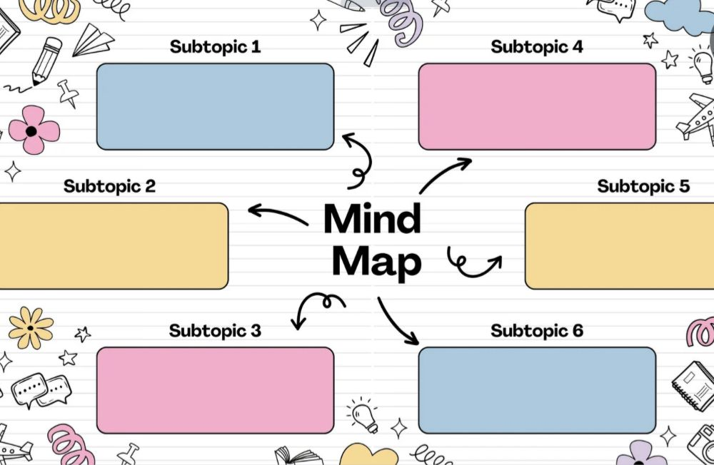

- Choose three of the tenses you include in your mind map and write a short production where you can use them: anecdote, story, a tale, etc.

