COLEGIO SANTA ROSA DE LIMA

“Embracing our history, we boldly build new paths of humanization."

INTRODUCTION
Welcome students! It`s a pleasure to be your teacher again. I have prepared an activity which is going to be finished on Wednesday,2nd. You have to upload it before that day.
I want to know about you and how your life is going so first we are going to do an activity related to that. Then, we are going to make a review and a short production with all you have learnt last year.

GET TO KNOW ACTIVITY
- Look at the picture and answer: “What is in my jar?” Write on the hearts in the jar:
- 3 things you have learnt last year
- 3 things you want to achieve this year
- 3 things you expect this year from the subject, your teacher, your classmates, or about yourself.

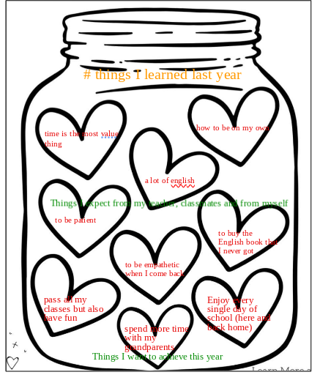

- Think about all the things you learnt last year and complete the chart.
Things I learnt | Things I love doing last year | Things I have some difficulties with
I learnt to use Canva and to do my homework in record time | Speaking | None

- What past, present or future tenses have we seen last year? Make a mind map, mention some of them and explain their uses, forms and adverbs. Mention their similarities and/ differences.
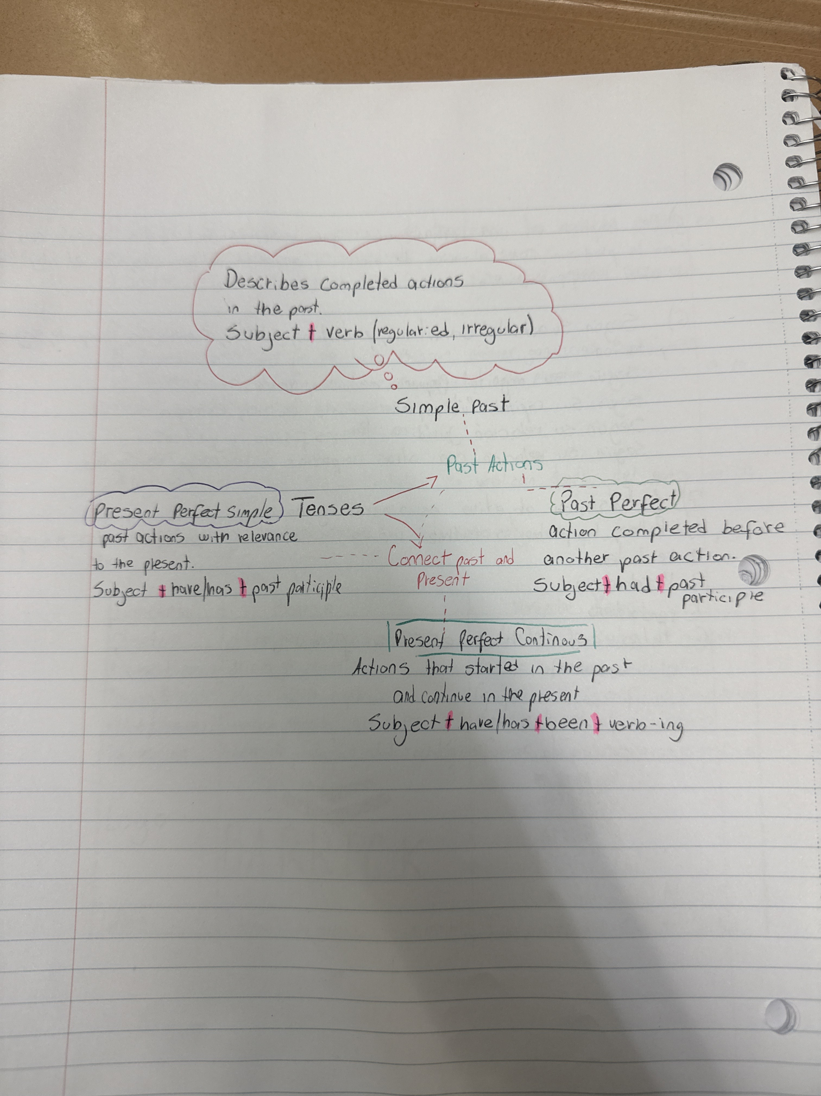

- Choose three of the tenses you include in your mind map and write a short production where you can use them: anecdote, story, a tale, etc.

Last spring break I went to a cruise but the day of the flight we spent the night in Miami. When I was in the airport watching Instagram, I saw a reel about the Miami Open, a tennis tournament, so I thought “What if there is a good match?” so I started to look on google and I found that ALCARAZ was going to play that night. So, I asked my dad if I could go, and he said that I could go only If somebody goes with me. I told my host mom, and she said “sure” I asked every single person on my crew and everyone said NO. I asked my host mom if she could come with me I went “I have asked everyone but nobody likes tennis” she said I'm sorry I don't like it either but you can go alone. As soon as I heard that I started to jump, I called my dad, and he said no, I kept trying to convince him so I said “please I have been asking for two hours and nobody wants to come” he said that I should ask my mom and my mom said, only if your host mom lets you go. The Hard Rock Stadium was 1 hour away but my host mom said yes, I was surprised that she let me hang out by myself in Miami. With y ticket already bought, and my phone with only 40 percent of life I headed to the Stadium. So now I can say that I have been in a Carlito’s match.

