COLEGIO SANTA ROSA DE LIMA

“Embracing our history, we boldly build new paths of humanization."

Good afternoon dear students! Now we are working on our Intership project. In this project we have different parts and each part has a task to do.
We have started seen vocabulary related to jobs. First, we saw professions we made a review from what we have seen last year and then we started to do a photocopy where we see other professions, factors that we should take into account when applying for a job and adjectives that we would like to describe us as a future professional.

Today you are going to start working on that. You have to do some exercises related to it and send it to me.

If there’s any doubt please contact me.

I hope you are really fine! See you!

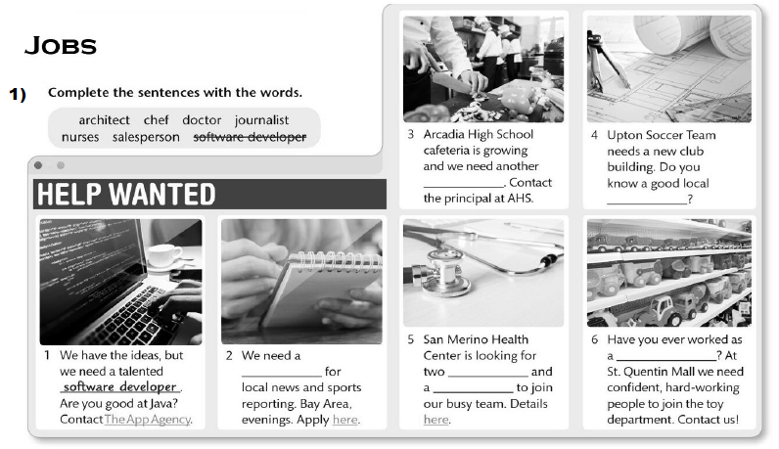
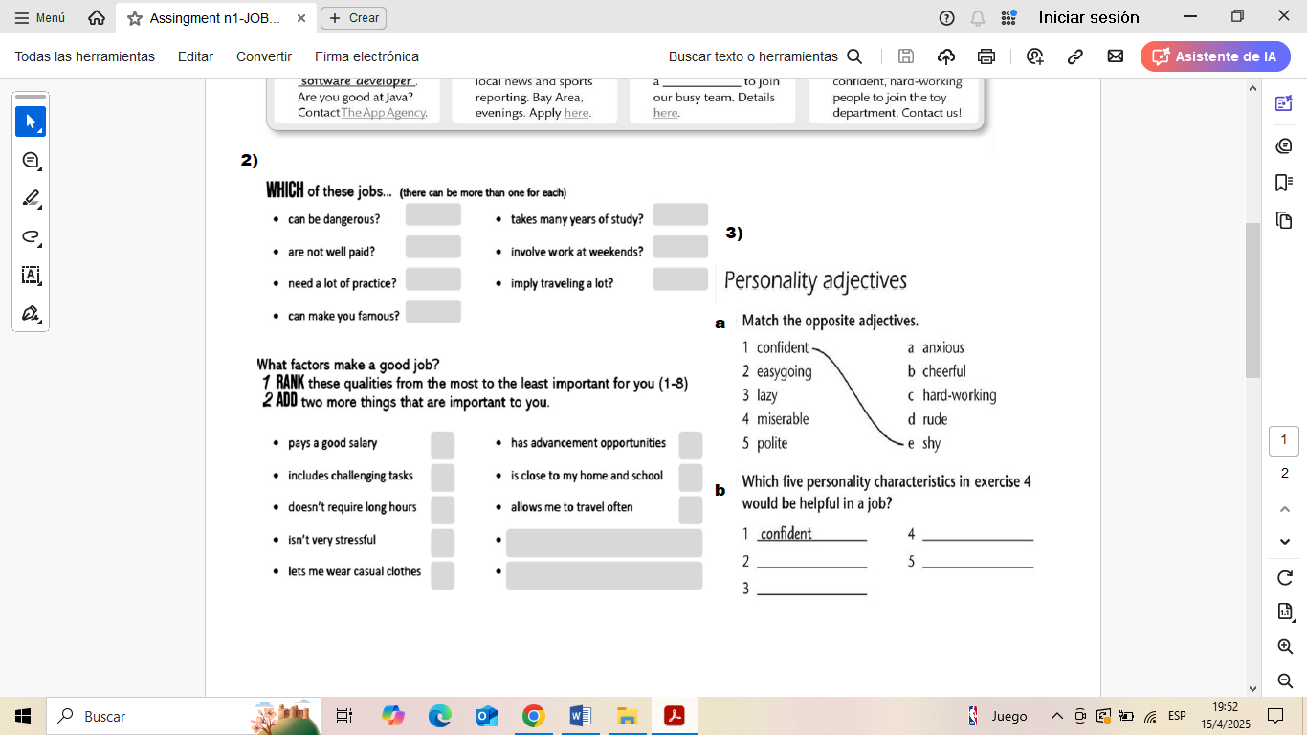

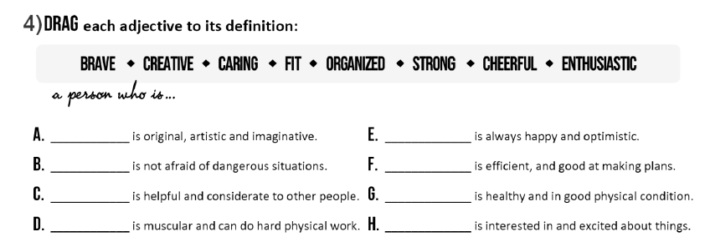
- Once you finish doing the activities complete the chart with the vocabulary you have learnt.
Professions/ Jobs | Factors | Adjectives
Architect | Well-paid | Confident

- Which other professions, factors, adjectives could you add to the chart? Add them in your chart with a different colour.

