EXTRA PRACTICE DATE:

- LOOK AT THE MAP AND DESCRIBE WHAT YOU SEE. USE: There is a…/ There are …
(Mira el mapa y describe lo que ves)

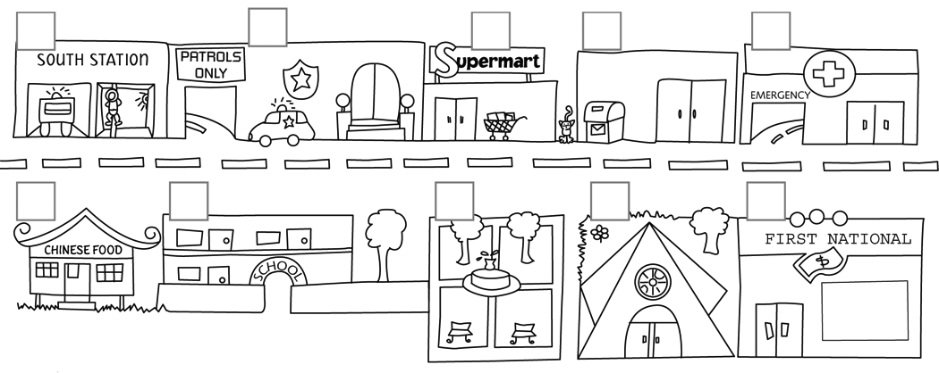

VOCABULARY:
trees: árboles
lots of: muchos/as
church: iglesia
bank: banco
hospital

