EXTRA PRACTICE DATE:

- READ AND COMPLETE. THEN, DRAW

1. Victoria is …………..…….. years old. …………. hair is long, straight and …………..…….. . Her ………….are blue.

2. Santi is …………..…….. years old. His hair is short, …………..…….. and blond and his eyes are …………..…….. .

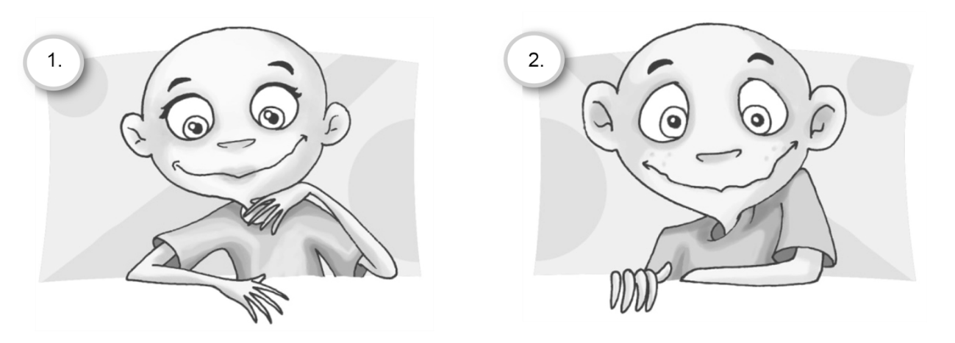

B- CROOS THE ODD ONE OUT

1. mother – grandfather – dog – daughter

2. long – big – curly – blonde

3. thirteen – twelve – fourteen – pen

4. people – eyes – hair – hand

5. blonde – fair – dark – wavy

6. friend – brother – grandmother – son

7. blue – small – green – brown

8. beautiful – nice – fifteen – big

