COLEGIO SANTA ROSA DE LIMA

“Sowers of hope, artisans of fraternity"

UNIT 1
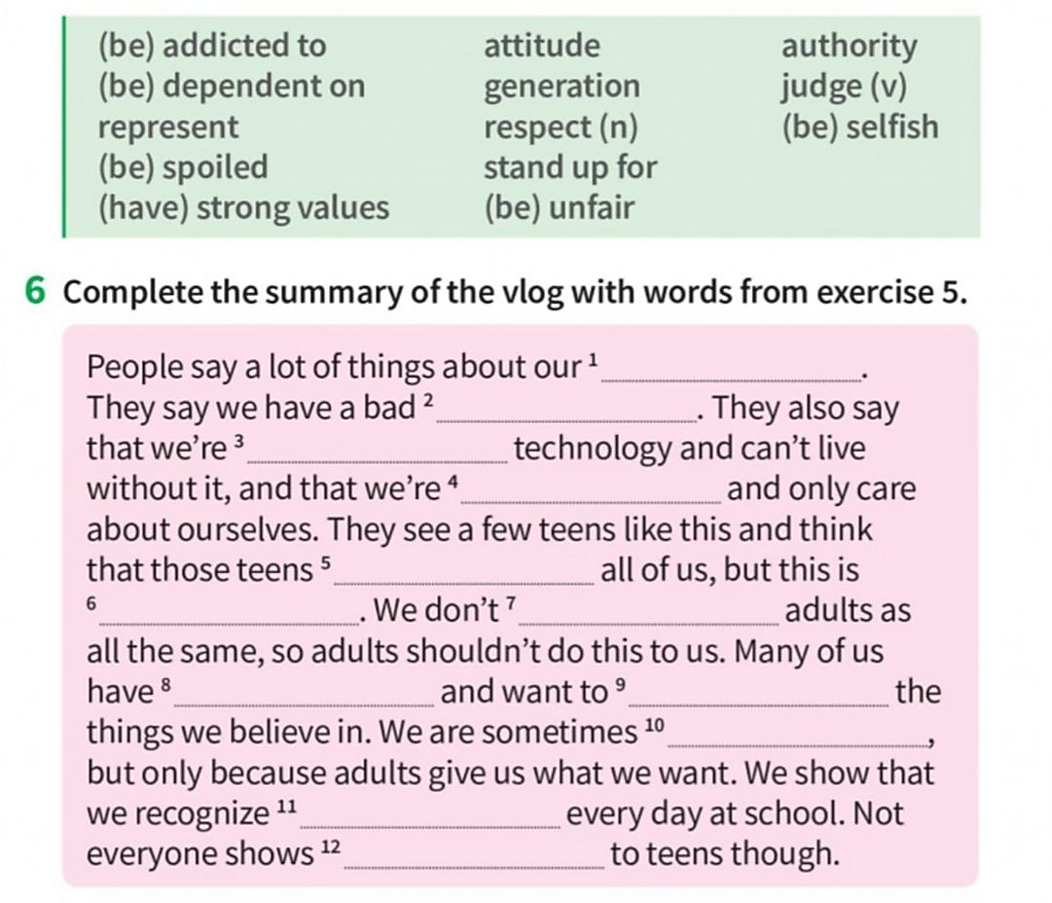
- Read the vocabulary related to social media on activity 5 page 9. Then, complete the text below with the corresponding word. Check you understand the meaning of all the words in the green box.

- Read the text on page 10 “Teen life” and complete activity 4 with the phrasal verbs you have in bold in the text. Before doing the activity, look for the meaning of each phrasal verb that appear in the text.
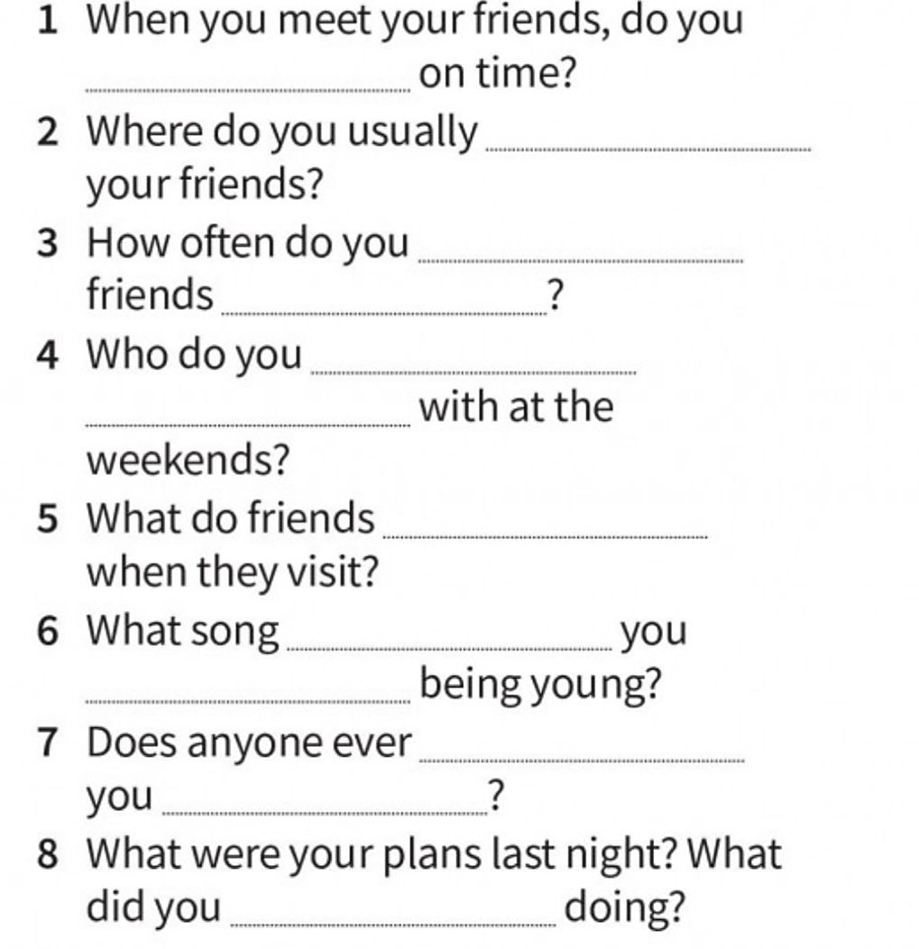

- Written project: From what you have learnt can you explain which of the words represent best your generation? Why? How do you think adults see today’s generation? Do you agree with them? Why/ why not? Write a short paragraph about it.

