COLEGIO SANTA ROSA DE LIMA

“Embracing our history, we boldly build new paths of humanization."

Evaluación de: Lengua Extranjera Ingles Año: 2025
Profesor: López Belén

- Read the text on page 10 activity 2. Then, work on activity 3 page 11.
Page 10 act 2
- I think he´s between 8 and 25 years old.
- The main change in this appearance is his hair style. Only in the last photo he´s got a beard.
- When I a child I used to have long curly blonde hair. I didn´t use to wear earrings. Today I have short curly darker hair and I wear one earring. I haven´t got a beard.
Page 11 act 3
- Ellar had worked with Linklater before this film. DK
- All the actors met up for only 15 minutes each year. F
- There is a scenes in the film where mason has a haircut. T
- One similarity bet ween Ellar and the character Mason is that they both loved photography. T
- Ellar and Linklater wouldn´t speak to each other at all except during shooting. F
- Ellar really enjoyed watching the film for the firs time. F
- Ellar thinks mason was more grown-up. DK
- Read the sentences extracted from the text and say which of these tenses corresponds to Simple Past, Past Continuous or Past Perfect.

- Linklater was looking for a young actor to play Mason.
Past continuous
- Ellar had made some commercials and had been in a film.
Past perfect
- Ellar didn’t use to change appearance much.
Simple past

- How much do you remember about each tense? Complete the chart with the uses, forms and adverbs of each past tense.
 | Simple Past | Past Continuous | Past Perfect
Use | An action finished in the past. | An action that was in progress in the past. | An action before another action in the past.
Forms | Aff: subject + verb in the past.  Neg: Subject + didn’t+ verb-inf  Int: (wh-) did + subject + verb in infinitive? | Subject + was/were + v-ing.  Subject + wasn’t/weren’t + v-ing.  (wh-) was/were + subject + v-ing?. | Subject + had + verb in a past participle.  Subject + hadn´t + verb in past participle.  (wh-) had + subject + verb in past participle.
Adverbs | -yesterday  -last night  -in 2020  -2 weeks ago | -at 7 o´clock  -from 8 to 10 pm | - Recently/just/already  - Yet  - Never  - Ever

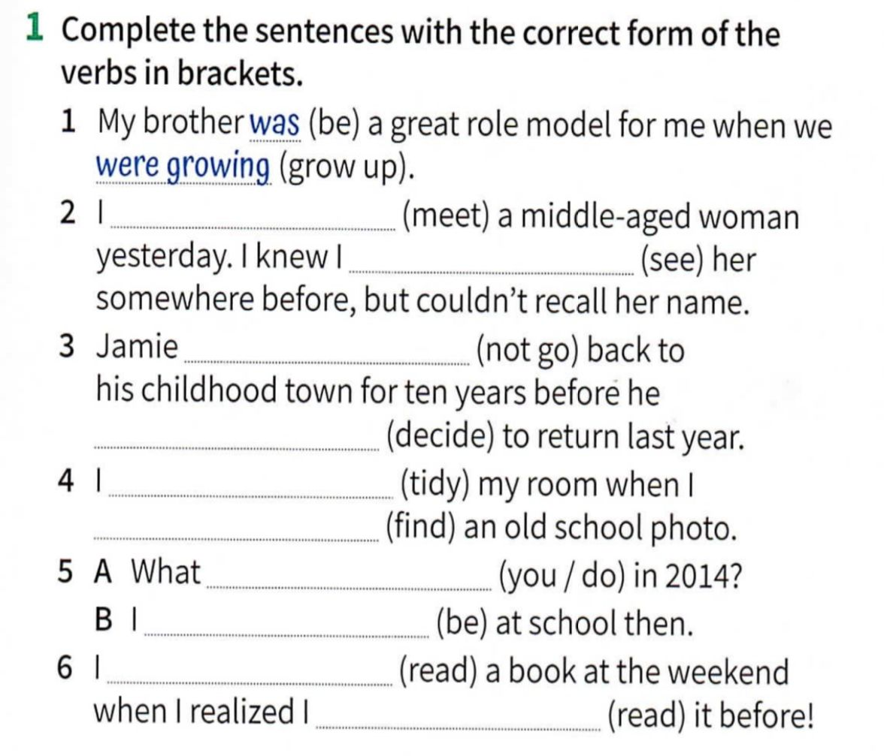
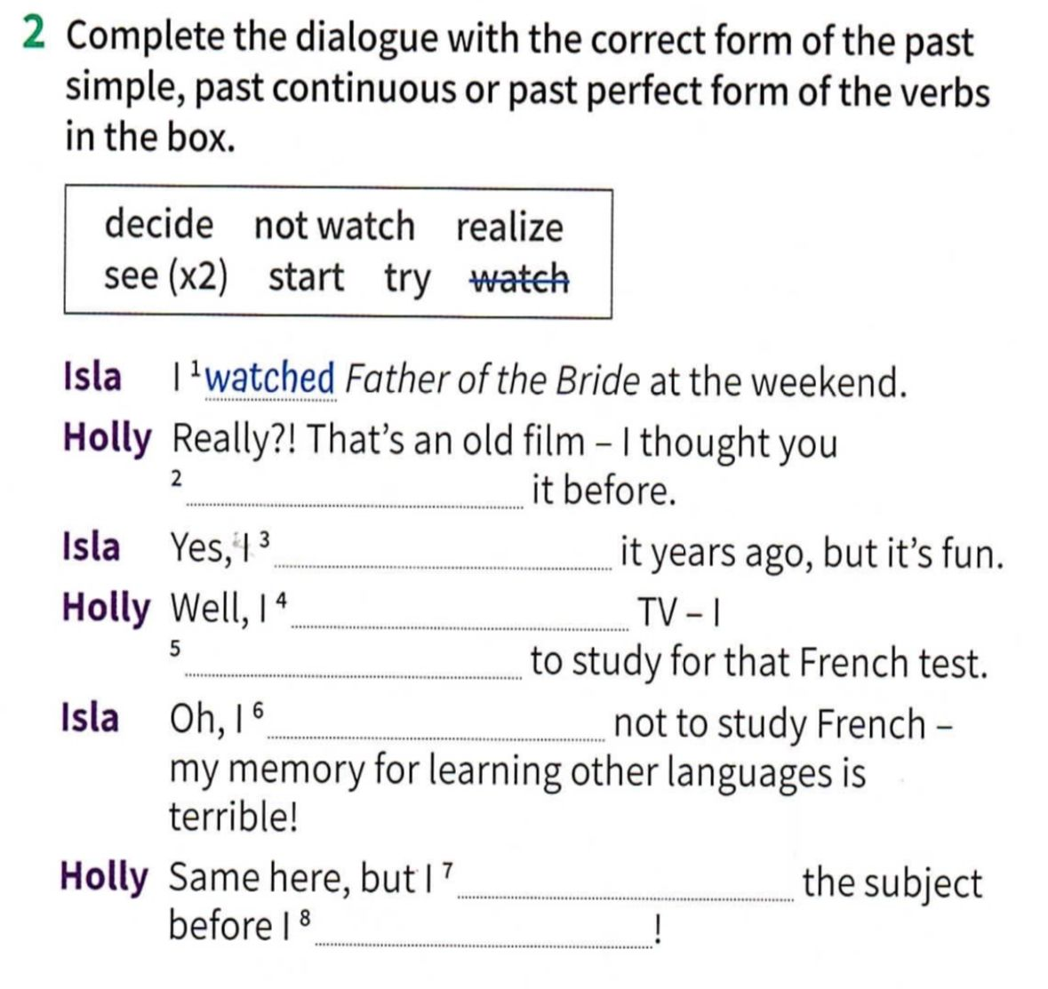
- Work on activity 1 and 2 page 107 to review past tenses.

- Written project. Choose one of the questions to answer. Use all the tenses and vocabulary you have learnt on this unit. Write at least 5 sentences.
- Which is one of your earliest memories?
- What objects/smells/songs reminds you a part of your childhood?
- Which is the worst/ best experience you have ever had?

4- 1- 2) met, had seen.
3) hadn´t gone, decided.
4) was tidying, found.
5) did do you, was.
6) was reading, had read.

2- 2) had seen
3)saw
4) didn´t watch
5) was trying
6) decided
7) had started
8)realized

- Which is one of your eariies memories?
I remember that when I was four years old I traveled with my mom to Mar del Plata. I was happy, we went to the beach everyday and ate hot corn. They were delicious!!
Then, when I was six, I went with my dad to Monumental stadium in Buenos Aires. River Plate won the match 3-0 against boca jrs. We ate a burger after that.

