COLEGIO SANTA ROSA DE LIMA

“Sowers of hope, artisans of fraternity"

UNIT 2: In business

- Which words come to your mind when you read/herd the word business? Can you mention some of them? Complete the brainstorming.

BUSINESS

- Read the vocabulary related to money and business and complete the sentences below.
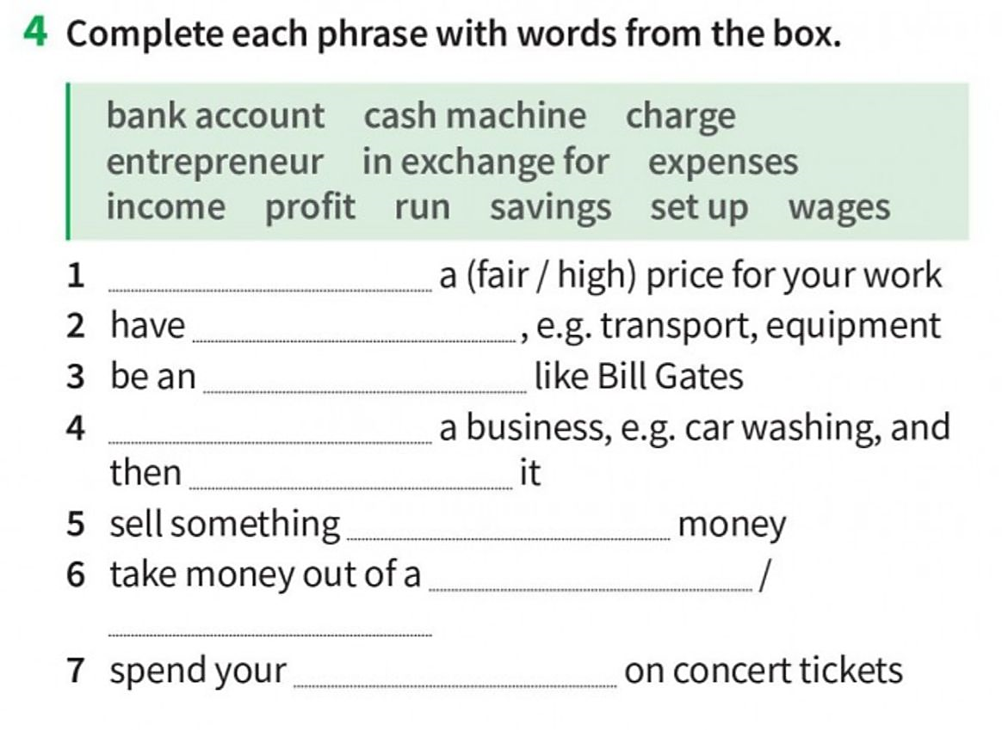

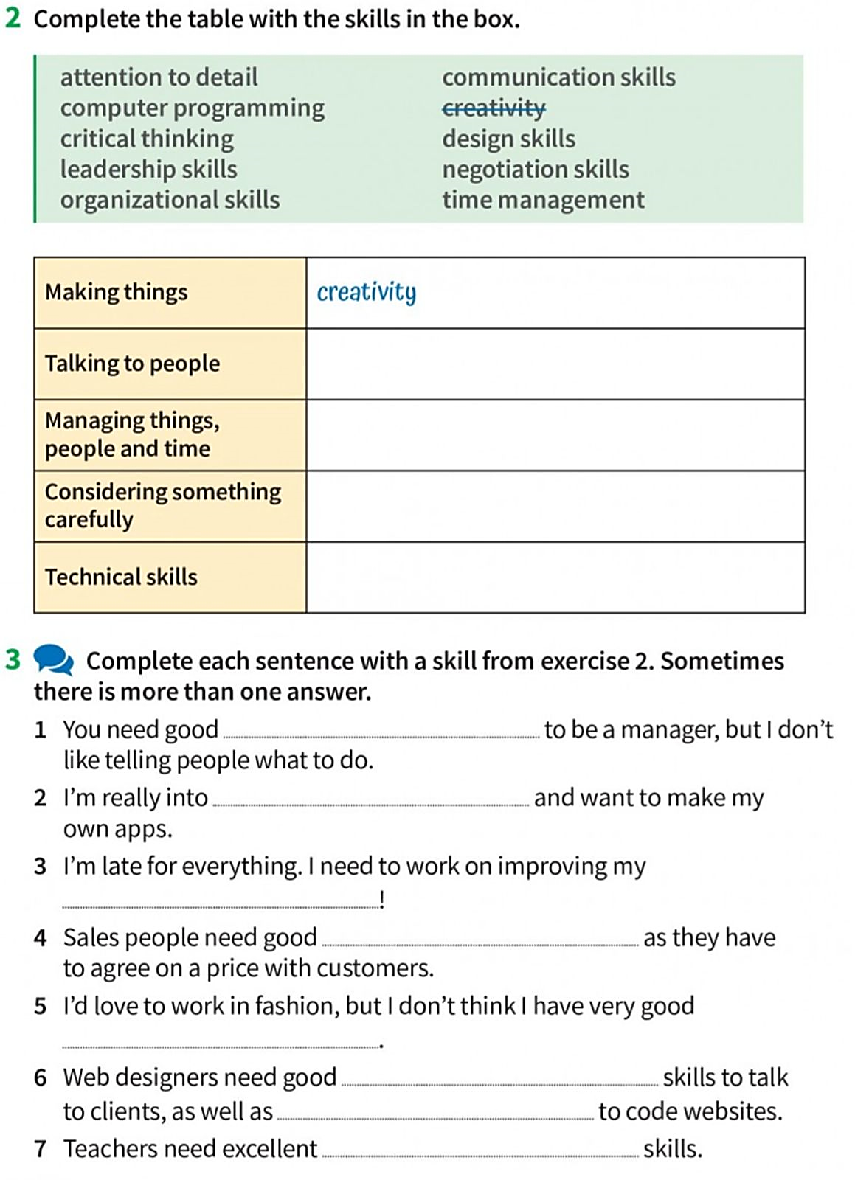
- Which skills do you think are necessary when running a business? Look at the skills in the box and complete the table.

- Complete the sentences with the skills on activity 3.

- Written project: Choose one of the questions to answer and write a paragraph about it using the vocabulary seen on this guide.
- What are the advantages and disadvantages of running your own business?
- Which skills are needed when starting a new business? Which one is for you the most important one? Why?

