COLEGIO SANTA ROSA DE LIMA

“Sowers of hope, artisans of fraternity"

UNIT 2: MAKE ME CARE

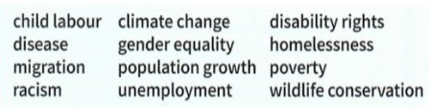
- Look at the pictures on page 20 and answer: With which social issues on page 21 activity 2 can you relate each picture?

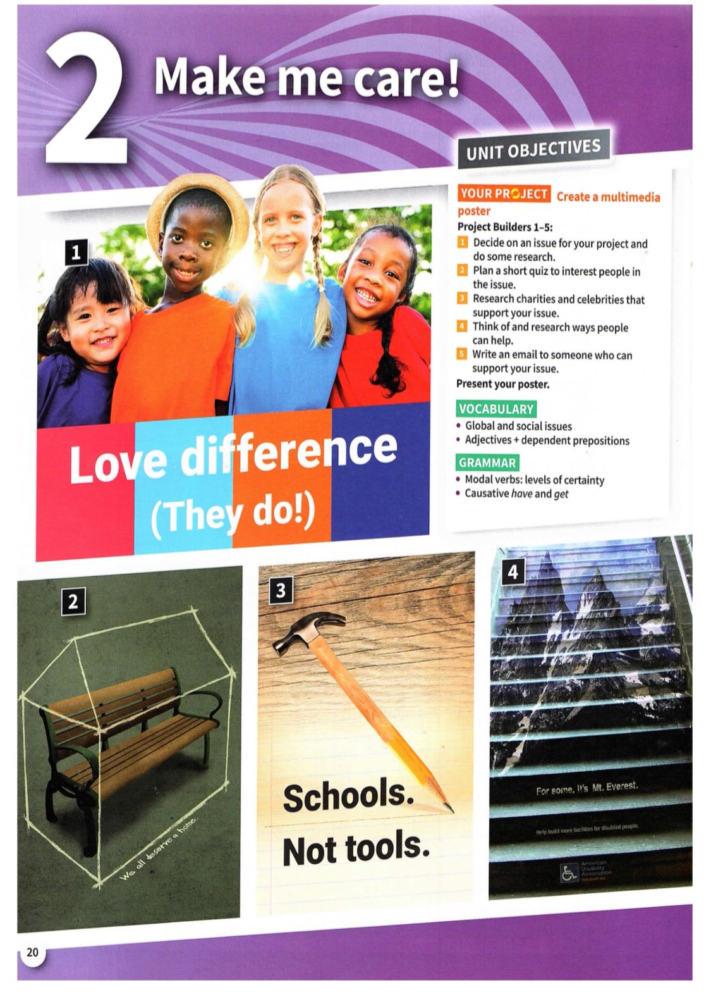

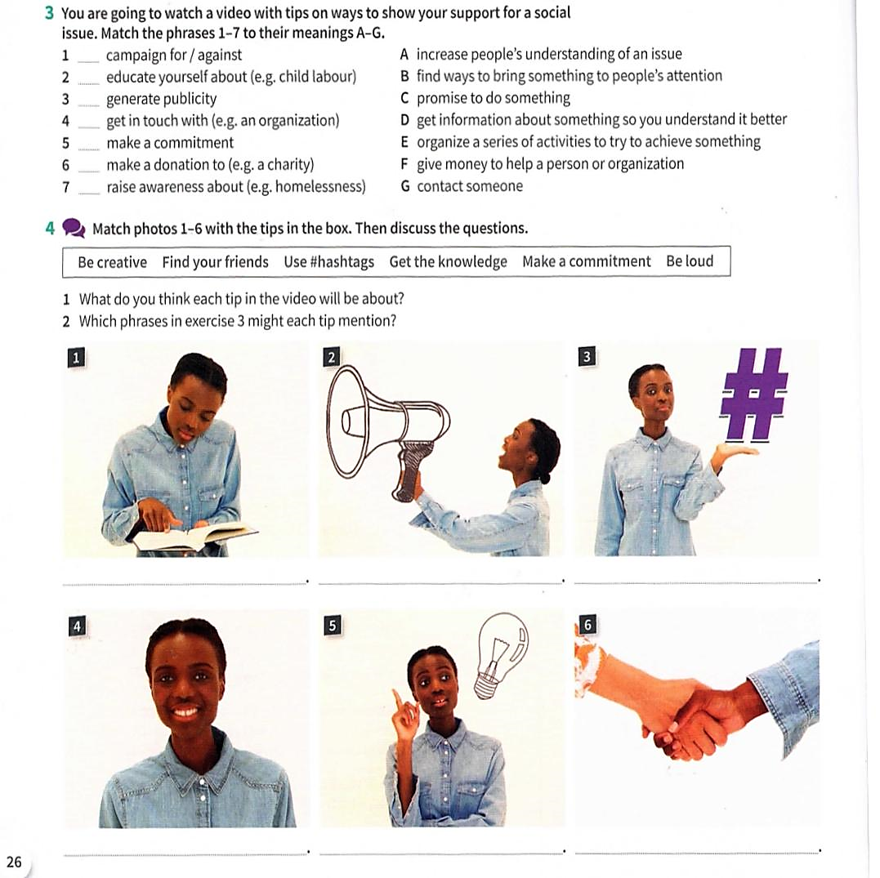
- Read and match.
- Match each picture with the corresponding expression.

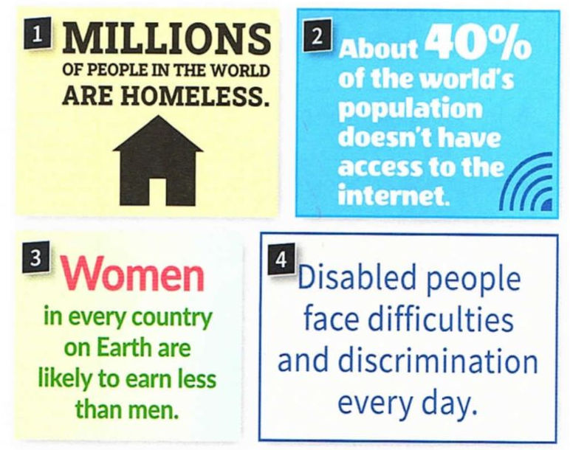
- Choose two of the problems below and write at least three possible solutions.

- Written project: Which of these social issues do you think are affecting most our world and society? Why? Provide examples. Use the vocabulary seen in this unit.

