COLEGIO SANTA ROSA DE LIMA

“Sowers of hope, artisans of fraternity"

UNIT 1: MAKING MEMORIES

- Read the text on page 10 activity 2. Then, work on activity 3 page 11.
- Read the sentences extracted from the text and say which of these tenses corresponds to Simple Past, Past Continuous or Past Perfect.

- Linklater was looking for a young actor to play Mason.
- Ellar had made some commercials and had been in a film.
- Ellar didn’t use to change appearance much.

- How much do you remember about each tense? Complete the chart with the uses, forms and adverbs of each past tense.
 | Simple Past | Past Continuous | Past Perfect
Use |  | An action that was in progress in the past.
Forms | Aff:  Neg:  Subject + didn’t+ verb-inf  Int:
Adverbs |  |  | - Recently/just/already  - Yet  - Never  - Ever

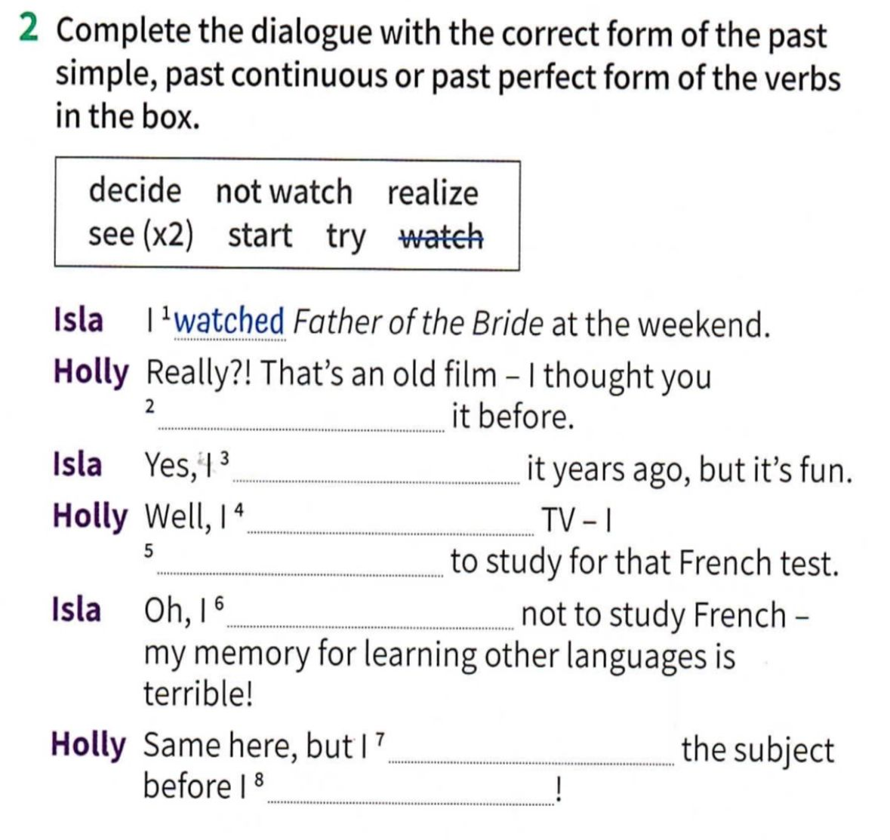
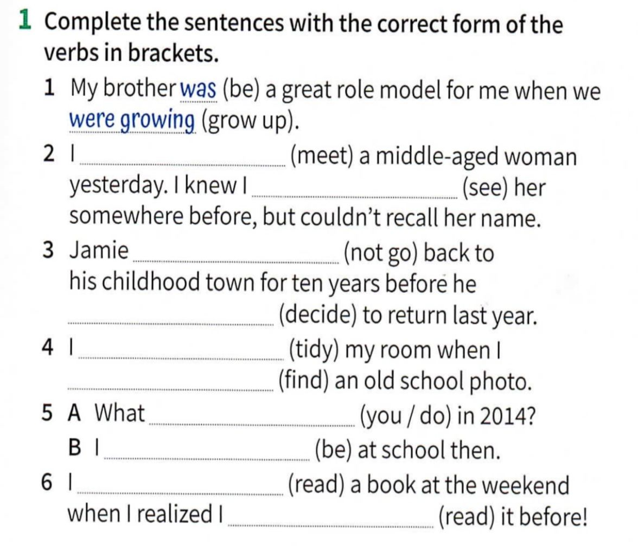
- Work on activity 1 and 2 page 107 to review past tenses.

- Written project. Choose one of the questions to answer. Use all the tenses and vocabulary you have learnt on this unit. Write at least 5 sentences.
- Which is one of your earliest memories?
- What objects/smells/songs reminds you a part of your childhood?
- Which is the worst/ best experience you have ever had?

