COLEGIO SANTA ROSA DE LIMA

“Embracing our history, we boldly build new paths of humanization."

Evaluación de: Lengua Extranjera Ingles Año: 2025
Profesor: López Belén

- Read the text on page 10 activity 2. Then, work on activity 3 page 11.
Activity 3
- DK
- False
- True
- True
- DK
- False
- True

- Read the sentences extracted from the text and say which of these tenses corresponds to Simple Past, Past Continuous or Past Perfect.

- Linklater was looking for a young actor to play Mason. PAST CONTINUOUS
- Ellar had made some commercials and had been in a film. PAST PERFECT
- Ellar didn’t use to change appearance much. SIMPLE PAST

- How much do you remember about each tense? Complete the chart with the uses, forms and adverbs of each past tense.
 | Simple Past | Past Continuous | Past Perfect
Use | An action finished in the past | An action that was in progress in the past. | An action previous to another action in the past
Forms | Aff:  Suject+ verb past  Neg:  Subject + didn’t+ verb-inf  Int: Did + Subject+ V inf? | Aff:  Suject+ was/were+V-ing  Neg:  Subject + wasn’t/weren’t+ V-ing  Int: Was/Were + Subject+ V-ing? | Aff:  Suject+ had+ Vpast part  Neg:  Subject + hadn’t +V past part  Int: Had+ Subject+Vpast part?
Adverbs | - Yesterday  - Last night/week  - 2 years ago  - In 2023 | - while/as  - yesterday at 5 o’clock | - Recently/just/already  - Yet  - Never  - Ever

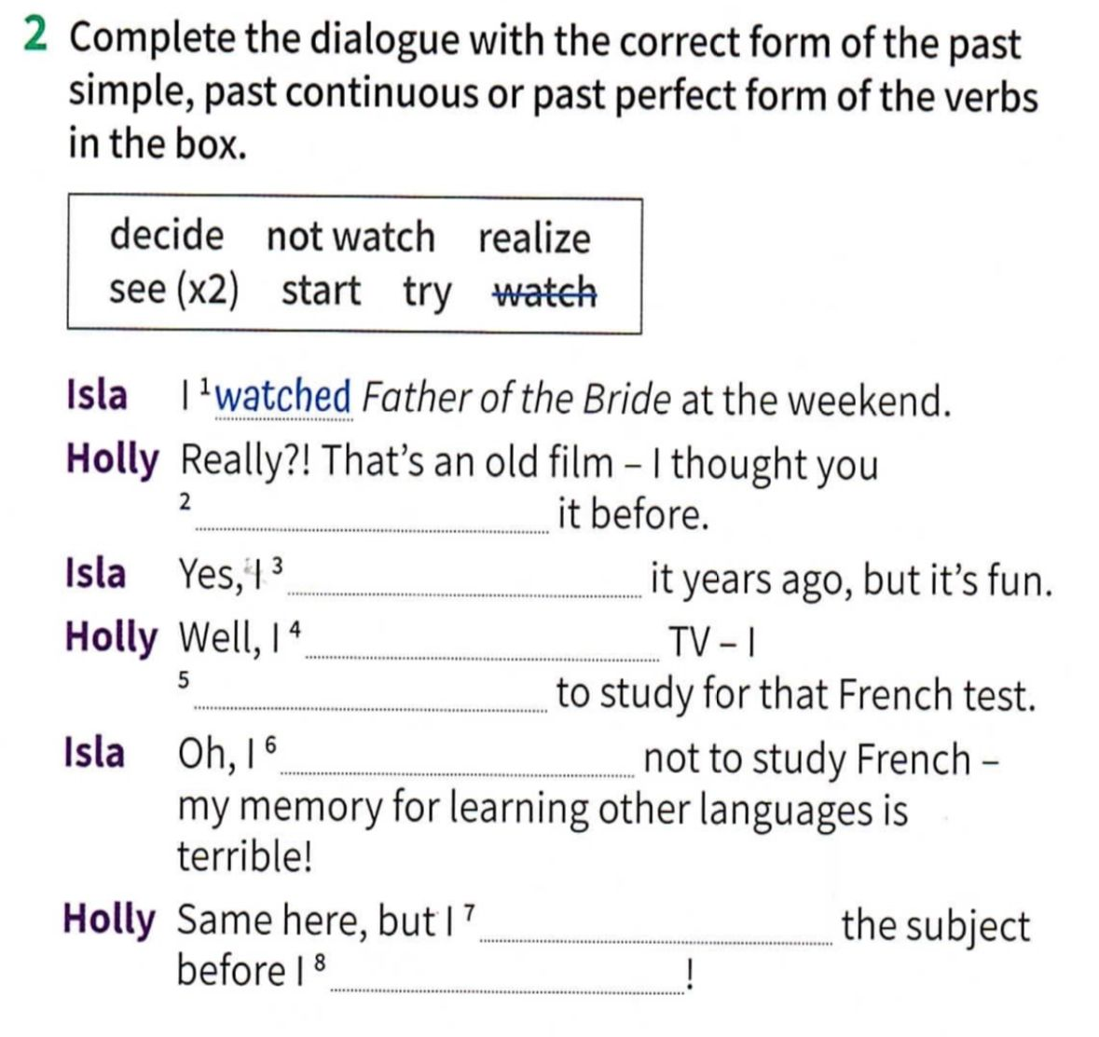
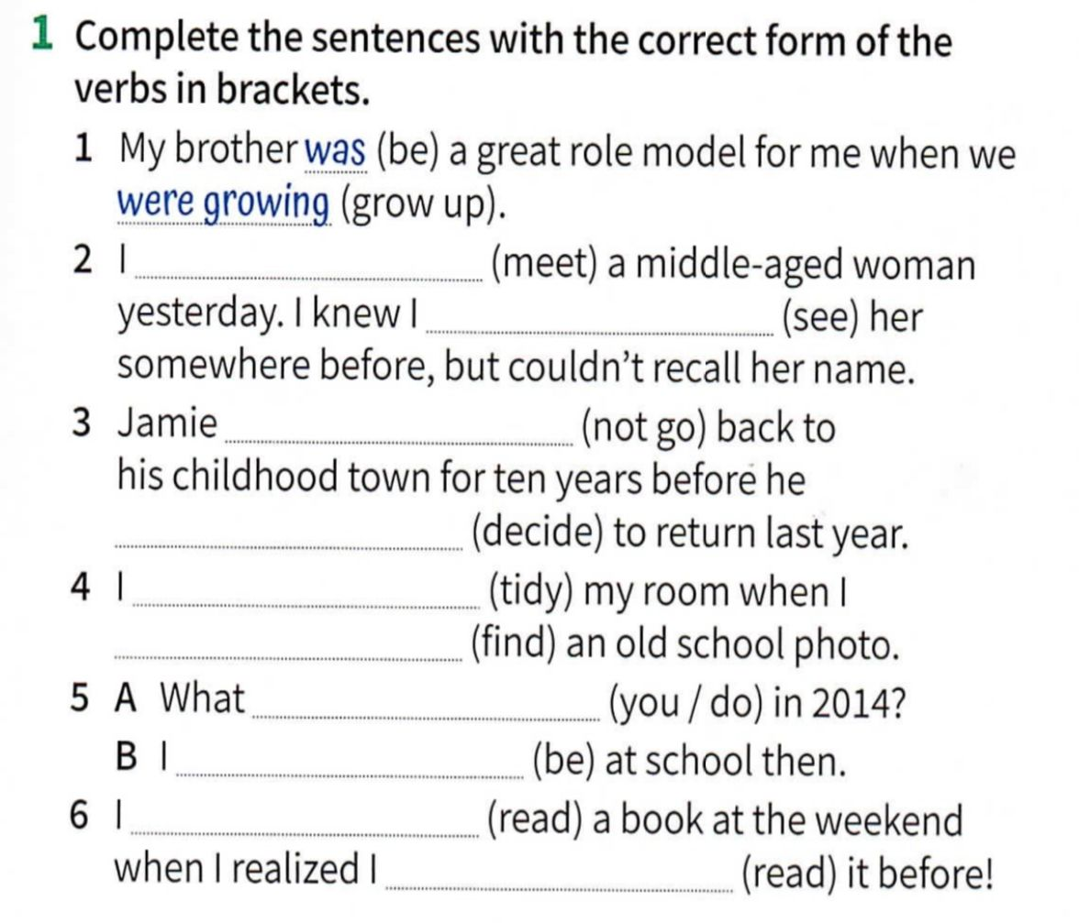
- Work on activity 1 and 2 page 107 to review past tenses.

- 2- met / had seen
3-hadn’t gone/ decided
4-was tidying/found
5-did you do/was
6-was reading/had read

- 2-had seen
3-saw
4-didn’t watch
5-was trying
6-decided
7-had started
8-realized

Written project. Choose one of the questions to answer. Use all the tenses and vocabulary you have learnt on this unit. Write at least 5 sentences.

- Which is one of your earliest memories?
- What objects/smells/songs reminds you a part of your childhood?
- Which is the worst/ best experience you have ever had?
One of my earliest memories is at the age of 5. I used to play with toys at my cousins ´house. I was really happy. I remember one day in particular. We were playing in the garden when a big dog appeared. I was scared! I had never seen an animal like that before!

