COLEGIO SANTA ROSA DE LIMA

“Sowers of hope, artisans of fraternity"

UNIT 2: In business

- Which words come to your mind when you read/herd the word business? Can you mention some of them? Complete the brainstorming.
money Trading profit
BUSINESS
car

travel

watch. Office
responsibility

- Read the vocabulary related to money and business and complete the sentences below.
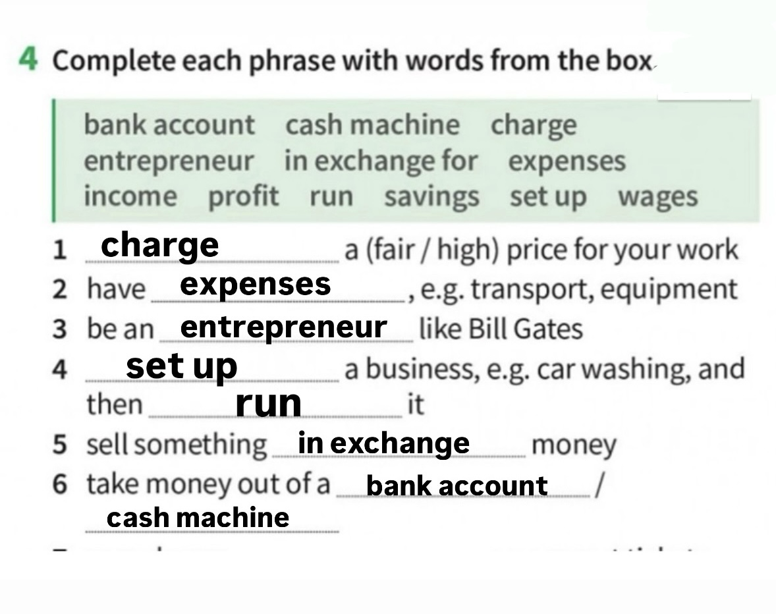

- Which skills do you think are necessary when running a business? Look at the skills in the box and complete the table.

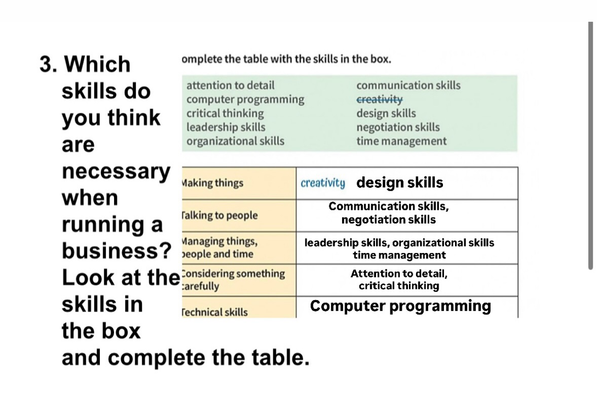

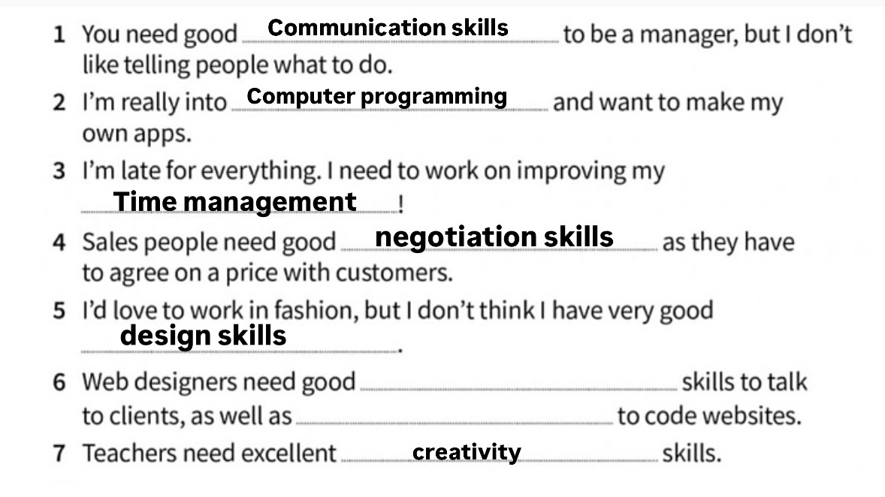
- Complete the sentences with the skills on activity 3.

- Written project: Choose one of the questions to answer and write a paragraph about it using the vocabulary seen on this guide.
- What are the advantages and disadvantages of running your own business?
Having your own business has good and bad things. A good thing is that you’re your own boss and you decide how to work. You can also learn more money, but it’s not easy there’s a lot of streets, and if it doesn’t work, you can lose money. You also have to work many hours. It’s a big challenge.
- Which skills are needed when starting a new business? Which one is for you the most important one? Why?
you need many skills to start a business, like communication, organization, and decision making. for me the most important is decision-making if you make good choices. Things go better. A bad decision can make you lose time or money.

