“Colegio San Bernardo” –Secundario Básico y Orientado-2025 - Teacher: Adriana Videla
STUDENTS ´ NAME:……………………………………………,,,,,,,,,,,,,,,,,,,,, -COURSE: 4 °año “B” -DATE:…………………………………….
Capacidades específicas: Comunicación .
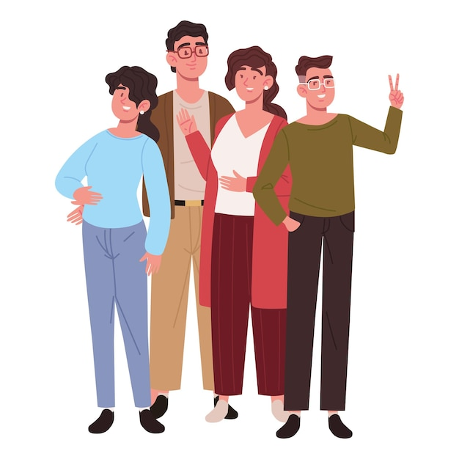
.Criterios de evaluación: Unit 2: . Leer y comprender textos .
Tema: Parental styles (Should/shouldn´t)
“ Reading Comprehension activity (Plan de contingencia)”

Read the article. Do the activities below it. SCORE:………………………/ 13 =………………………..
Title: “Parental styles”
Parenting styles can have a significant impact on a child's development and behavior. There are two main types of parenting styles: strict and liberal.
Strict parents tend to be more authoritarian and have high expectations for their children's behavior. They often use punishment and discipline to enforce rules and may not allow for much flexibility or autonomy. While strict parents may help children develop self-discipline and responsibility, they may also lead to rebellion or low self-esteem in some cases.
On the other hand, liberal parents tend to be more permissive and focus on nurturing their children's individuality. They often prioritize building a strong emotional bond with their children and may be more likely to negotiate rules and boundaries. While liberal parents may help children develop creativity and self-expression, they may also struggle with setting clear boundaries and expectations.

1- Answer the questions about the article.
1. What are the two main types of parenting styles mentioned in the text?
………………………………………………………………………………………………………………………………………
2. How do strict parents tend to approach discipline and rule enforcement?
………………………………………………………………………………………………………………………………………
3. What are some potential benefits of having strict parents?
………………………………………………………………………………………………………………………………………
4. How do liberal parents prioritize their relationship with their children?
…………………………………………………………………………………………………………………………………………
5. What is a potential challenge for liberal parents?
………………………………………………………………………………………………………………………………………..
2- Fill in the blanks with the words in the box. The text can also help you.

1-Parenting styles can have a significant impact on a child's development and behavior. There are two main types of parenting styles: ________ and ________.
2-Strict parents tend to be more ________ and have high expectations for their children's behavior. They often use ________ and discipline to enforce rules.
3-Liberal parents tend to be more ________ and focus on nurturing their children's individuality. They often prioritize building a strong ________ bond with their children.
3-Give suggestions to these parents. Use: should/shouldn´t and a verb from the box.

1. You should _________ a bedtime routine to help your child wind down before sleep.
2. You should _________ your child find a tutor or extra help outside of school.
3. You should _________ your child relaxation techniques, such as deep breathing or visualization.
4. You should _________ your child join a club or activity that interests them to meet new people.
5. You should _________ your child how to manage their emotions and express themselves in a healthy way.
- encourage - teach (x2) - establish - help
. liberal . punishment . Emotional .permissive. . strict authoritarian

