Neme: Angelo Mercado 2ND YEAR “A”
DATE: AUUGUST 22ND 2025
Pages in the book: pages 128 (3a), 153

1) Look at the chart and complete
(mirá el cuadro. Las x significan que no hace esa
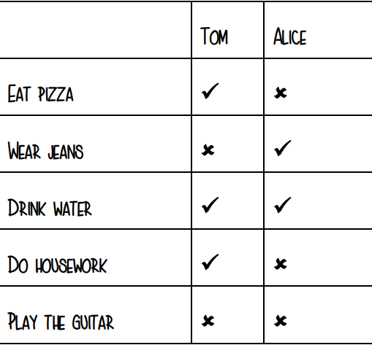
actividad y los ticks que si las hace. )

1 Tom eats pizza.
2 Tom doesn't wear jeans.
3 Tom and Alice drink water.
4 Tom and Alice don't play the guitar.
5 Alice doesn't eat pizza.
6 Alice wears jeans.
7 Tom does housework
2) Translate (traduce en inglés)
1 Yo no leo libros. → I don't read books.
2 Mi Hermana Habla Aleman. → My sister speaks German.
3 Ella no estudia historia. → She doesn't study History.

3) 3. Write about san juan/argentina. What do people do? (hicimos esta actividad en clase asi que está en tu cuaderno. debes escribir al menos 3 oraciones debajo de cada titulo, podes empezar con people in argentina….no uses los mismos verbos. las oraciones pueden ser positivas o negativas)

Food (comida):
- People in Argentina eat empanadas and asado.
- People drink mate every day.
- People don't eat spicy food very often.
Traditions (tradiciones):
- People celebrate the National Grape Harvest Festival.
- People dance folklore music.
- People don't celebrate Halloween a lot.
Places (lugares):
- People visit Valle de la Luna.
- People go to the mountains in summer.
- People don't visit the beach because it's far.

