COLEGIO SANTA ROSA DE LIMA

“Sowers of hope, artisans of fraternity"

UNIT 3: Rise to the challenge

- Look at the different challenges on page 32. Do you know which type of challenge is it?
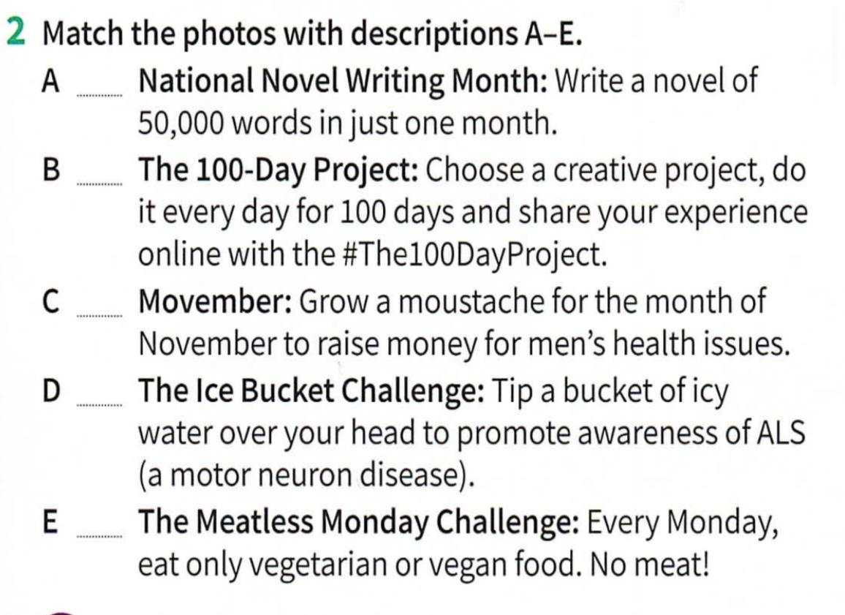
- Work on activity 2 page 33.

- Then, answer the questions:
- Have you ever heard of any of the challenges above?
- Have you done any? Which might you like to try?
- Why do people do challenges like these?

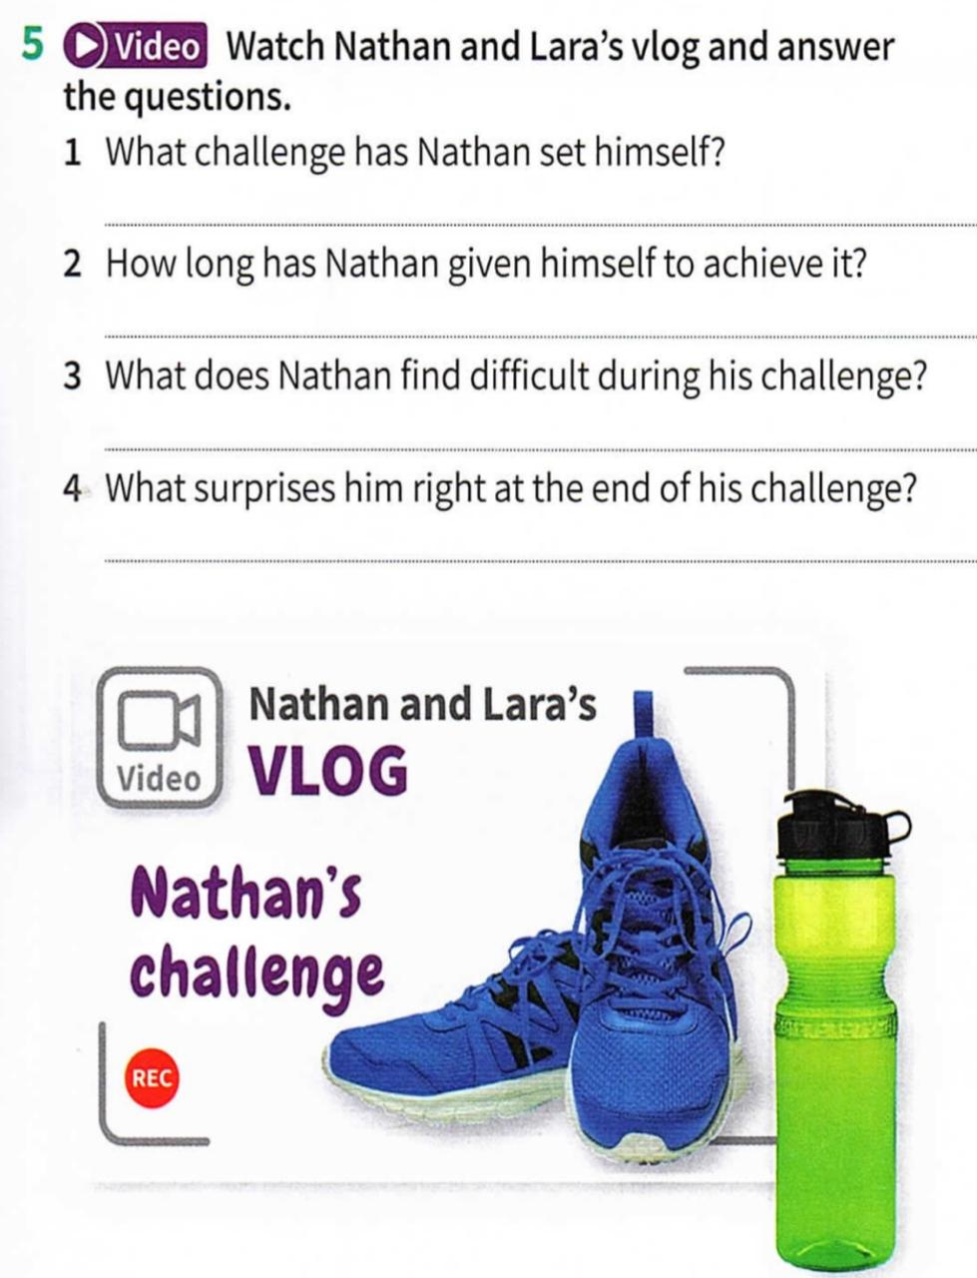
- Watch the video on activity 5 and answer the questions.

- Complete the article on activity 6 page 33 with the expressions extracted from the video.
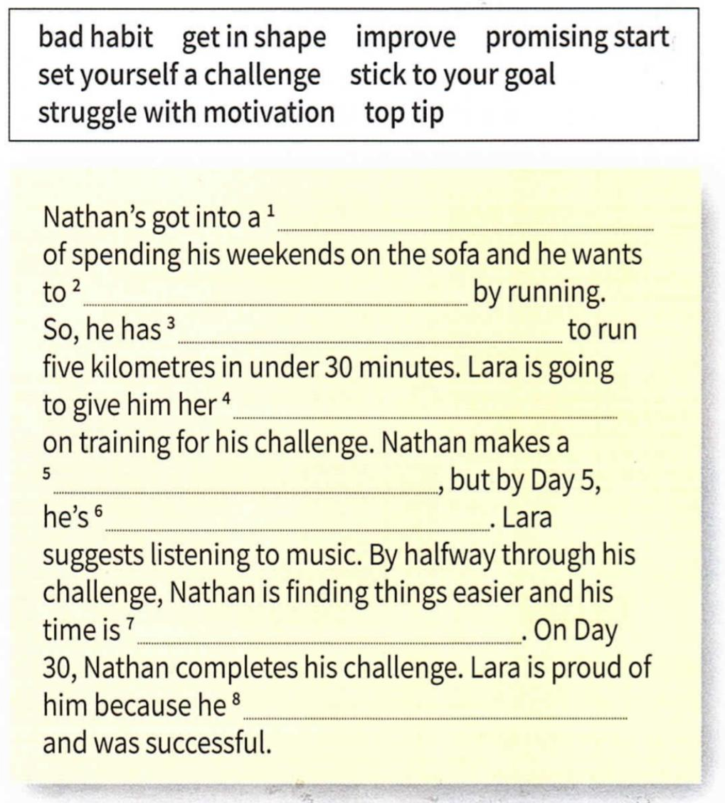

- Choose one of the following questions to answer and write a short paragraph.
- What’s the most challenging thing you’ve ever done and why?
- How important is for you to have challenges in our life?
- Do challenges make people stronger or just stressed? Why?

