“Colegio San Bernardo” –Secundario Básico y Orientado-2025 - Teacher: Adriana Videla
STUDENT´S NAME:……………………………………………,,,,,,,,,,,,,,,,,,,,, -COURSE: 4 °año “B” -DATE:…………………………………….
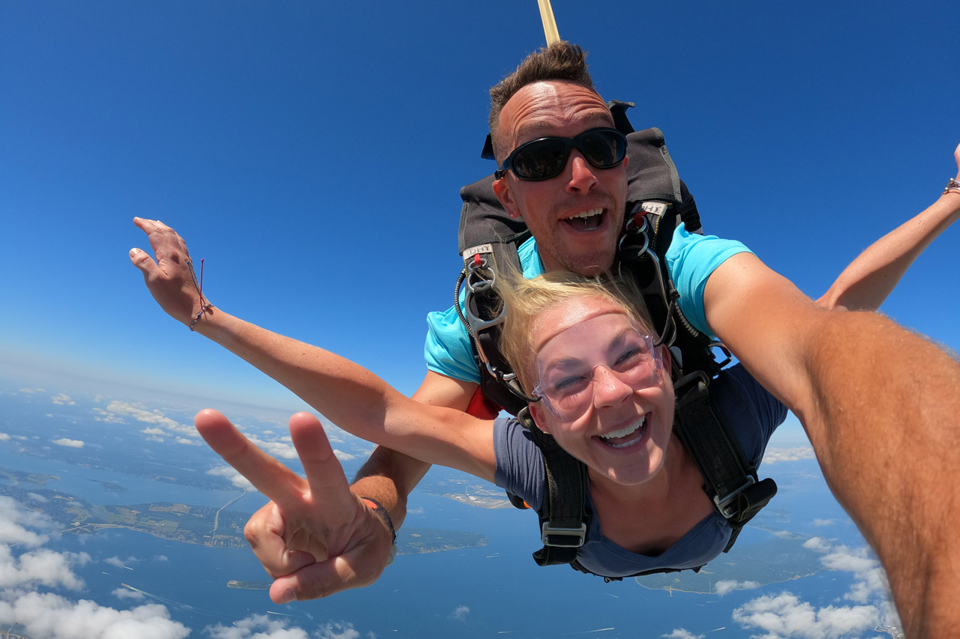
Capacidad general: Comunicación .
. Unit 4: “Holiday Adventures”
Tema: Verbos + actividades de vacaciones y tiempo libre.(Page 48)
1-
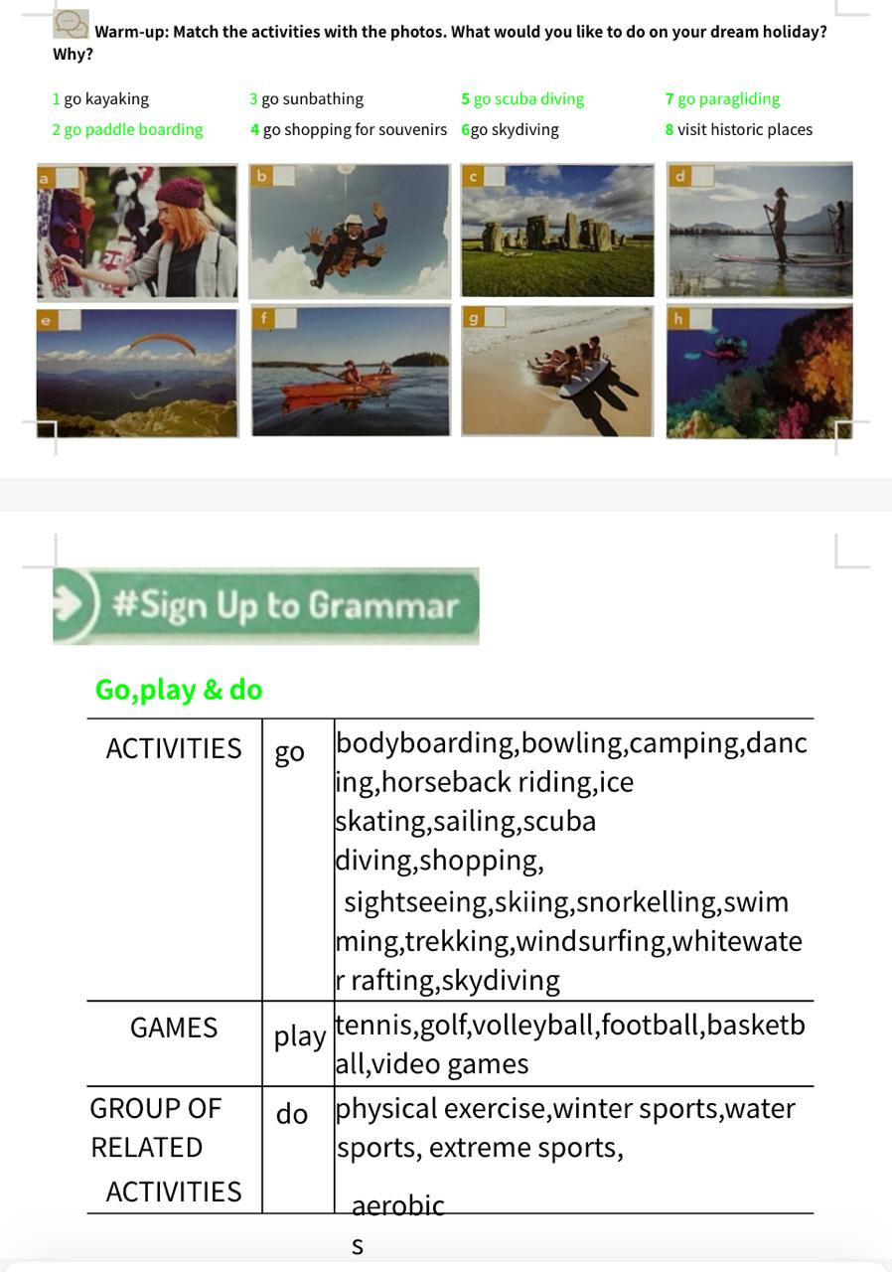

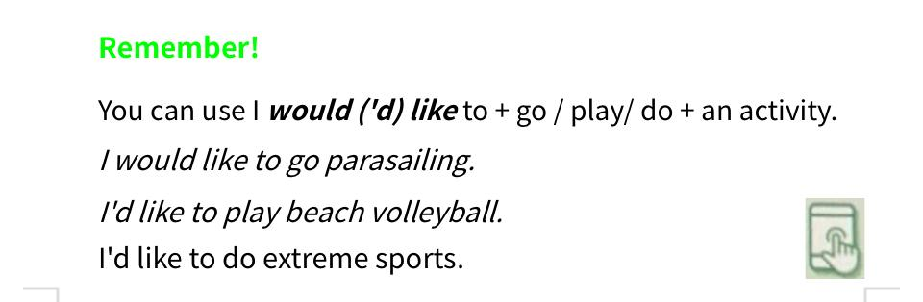

2- Choose two of the activities of activity 1 and write a sentence using the above structures:
For example: What would you like to do in your ”Dream holiday”?
- I would/ ´d like to go sunbathing and parasailing.
3-
Read Sarah´s post and complete it with the verbs in the box in the correct form.
