
GLOSSARY
1- GO TO BED: …………………………………
2- VESTIRSE: ……………………………………
3- DO HOMEWORK: …………………………..
4- CHAT ONLINE: ……………………………….
5- DESAYUNAR: …………………………………
6- HAVE DINNER: ………………………………
7- LEVANTARSE: ……………………………….
8- TEMPRANO: …………………………………..
9- BAÑARSE: …………………………………..
10. MEET MY FRIENDS: ………………
11- MIRAR TELE: ……………………………….
12- COCINAR: ……………………………………
13- HAVE LESSONS: …………………………
14- ALMORZAR: ………………………………
15- PRACTICE SPORTS: ……………………..
16- TOMAR UNA SIESTA: …………………
17- ESTUDIAR: ………………………..
18- HAVE MATE: ………………………..
19- IN THE MORNING ……………………….
20- EN LA NOCHE: ……………………………
21- START:………………………
22- FINISH: ……………………….
GUIA
INTEGRADORA
DE CONTENIDOS
DE
LA UNIDAD 2

GRAMMAR AND VOCABULARY

1) Read and order the words.

a) gets / at / up / Sabrina / seven o’clock

b) go / doesn’t / to university / Robert

c) have / in the school / you / don’t / breakfast

d) has / at 1pm / Lucy / lunch /

e) Nico / plays / in the afternoon / video games

2) Read and circle the correct Word.

a) Dany always has ……………… in the cafetería.
HOMEWORK - BREAKFAST - DRESSED

b) I don’t …………… television in my bedroom.
WATCH - PLAY - DO

c) The cat ……………… up at five in the morning.
GETS - HAS - DOES

d) Mum always ……………… pasta on Sundays.
GOES - COOK - COOKS

e) Nataly and I never ……………breakfast at school.
HAVE - DO - GO

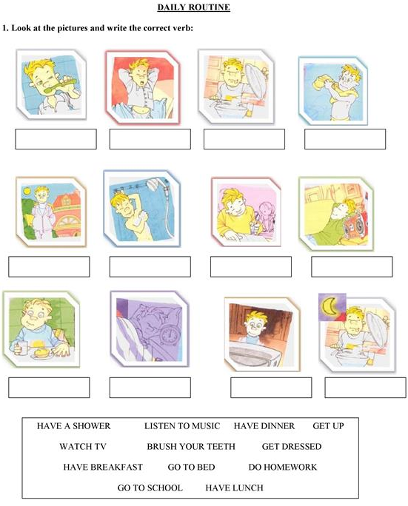

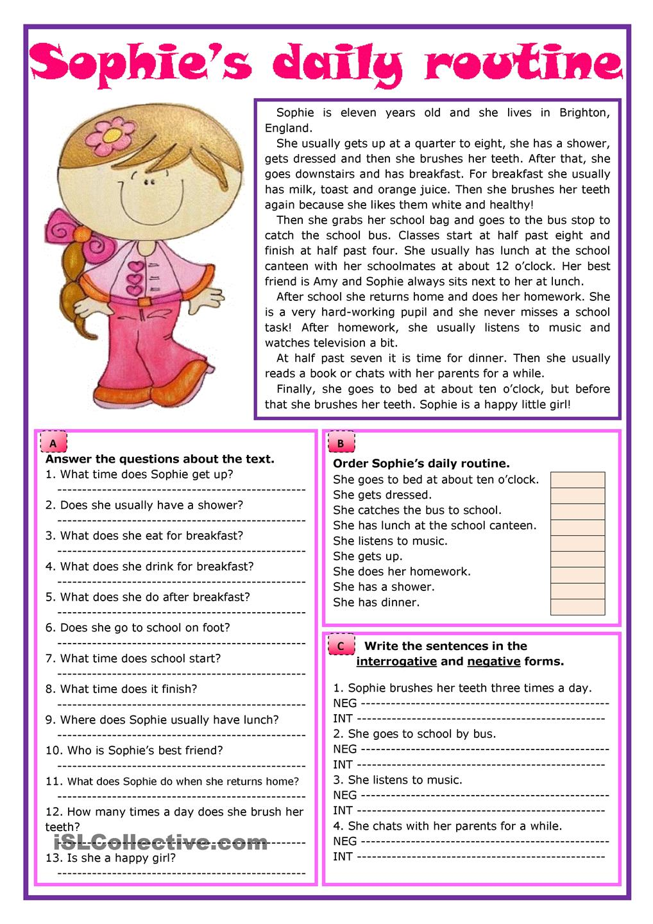

Read about Daniel’s routine and complete the blanks with the correct form of the verbs in the simple present

Daniel’s family is a small: George is the father and Pamela is the mother.
They ………………..(have got) two sons: David is eleven and Rouben is nine.
Every day Daniel ……………………. (get up) at half past seven then
he …………………..(have breakfast) with his brother Rouben.
George and Pamela ……………………….( not have ) breakfast at home.
At about ten Daniel……………………………(get dressed)
At school Daniel ……………..…………. (study) from quarter past eight to two o’clock.
In the afternoon he ………………………..(have) a shower and …………….. (go) to drawing lessons and Rouben ………………(play) basquetball in the club.
Before dinner Daniel and Rouben always ………………………(do) their homework and later they …………………(watch ) t.v. At about half past nine they …………………..(have) dinner with the family. Daniel …………….(love) having a shower at night but Rouben ……………..(not like) it. At about hafl past ten they ……………..(go) to bed.

