ACTIVITIES:
PAST CONTINUOUS:
- Fill in the blanks with the correct form of the past continuous:
- At 7 p.m. yesterday, I __________ (do) my homework.
- They __________ (listen) to music all afternoon.
- We __________ (not/play) basketball yesterday at 5 o’clock.
- The teacher __________ (explain) the lesson very clearly.
- My friends __________ (chat) online last night.
- Change these affirmative sentences to negative ones:
- She was dancing at the party.
- I was writing a letter.
- They were sleeping in the classroom.
- We were running in the park.
- He was watching TV.
- Find the error and correct it:
- She were playing the piano.
- They was studying English.
- I was not playing football yesterday?
- Was you listening to music?
- We was dancing in the gym.
- Look at the image and write 4 sentences in the past continuous to describe what happened in the scene.
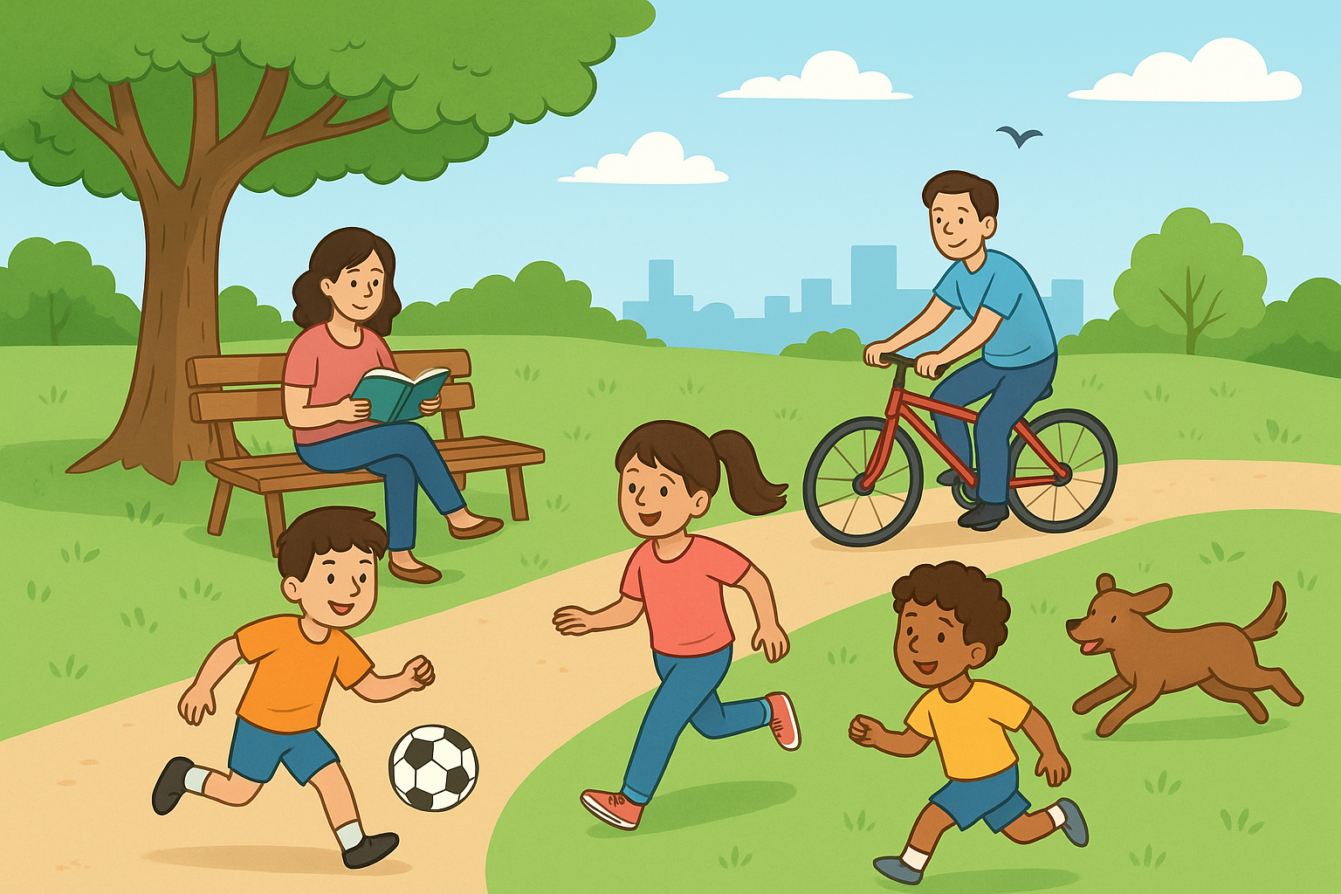

PAST SIMPLE VS. PAST CONTINUOUS:

- Join the sentences:
  - I was reading a book.
  - While my brother was sleeping,
  - They were dancing
  - The students were laughing
  - She was crying
- while my parents were talking.
- when her friend called her.
- while the teacher was writing on the board.
- when the power went off.
- when the music stopped.

- Complete the sentences with when or while:
- I was sleeping ________ the alarm rang.
- She was reading ________ I entered the room.
- ________ we were watching TV, the phone rang.
- He hurt his leg ________ he was playing football.
- Complete the sentences with the correct past tense:
- ________ she was cooking, her kids were doing homework.
- She __________ (read) a book when the phone __________ (ring).
- While we __________ (walk) in the park, it suddenly __________ (start) to rain.
- They __________ (play) football when I __________ (arrive).
- He __________ (study) when his friend __________ (call).
- I __________ (see) an accident while I __________ (drive) to school.
- Put in order to form sentences:
- the / raining / was / it / started / suddenly
- TV / when / the / was / watching / I / phone / rang
- they / in / were / the / playing / park / football
- a / was / book / she / reading / her / lost / bag / she
- while / the / was / cooking / children / dinner / were / playing

SHOULD/ SHOULDN’T
  - Fill in the spaces with should or shouldn't:
- You ______ do your homework every day.
- Students ______ arrive late to class.
- We ______ respect our teachers.
- You ______ eat a lot of sweets before going to bed.
- People ______ recycle more.

  - Choose the correct option:
- You ______ respect your parents. a) should /b) shouldn’t
- You ______ drink dirty water. a) should /b) shouldn’t
- We ______ help our classmates. a) should/ b) shouldn’t

  - Match the situations with the advice
Situations:
a) I have a stomachache.
b) I failed the English test.
c) I feel tired.
d) I want to learn English faster.
e) My room is messy.
Advice:
- You should sleep more hours.
- You shouldn’t eat so much candy.
- You should clean it today.
- You should practice every day.
- You should study harder next time.
  - Put true or false
- You shouldn’t sleep 8 hours.
- You shouldn’t drink water.
- She should eat too much candy
- We should help old people
- They should recycle bottles
  - Complete the table with the advice in the correct place
Use knee and elbow pads – wear gloves- go somewhere quiet- take risks- go too fast
You should … | You shouldn’t …

VOCABULARY ACTIVITIES:
PARTS OF THE BODY:

  - Look at the picture and complete with the parts of the body
a)
b)
c)
d)
e)
f)
g)
h)
i)

SPORTS EQUIPMENT:
  - Look at the picture and complete with the equipment

OPPOSITE ADJECTIVES:
1) Matching Activity: Match the adjectives with their opposites.
Disobedient -Short -Strong -Pretty - Dirty -Ugly- Weak- Clean – Small- Slow - Quiet- Fast -Big -Tall -Noisy Cold -Good -Bad - Cool -Hot - Warm – Safe- Wet -Dry - Interesting -Dangerous-Boring- Obedient.
2. Fill in the blanks: Complete with the correct adjective.
1. The baby is very ______. (small/big)
2. This movie is so ______. I can’t stop watching! (boring/interesting)
3. Be ______ in the library, don’t be ______. (quiet/noisy)
4. The soup is ______, don’t touch it! (hot/cold)
5. My brother is very ______. He goes to the gym every day. (weak/strong)
3. True or False: Write T (True) or F (False). Correct the false ones.
1. Ice is hot. (___)
2. A lion is a dangerous animal. (___)
3. The desert is usually wet. (___)
4. A tall person is the opposite of a short person. (___)
5. Homework is always interesting. (___)
4. Sentence Transformation: Rewrite using the opposite adjective.
1. The room is clean → The room is ______.
2. This video game is boring → This video game is ______.
3. She is tall → She is ______.
4. The weather is warm → The weather is ______

