Actividades de contingencia September 10 th
Complete the sentences with can or can’t.

1

Lian / draw animals ✓
Lian .
2

Lucas / sing well ✗
Lucas .
3

Alex / fix computers ✓
Alex .
4

Granny / play the guitar ✗
Granny .
5
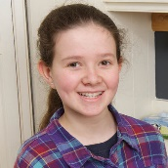
Jen / make cupcakes ✓
Jen

Vocabulary
Complete with play, make or ride.

- play basketball
- …………….a poster
- ……………. a horse
- ……………. a bike
- …………….. the piano
- ……………. cupcakes
Grammar
Write questions.

- you / fix a bike?
you / play volleyball?
………………………..?
- your mum / speak English?
………………………?
- your classmates / speak Spanish?
………………………?
- you / ride a horse?
………………………….?
- your best friend / play the piano?
……………………………?

