Trabajo Práctico Simple Past 3º D

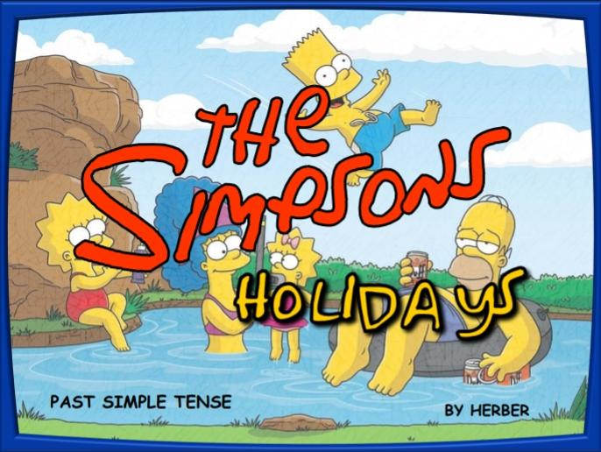
Teacher Mariela

Alumno: Romeo Suarez

2025

Where did the family go last summer?
The planned to went to the beach.
How did they go there?
They wentin their red car and drove south.
Who drove the car?
Who wased driving the car Is Homer.
What did Bart do at the beach?
Bart surfed a big wave.
Did Maggie swim there?
Maggie yes i swing in a smalled lake.
What did she do?
Lisa helped her father plantheir holydays and Lisa thew a bucket of water on Barts back, doneed with His brothers on the beach, and swam in a small lake.
What happend to Homer?
A crab bit homer’s nosé, then he donced with Marge and then they bathed in a river.
What did Lisa do?
Lisa threw a bucket of water on Bart.
Why did the children have fun?
They had fun dancing on the sand.
What did they wear?
They wore clothes made of green leaves.
Where did their parents go at night?
Homer and Marge went to the disco.
Did they dance to rock music?
No, they danced to Latin music.

Where did the family go later?
They went to the mountains.
Was it cold there?
No, it was hot.
Did they have a bath in a river?
No, they had a bath in a small lake.
Did Bart ride his bike?
No, Lisa rode her bike.
What did he do?
He went skating.
Where did Homer go the next day?
Homer went fishing.
What did he eat?
He ate a doughnut.
What did Marge and the girls do?
Marge and the girls picked some beautiful flowers. And then they returned home happy.

