COLEGIO SANTA ROSA DE LIMA

“Sowers of hope, artisans of fraternity"

UNIT 3: Rise to the challenge

- Look at the different challenges on page 32. Do you know which type of challenge is it?
I know challenge 1, the ice bucket.
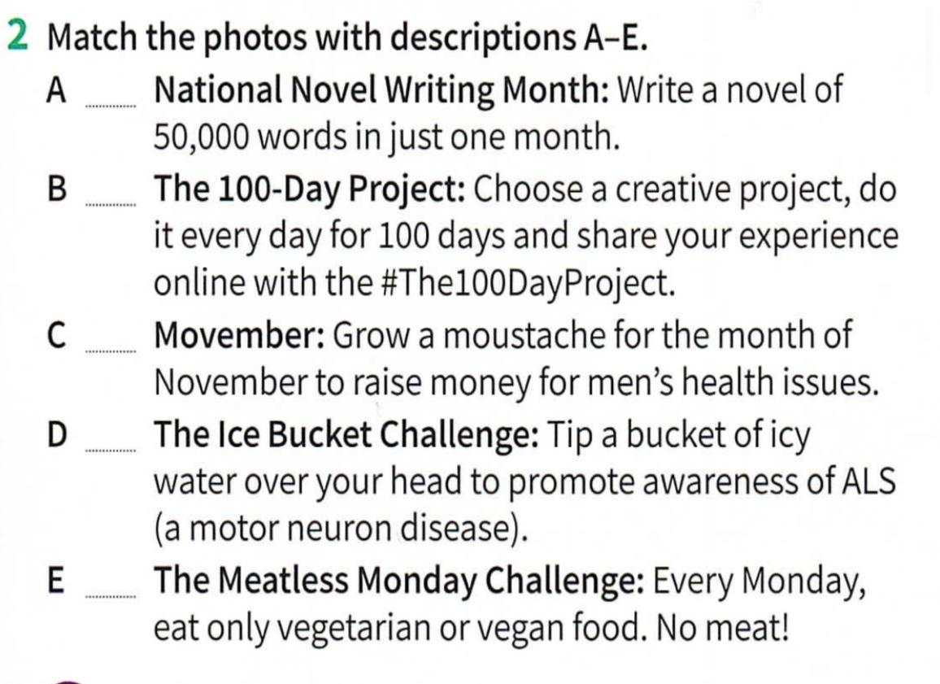
- Work on activity 2 page 33.
3
5

2

1

4

- Then, answer the questions:
- Have you ever heard of any of the challenges above?
- Have you done any? Which might you like to try?
- Why do people do challenges like these?
- I have only heard about the ice bucket challenge.
- No, I haven´t. I´d like to try the moustache challenge.
- To have fun.

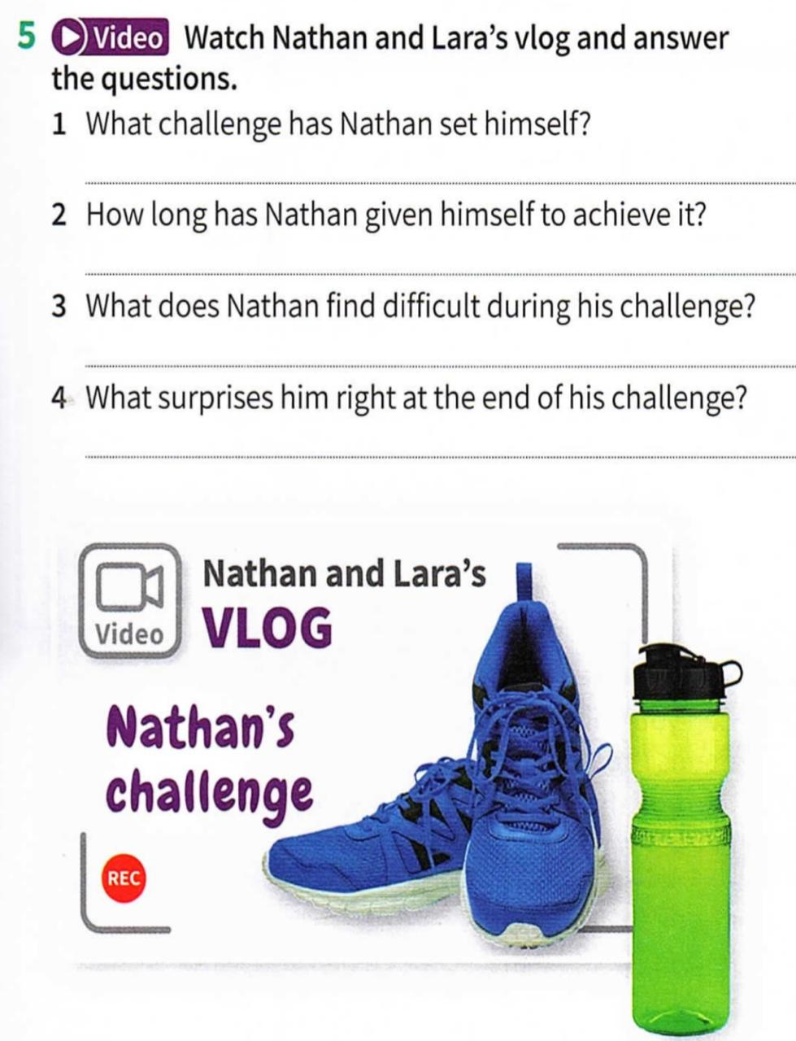
- Watch the video on activity 5 and answer the questions.

- He decided to get in shape by running.
- He wants to run 5 km in 30 minutes.
- It´s difficult for him to feel motivated.
- He could complete the challenge in less than 30 minutes.

- Complete the article on activity 6 page 33 with the expressions extracted from the video.
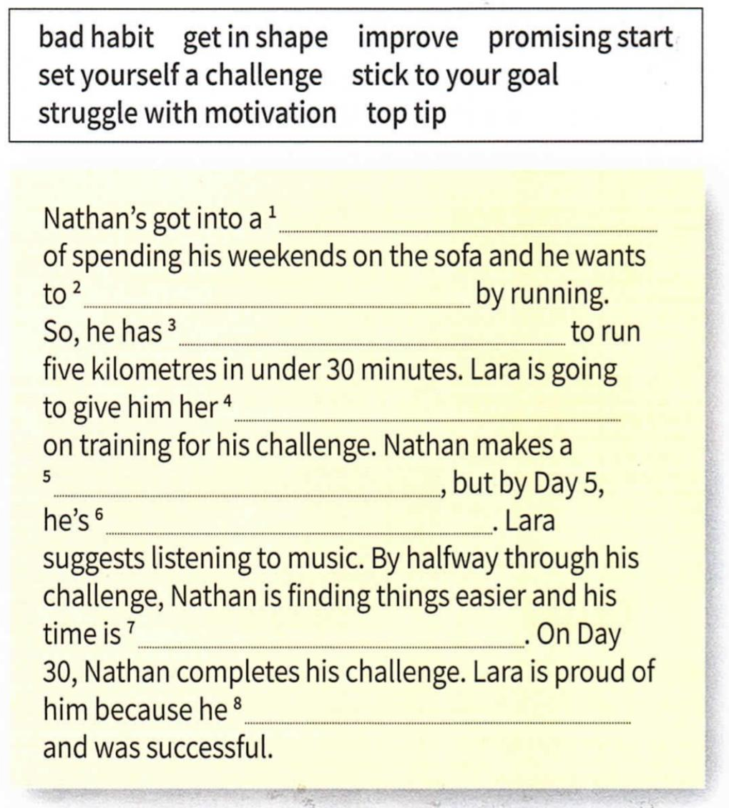

- bad habit
- get in shape
- set himself a challenge
- top tip
- promising start
- struggling with motivation
- improving
- sticked to his goal

- Choose one of the following questions to answer and write a short paragraph.
- What’s the most challenging thing you’ve ever done and why?
- How important is for you to have challenges in our life.
- Do challenges make people stronger or just stressed? Why?

I think challenges make people stronger because they can develop some skills and improve in some areas of their lives. For example, I play football and train two hours a day. It´s challenging for me.

