GUIA INTEGRADORA N°2  PRESENTE SIMPLE  Student’s name______________________  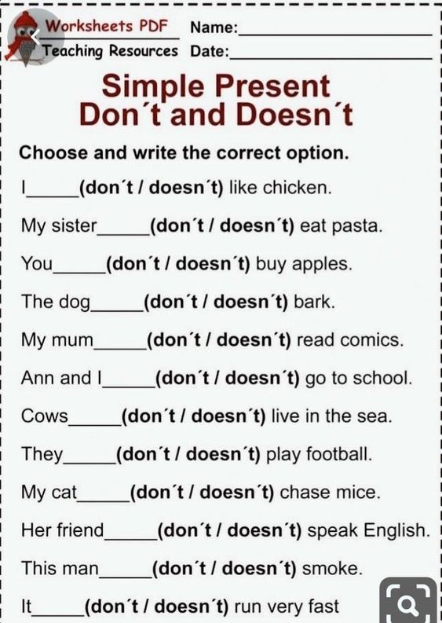 | ANSWER ABOUT YOU AND YOUR FRIENDS  - What’s your best friend’s name?   - How old is your best friend?  - What’s your name?  - How old are you?  - What time do you get up?  - Do you eat breakfast?  - Do you have breakfast at school?  - What’s your favourite snack?  - Does your friend go to school in the afternoon?  - Does your friend have a shower in the morning?  - What do you usually eat for lunch?  - Do you take a nap?  - Does your friend practice any sport?  - What does your friend do in the evening?

WRITE THE VERBS IN THE CORRECT VERB  FORM IN THE PRESENT SIMPLE  AMY AND LISA LIVE WITH THEIR MUM CARLA.  READ HER ROUTINE AND WRITE THE VERBS IN THE PRESENT SIMPLE FORM.  - Carla ____________ (BE) thirty nine years old.  - She __________________(GET UP) at five everyday.  - Carla, Amy and Lisa _________________ (HAVE) breakfast in the kitchen.  - Amy and Lisa ___________________(GO) to school.  - Classes ____________________ (START) at nine o’clock.  - Carla __________________________ (NOT WORK) in the morning.  - She usually _______________________(DO) yoga or she ______________________(GO) shopping. |   - Carla ___________________(LOVE) running.  - She __________________ (NOT LIKE) going to the gym.  - At five in the afternoon Carla ____________________(HAVE) a shower and she _______________________(GO) to work in a clinic.  - At ten o’clock Carla, Amy and Lisa ________________(HAVE) dinner. Then, they __________________( GO) to bed.

