GUIA INTEGRADORA N°2  PRESENTE SIMPLE  Student’s name: Valentín Blanes  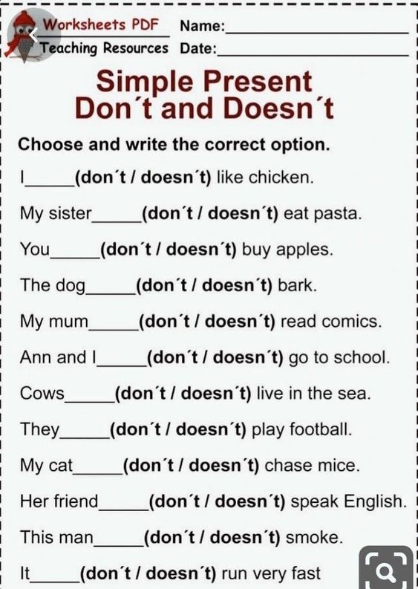  CONTESTADA AL FINAL DE LA HOJA |   ANSWER ABOUT YOU AND YOUR FRIENDS  - What’s your best friend’s name?  My best friend is Joaquín  - How old is your best friend?  My best friend is 12 years old  - What’s your name?  My name is Valentín  - How old are you?  I am 12 years old  - What time do you get up?  I get up 6 o’clock  - Do you eat breakfast?  I eat coffe, milk and toast  - Do you have breakfast at school?  Yes, I do  - What’s your favourite snack?  I like fruits, chocoarroz  - Does your friend go to school in the afternoon?  No, he doesn´t  - Does your friend have a shower in the morning?  No, he doesn´t  - What do you usually eat for lunch?  I eat meat, rice, bread, vegetable  - Do you take a nap?  Yes, I do  - Does your friend practice any sport?  Yes, he does  - What does your friend do in the evening?  He plays videogames

WRITE THE VERBS IN THE CORRECT VERB  FORM IN THE PRESENT SIMPLE  AMY AND LISA LIVE WITH THEIR MUM CARLA.  READ HER ROUTINE AND WRITE THE VERBS IN THE PRESENT SIMPLE FORM.  - Carla IS (BE) thirty nine years old.  - She GETS UP (GET UP) at five everyday.  - Carla, Amy and Lisa HAVE (HAVE) breakfast in the kitchen.  - Amy and Lisa GO (GO) to school.  - Classes START (START) at nine o’clock.  - Carla DOESN´T WORK (NOT WORK) in the morning.  - She usually DOES (DO) yoga or she GOES (GO) shopping. |   - Carla LOVES (LOVE) running.  - She DOESN´T LIKE (NOT LIKE) going to the gym.  - At five in the afternoon Carla HAS (HAVE) a shower and she GOES (GO) to work in a clinic.  - At ten o’clock Carla, Amy and Lisa HAVE (HAVE) dinner. Then, they GO ( GO) to bed.

I DON´T LIKE CHICKEN
MY SISTER DOESN’T EAT PASTA
YOU DON´T BUY APPLES
THE DOG DOESN´T BARK
MY MUM DOESN´T READ COMICS
ANN AND I DON´T GO TO SCHOOL
COWS DON´T LIVE IN THE SEA
THEY DON´T PLAY FOOTBALL
MY CAT DOESN´T CHASE MICE
HER FRIENDS DOESN´T SPEAK ENGLISH
THIS MAN DOESN´T SMOKE
IT DOESN´T RUN VERY FAST

