GUIA INTEGRADORA N°2  PRESENTE SIMPLE  Student’s name_____Joaquin Mereles  __*I don´t like chicken  *My sister doesn´t eat pasta  *You don´t buy apples  *The dog doesn´t bark  *My mum doesn´t read comics  *Ann and I don´t_ go to school  *Cows don´t live in the sea  *They don´t play football  *My cat doesn´t chase mice  *Her friend doesn´t speake English  *this man doesn´t smoke  *It doesn´t run very fast  ______________  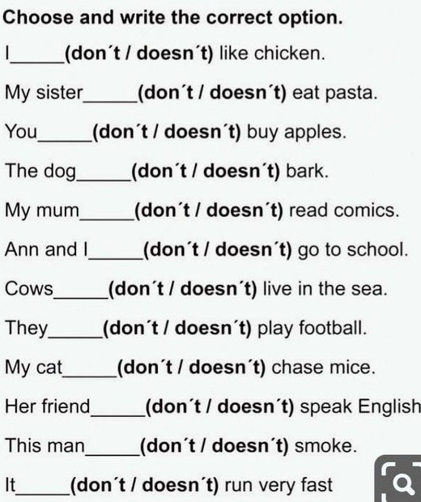 | ANSWER ABOUT YOU AND YOUR FRIENDS  - What’s your best friend’s name? My best friend´s name is Valentin   - How old is your best friend? Hi is 12 years old  - What’s your name? my name is Joaquin mereles  - How old are you? I am 12 years old  - What time do you get up? I get up 6:45  - Do you eat breakfast? No I don´t  - Do you have breakfast at school? Yes I do  - What’s your favourite snack? My favourite snack is alfajor  - Does your friend go to school in the afternoon? No hi doesn´t  - Does your friend have a shower in the morning? No hi doesn´t  - What do you usually eat for lunch? I usually eat milanesas whit salad  - Do you take a nap? Yes I do  - Does your friend practice any sport? Yes hi does  - What does your friend do in the evening? No hi doesn´t

WRITE THE VERBS IN THE CORRECT VERB  FORM IN THE PRESENT SIMPLE  AMY AND LISA LIVE WITH THEIR MUM CARLA.  READ HER ROUTINE AND WRITE THE VERBS IN THE PRESENT SIMPLE FORM.  - Carla __________is__ (BE) thirty nine years old.  - She ______gets up____________(GET UP) at five everyday.  - Carla, Amy and Lisa _____has____________ (HAVE) breakfast in the kitchen.  - Amy and Lisa ______________go_____(GO) to school.  - Classes ______________star´s______ (START) at nine o’clock.  - Carla _________________DOESN´T_________ (NOT WORK) in the morning.  - She usually _______IS________________(DO) yoga or she ______________GO________(GO) shopping. |   - Carla __________LOVE_________(LOVE) running.  - She __________DON´T________ (NOT LIKE) going to the gym.  - At five in the afternoon Carla ___________HAS_________(HAVE) a shower and she __________GO_____________(GO) to work in a clinic.  - At ten o’clock Carla, Amy and Lisa ______HAVE__________(HAVE) dinner. Then, they ________________GO__( GO) to bed.

