UNIT 3:
In this unit we will learn...

How to describe a typical day.
How to interview a student.
How to describe a special event at school.

GRAMAMR BANK
- Present simple (Affirmative / Negative)
- Present Simple (Questions and short answers)

VOCABULARY
- Routine activities
- Adverbs of frequency
- Free time activities

We use the PRESENT SIMPLE to talk about things we do on a regular basis, facts, feelings and opinions:
I like books. / He likes books. / I go to school. / She works in a hospital.
I don’t like books. / He doesn’t like books. / I don’t go to school. / She doesn’t work in a hospital.
We use ADVERBS OF FREQUENCY to say how often we do things:
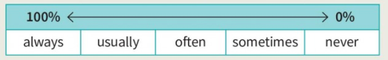
We usually put the verb between the subject and the verb:
I never drink coffee.
She sometimes drinks coffee.
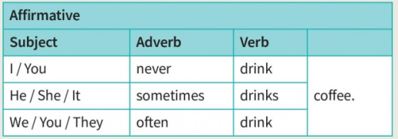
We can use always, usually and often in the negative:
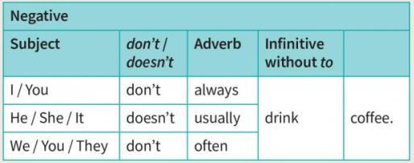

With the verb be, the adverb comes after the verb.
Karen is often at home on Saturdays.

Sometimes and usually can also come at the beginning or end of a sentence.
Sometimes, I listen to music on the bus.
Winters are very cold here, usually.

We can use always, usually and often in the negative after don’t / doesn’t.
I don’t always have breakfast. (= I sometimes do.)
I don’t usually / often get to bed late.

We don’t use a negative verb with never.
It never rains in summer.
(NOT: It doesn’t never rain in the summer.)

ACTIVITIES.
VOCABULARY

- Look at the activities in the box. Which do you do every day? Which activities do you only do on school days?
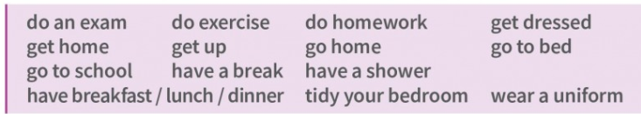

Complete the pictures with the correct vocabulary.
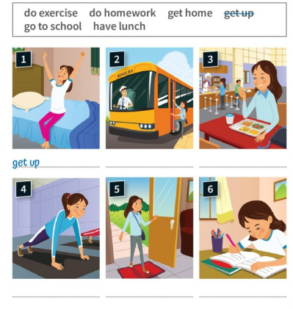

B. Choose the correct option.
1 I gets / get dressed in my bedroom.
2 My brother get / gets up early every day.
3 Students have / has lunch in the cafeteria.
4 We doesn’t / don’t wear a uniform at school.
5 I don’t have / has breakfast every morning.
6 My teacher doesn’t / don’t get home before 5 p.m.

B. Write true sentences for you. Use the affirmative or negative form of the verb.

E.G: I get dressed before breakfast.

1 I ............................................................... (do) exercise every day.
2 Our English teacher ............................................................... (have) lunch at school.
3 School ............................................................... (finish) before 4 p.m.
4 My parents ............................................................... (tidy) my bedroom.
5 I ............................................................... (go) to bed before 10 p.m.

C. Complete the diagram with the adverbs of frequency in the box.
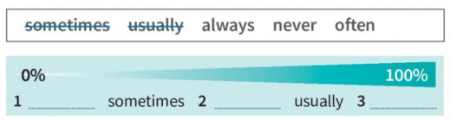

C. Look at these sentences from the text. Choose the correct option to complete the rules in the table.

Students are never hungry after lunch.

Students usually start school on the day after their fourth birthday.

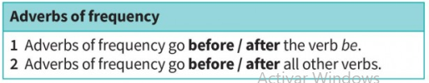

D. Use the phrases to write true sentences for you. Use an adverb of frequency in the correct position.
E.g: get home before 6 p.m. — I always get home before 6 p.m.
1 be late for school
2 go to bed before 10 p.m.
3 have breakfast
4 do my homework
5 do exercise at weekends

E. Choose the correct words.

1 Victor … to school by bus. A go B goes ✅

2 My parents … take me to school. A don’t B doesn’t

3 That TV show … at nine o’clock. A finish B finishes

4 Sarah … get up before 9.00 at the weekend. A don’t B doesn’t

5 You … lunch in the cafeteria. A have B has

F. Complete the text using the present simple form of the verbs in brackets.

Jack Harris 1 _______ (live) in Alaska with his parents and his sister, Kyra. Jack and Kyra 2 _______ (not go) to a school because they are 100 km from the nearest town. They 3 _______ (have) their lessons at home on the computer.
Jack’s first lesson 4 _______ (start) at nine o’clock. He 5 _______ (not wear) a uniform. During the lessons, Jack 6 _______ (listen) to his teachers and they 7 _______ (ask) him questions.
Jack’s lessons 8 _______ (finish) at twelve o’clock, but he 9 _______ (study) after lunch, too. Jack and Kyra 10 _______ (do) homework for two hours every day.

G. Rewrite the sentences using the negative form.

E.g: 1 The students clean the classroom. _____ The students don’t clean the classroom.

2 Sam does exercise before school.

3 I get up at six o’clock.

4 That bus goes to the shopping mall.

5 My friends and I study Japanese.

H. Write sentences with information about a typical day at an invented school.
- School always starts at …
- Our first class starts at …
- We usually do … hours of homework every day.
- Students don’t …
- Teachers never …
- Our school doesn’t …
- We have lunch at …
- School finishes at …
- Are the sentences correct (C) or incorrect (I)?
- That girl never is late for class. ☐ C ☑ I
- We sometimes watch music videos. ☐ C ☐ I
- Teachers ask often a lot of questions. ☐ C ☐ I
- That boy always has lunch in the cafeteria. ☐ C ☐ I
- They go never to bed before 8.00 p.m. ☐ C ☐ I
- Schools are usually closed at weekends. ☐ C ☐ I
J. Rewrite the sentences using the adverbs of frequency in brackets.
- We do exercise in PE class. (usually)
We usually do exercise in PE class.
- Mark is at home on Saturdays. (often)
- I tidy my bedroom. (sometimes)
- Nadia goes shopping with me. (never)
- Jamie is kind to people. (always)
- I do my homework after school. (usually)
K. Write four sentences about your daily routine. (Use the present simple, adverbs of frequency and time expressions below).
always – usually – often – sometimes – never
before school | after school | after dinner
at school |  | before bed
I always have breakfast before school.
____________________________________________________________________________________________________________________________________________________________________________________________________________________________________________________________________________________________________________________________________________________________
READING.
  - Learn about robots that help students and then answer the questions with Y (yes), N (no) or DS (doesn’t say).

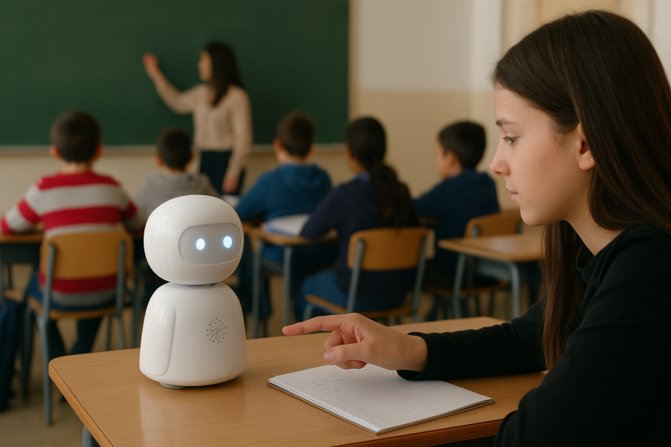
How often do you use Daz?
I use him every school day. I often stay at home in the morning and I go to school in the afternoon.
Do your classmates help you?
Yes, they do. They take turns to work with me. And they carry Daz from class to class. They’ve got a coat for Daz, so he doesn’t get cold when he travels around the school!
How do you feel about school now?
I feel really positive about it. I see my friends every day and I feel ready for my exams.
Does your family like Daz?
My family loves him. My grandma sometimes talks to him!
Makayla

In this classroom there’s a student at every desk. But one of the students is a small robot, called Daz. It stands on the desk and moves its head up and down, and from side to side. Does this school teach robots? Well, no, it doesn’t. The robot helps a student at home called Makayla.
Makayla is 16. She has an illness called Chronic Fatigue Syndrome. She often feels tired and she sometimes hasn’t got the energy to go to school.
Thanks to Daz, Makayla can be at home and in class at the same time. With her tablet, she connects to Daz, and she sees and hears the teacher and the other students. And what does Makayla do if she’s got a question? She flashes Daz’s blue light and the teacher lets her speak.



Does Makayla always go to school? N
- Does Daz move his head? _______
- Do Makayla’s classmates talk to her in class? _______
- Does Makayla ask questions in class? _______
- Does Daz stay in one classroom? _______
- Has the school got other robots? _______
- Does Makayla feel happy about school? _______
B. Discuss the questions.
1- Are these robots a good idea? Why? Why not?
2- How can you help your classmates when they aren’t at school?
GRAMMAR. Present Simple: questions and short answers.
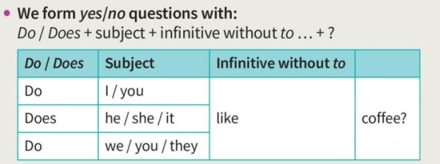
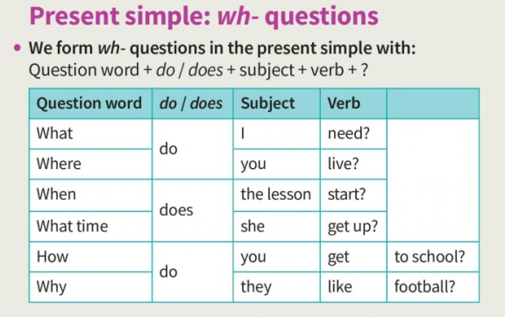
- We can also use question words with the verb.
‘What’s your favourite café?’ ‘Rioshi’s on Sanur Road.’
‘What colour are her shoes?’ ‘Red and white.’
‘Which class are you in?’ ‘I’m in 8G.’
  - Complete the table with do, does, don’t or doesn’t.
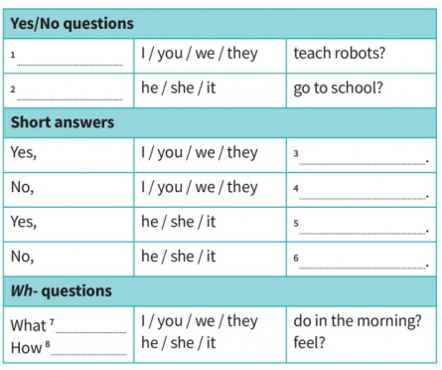
B. Match questions 1–5 with answers A–E.
A. She feels good about it.
B. They take turns to work with her.
C. No, it doesn’t.
D. She uses it every school day.
E. Yes, they do.
- Does Makayla’s school teach robots? _______

- Do Makayla’s classmates help her? _______

- What do Makayla’s friends do? _______

- How does Makayla feel about school now? _______

- How often does Makayla use Daz? _______

C. Choose the correct option. Then answer the questions with short answers.
- Do / Does you do homework every day?

- What does your family has / have for breakfast?

- Do / Does your head teacher teach classes?

- What / How often do you do tests in English?

- Where do / does students go at lunchtime?

- Do / Does your friends have lunch with you?

D. Write questions using the question words in the box.
What – What time – Where – Who – How – How often
- ______ do you travel to school? I travel by bus.
- ______ do you do exercise? In the gym.
- ______ do you tidy your bedroom? Every week.
- ______ do you go to school with? I go with my brother.
- ______ do you have breakfast? At 7.45.
- ______ do you do at break time? I talk to my friends.

E. Choose the correct question.

1 A Do they feel happy today?
B Does they feel happy today?

2 A Do Ben speak Italian?
B Does Ben speak Italian?

3 A Do you help other people?
B Does you help other people?

4 A What do you have for lunch?
B What do you have for lunch?

5 A How often Nina goes shopping?
B How often does Nina go shopping?

F. Complete the present simple questions with do, does and the verbs below.

do – finish – give – have – start – use – wear

1 ___ you wear ___ a uniform to school?
2 ______ your first class ______ at 9.00?
3 ______ you ______ your phone in class?
4 ______ your last class ______ at 3.00?
5 Who ______ you ______ lunch with at school?
6 What ______ you ______ after school?

G. Write present simple questions. Write answers that are true for you.

1 you / tidy / your bedroom?

Do you tidy your bedroom?
Yes, I do. / No, I don’t.

2 your friends / study a lot?
____________________________________________________________
____________________________________________________________

3 you / carry / a school bag?
____________________________________________________________
____________________________________________________________

4 What time / you / get / to school?
____________________________________________________________
____________________________________________________________

5 How often / you / play / video games?
____________________________________________________________
____________________________________________________________

