COLEGIO SANTA ROSA DE LIMA

“Sowers of hope, artisans of fraternity"

UNIT 4: Picture this

- Look at the pictures on page 44. Which similarities and/or differences can you identify?
Similarities: they are no outdoor activities, they are not with screens
Differences: each one does different activities, some are alone and others in a group.
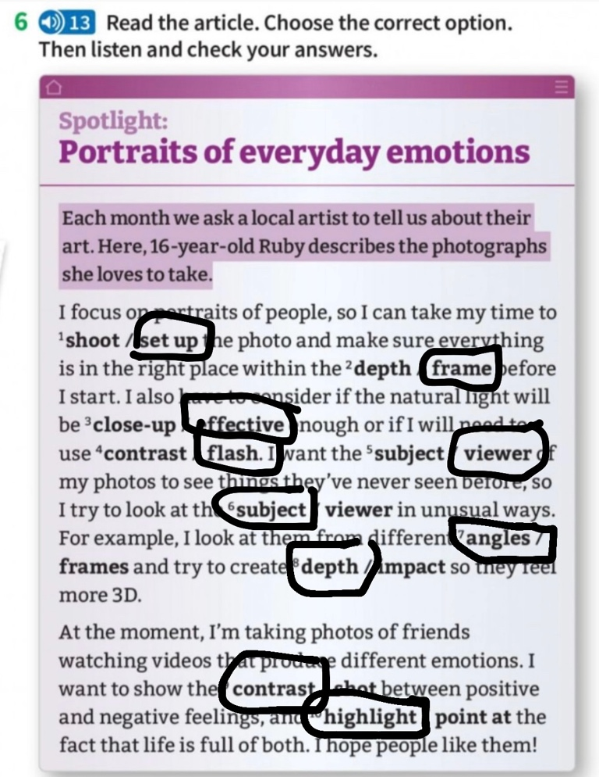

- Work on activity 5 page 45. Then, do activity 6.

- Work on activities 2,3 and 4 page 46.
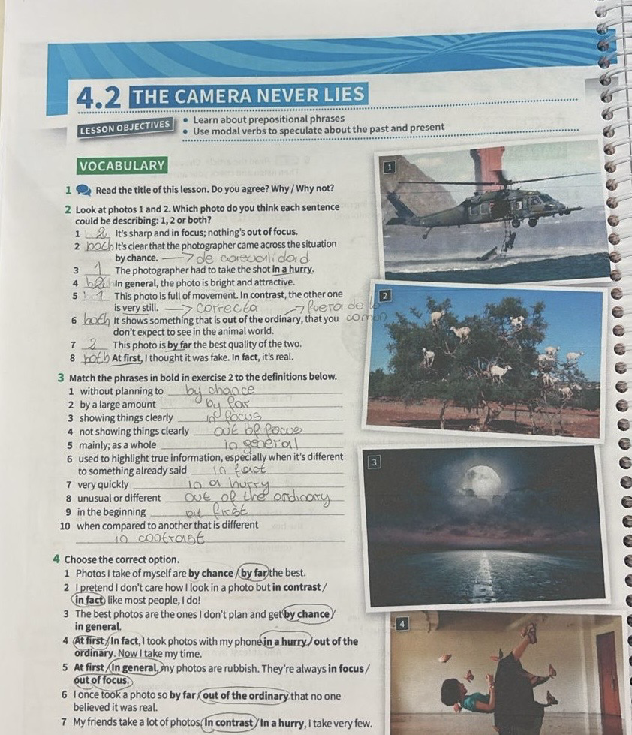

- Read the article on page 47 activity 7 and answer the question on it.


- Read the examples/ sentences extracted from the text and complete the chart on activity 8 page 47.
- When do we use this modal verbs?
- How do we use them when we talk about a present or a past action?

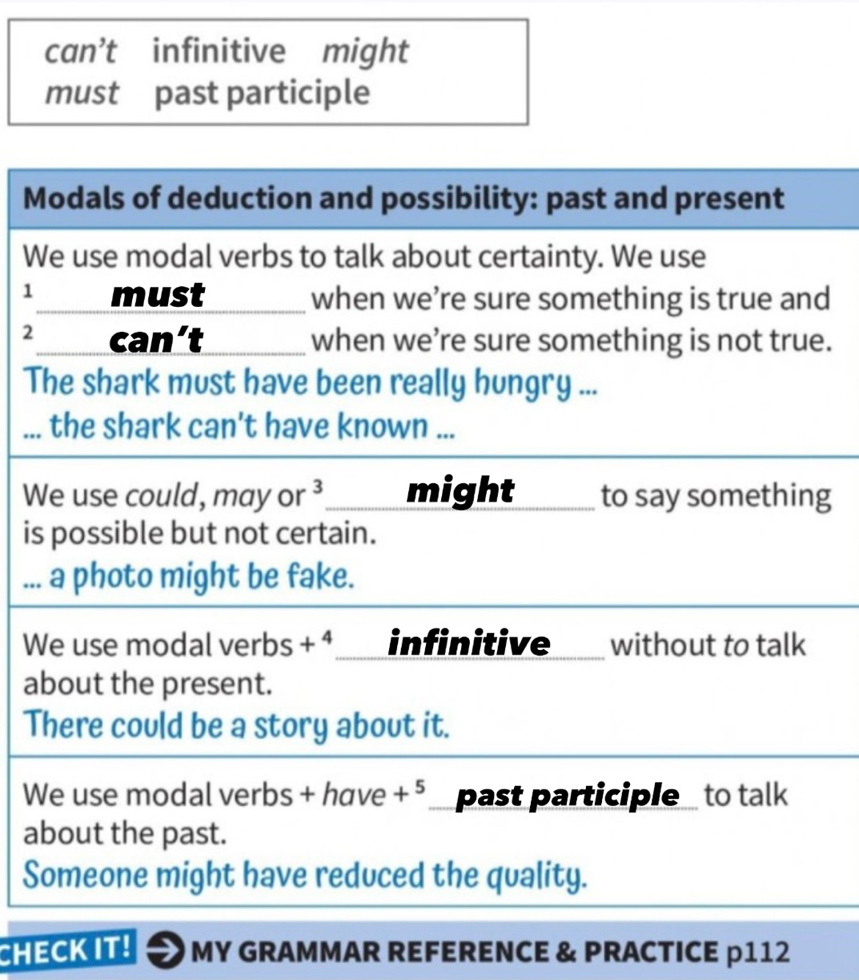

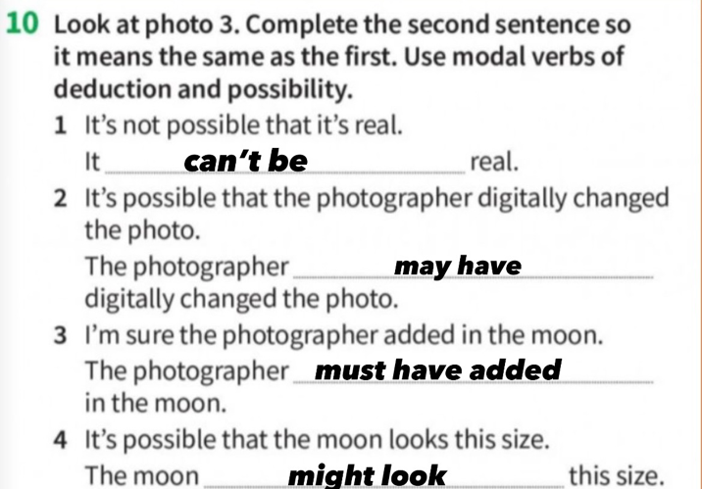
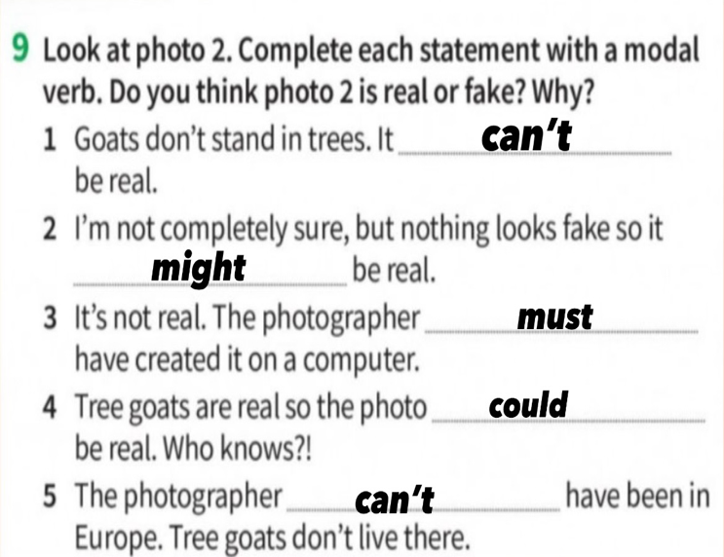
- Work on activity 9 and 10 page 47.

- Written project: Choose one photo you like the most and describe it. You can use some of the words below. (Put your photo here in your guide when you send it)



