
TEST UNIT 3
LENGUA EXTRANJERA: INGLÉS /37
CURSO: 5°”B”
PROFESORA: Georgina Rossi
ALUMNO/A:
FECHA: 5th October
TEMAS EVALUADOS: Lectura Comprensiva. Vocabulario. Presente Perfecto con How long, for y since. Presente Perfecto contrastado con Pasado Simple. Listening.

- Read the text and answer the questions. (5x2=10)
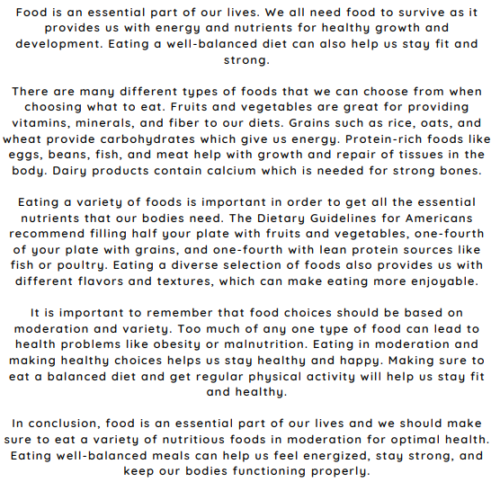
- Why is food important?
- What do dairy products contain?
- According to The Dietary Guidelines for Americans, how is an ideal plate formed?
- What can cause obesity or malnutrition?
- What is the consequence of eating a well-balanced diet?

- Complete the sentences with these words: crunchy, creamy, boil, bake, frozen, barbecue, fry, raw, sweet, microwaved and fresh. (11x1=11)
- I prefer my vegetables ______________ and _____________ for a healthy snack.
- The ice cream parlor offers a variety of ______________ flavors, including vanilla and chocolate.
- My favourite dessert is a ___________, decadent chocolate mousse.
- On a hot summer day, nothing beats the refreshing taste of a _______________ fruit popsicle.
- I love to grill ________________ chicken on weekends, and the sauce is always smoky and flavorful.
- When I'm in the mood for a ___________________ snack, I reach for a bag of potato chips.
- To make French fries, you need to cut the potatoes into thin strips and then __________ them until they're golden brown.
- __________ some water before adding the pasta to cook it al dente.
- She decided to _________________ a homemade apple pie for dessert.
- Her preference was for freshly prepared meals, but when time was limited, she settled for a ___________________ dinner.

- Read and complete with: How long, for or since. (6x1=6)

- _________________has Rachel lived in London?
- She has lived in London __________10 months.
- _______________have your grandparents been married?
- They’ve been married ___________50 years.
- _______________have you worked here?
- I’ve worked here ____________March.

- Choose the correct option: Present Perfect or Simple Past? (10x1=10)

- Susan went/has gone shopping yesterday.
- They cleaned /have cleaned the room. It looks great.
- Last summer we went / have gone Berlin.
- The children finished / have finished their homework. Now they can watch TV.
- I lost / have lost my car keys. Have you seen them?
- We ate / have eaten snails on our last holiday.
- She wasn't / hasn't been abroad before.
- I'm sorry, but I didn't do / haven't done my homework.
- I sent /have sent you an email two days ago.
- He didn't meet / hasn't met me yet.

