GRAMMAR

“SHOULD / SHOULDN’T”

• Should is used to give advice or recommendations. (“Deberías” es usado para dar consejos o recomendaciones)
👉 You should study for the exam. (Deberías estudiar para el examen).
• Shouldn’t is used to say what is not recommended.
👉 You shouldn’t eat too much junk food. (No deberías comer tanta comida chatarra).

Form
✅ Affirmative: Subject + should + verb infinitive
(-) Negative: Subject + shouldn’t + verb infinitive
(?) Question: Should + subject + verb infinitive?

OPPOSITE ADJECTIVES:
- Pretty (Bonito) # Ugly (Feo)
- Clean (Limpio) # Dirty (sucio)
- Weak (Débil) # Strong (Fuerte)
- Quiet (Tranquilo) # Noisy (Ruidoso)
- Small (Pequeño) # Big (Grande)
- Slow (Lento) # Fast (Rápido)
- Short (Corto) # Tall (Alto)
- Good (Bueno) # Bad (Malo)
- Hot (Caliente) # Cold (Frio)
- Warm (Cálido) # Cool (Frio)
- Wet (mojado) # Dry (seco)
- Safe (Seguro) # Dangerous (Peligroso)
- Boring (Aburrido) # Interesting (Interesante)
- Obedient (Obediente) # Disobedient (Desobediente)

“COMPARATIVES”
Comparatives form of the adjectives
- Use the comparatives form to compare two things, places or people:
Ex: A Lion is stronger than a Zebra

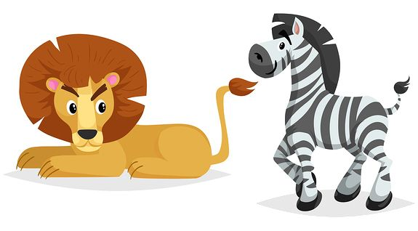

- The form of the comparative depends on the number of syllables of the adjectives:
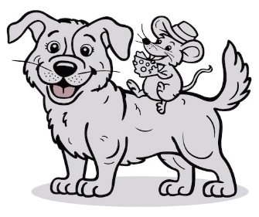

- Use than after the comparative adjective (“Than” = Que)
Ex: A mouse is smaller than a dog.

- Use (More = Más) to compare long adjectives
Form : subject + more + adjective + than
Ex: I think dogs are more obedient than cats

“Zero conditional”
Use:
- We use the “Zero conditional” to talk about facts that are generally true
(Nosotros usamos el “condicional cero” para hablar de hechos que son generalmente verdaderos)

Form:
- These sentences have two clauses: the main clause and the subordinate clause (If clause)
- We form the zero conditional with Present simple in the main clause + the subordinate clause introduced by If/ When + Present Simple.

I call a friend if I´m depressed.
Main clause Subordinate clause
Example:
- If you touch fire, you get burned. (Si tocas fuego, te quemas.)
- If you don’t water plants, they die. (Si no riegas las plantas, se mueren.)

If + Present Simple

- Affirmative:
If you heat water, it boils. (Si calientas agua, hierve.)

- Negative:

If you don’t study, you fail. (Si no estudias, desapruebas.)

- Interrogative:

What happens if you mix blue and yellow? (¿Qué pasa si mezclas azul y amarillo?)

“First Conditional”
Use:
- We use the “First Conditional” to talk about real future situations

Form:
- These sentences have two clauses: the main clause and the subordinate clause (If clause)
- We form the First conditional with: Future in the main clause with Will + the subordinate clause introduced by If/ When + Present Simple.

If you study, you will pass the exam.

Subordinate clause Main clause

If + Present Simple, Will + Verb infinitive

- Affirmative:
If it rains, we will stay at home. (Si llueve, nos quedaremos en casa.)

- Negative:
If you don’t study, you won’t pass the exam. (Si no estudias, no aprobarás el examen.)

- Interrogative:
What will you do if you win the lottery? (¿Qué harás si ganas la lotería?)

