COLEGIO SANTA ROSA DE LIMA

“Sowers of hope, artisans of fraternity"

UNIT 4: Moments in science

- Look at the title of the unit and pay a look at the different pictures on page 44 and answer:
- What is science for you? Which words can be related to it?
- Do you know the name of the science that each picture represents?
- Which other areas of science can you mention?
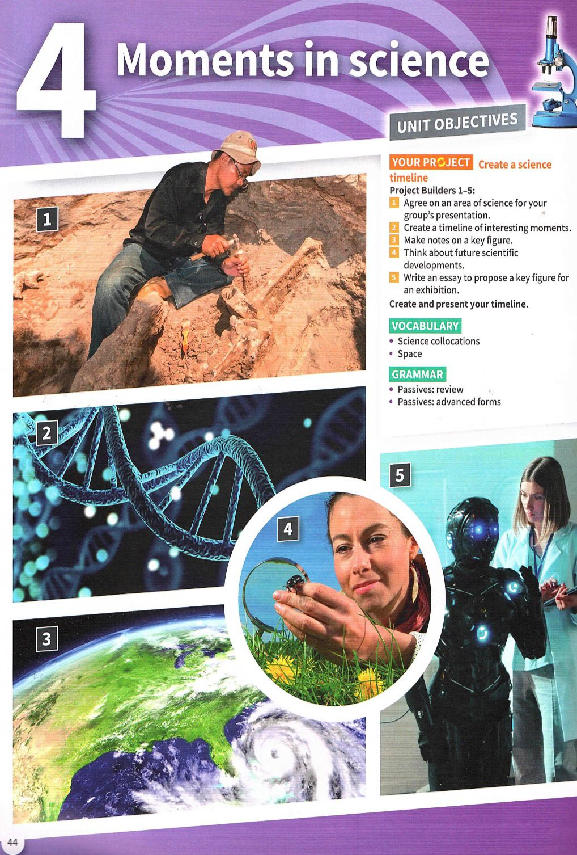

- Watch the video “Science at home”. What is their theory? Do they manage to prove it?
- Work on activity 5 and 6 page 45.
- Work on activity 2 and 3 page 46.
- Read the following sentences and answer:
- Do these sentence have the same meaning?
- Can you identify any similarity and/ or difference between them? Which ones?

People are making plans to use moon cars. Plans to use moon cars are being made.

They launched the first space shuttle in 1981. The first space shuttle was lauched in 1981.

- Watch the following video and answer: https://youtu.be/nRGLDD0BBdc?si=F4XLKNMcHL3CRdWh
- How do we call this new topic?
- What other similarity and/or difference between active and passive sentences can you mention?
- What things have we bear in mind when seeing and working with passive sentences?


- Work on activity 9 page 47.

