COLEGIO SANTA ROSA DE LIMA

“Sowers of hope, artisans of fraternity"

UNIT 5: OUR VALUES

- Look at the different pictures that introduce the unit on page 56 and answer:
- Which is the first thing that comes to your mind? How each of these pictures make you feel?
- Does any of these pictures remind you of something you experienced before? Which one?
- Which is your favourite one? Why?

- Work on activity 2 page 57.

- Do activity 3 page 58. Then, work on activity 4 page 59.

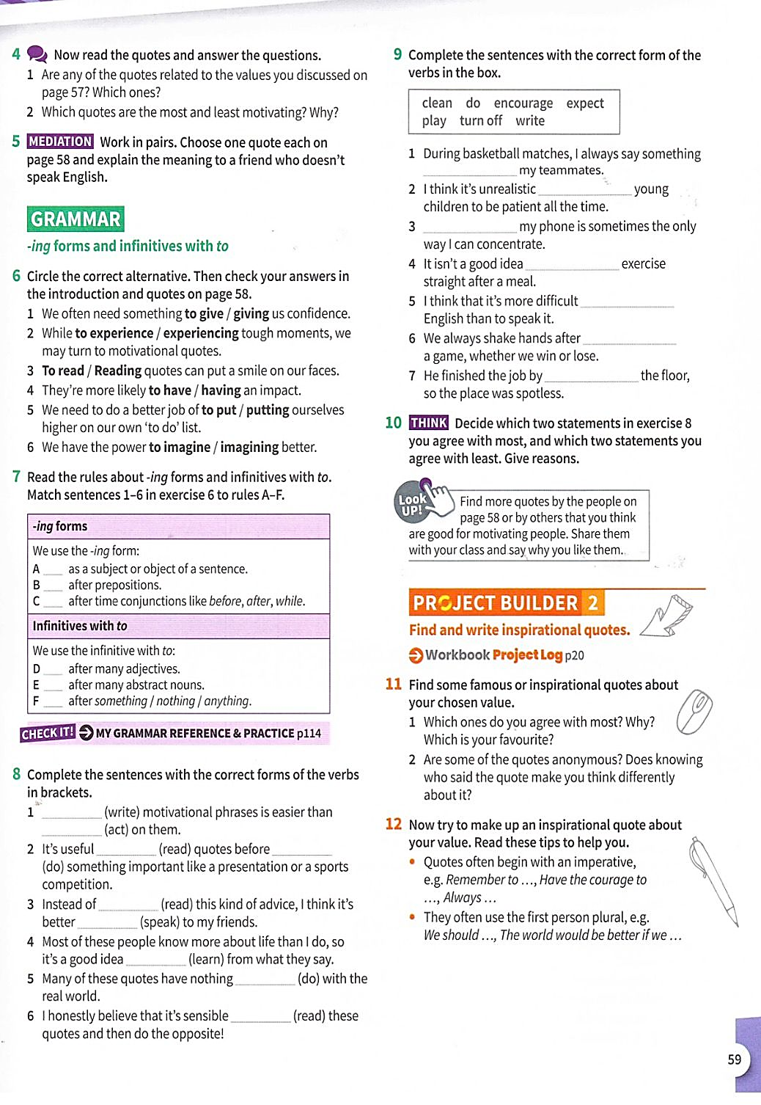
- Work on activity 6 and 7.

- Do activity 8.

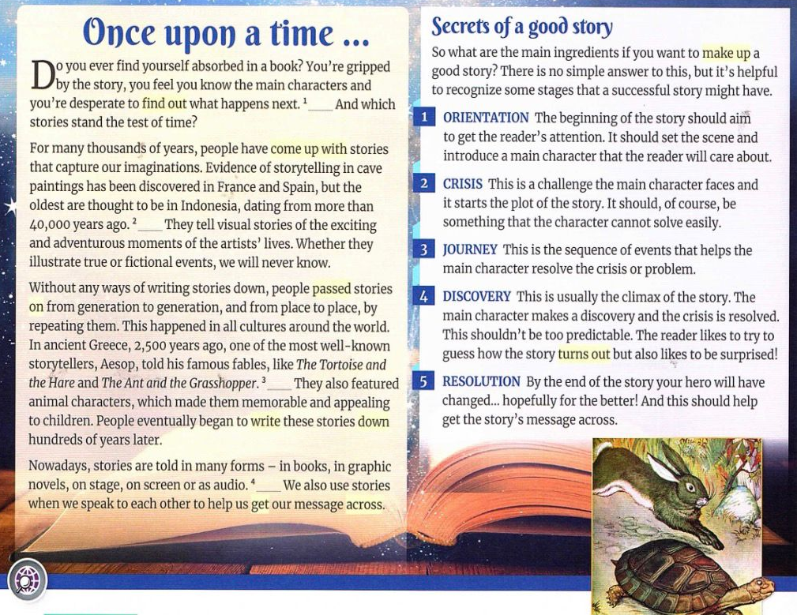
- Read the text on page 60 and answer the questions on activity 1. Then, do activity 2.

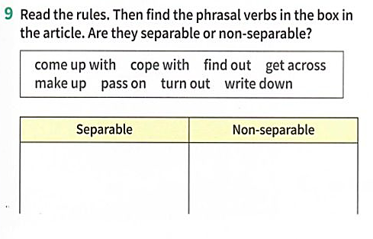
- Do activity 4 and 9 page 61.

- Work on activity 10.
- Final project: write your own motivational quotes with all what you have learnt in this unit. Vocabulary (qualities, phrasal verbs) and grammar (to-inf/-ing verbs).

