COLEGIO SANTA ROSA DE LIMA

“Sowers of hope, artisans of fraternity"

UNIT 5: Survival

- Look at the title of the unit on page 56 and the pictures that appear on it. What can you see? Which words first come to your mind when you read and look at them? Make a brainstorming.
Some words that come mind: danger-alone-wild-forest-help-water-adventure

- Complete the survival quiz with the words in the box.
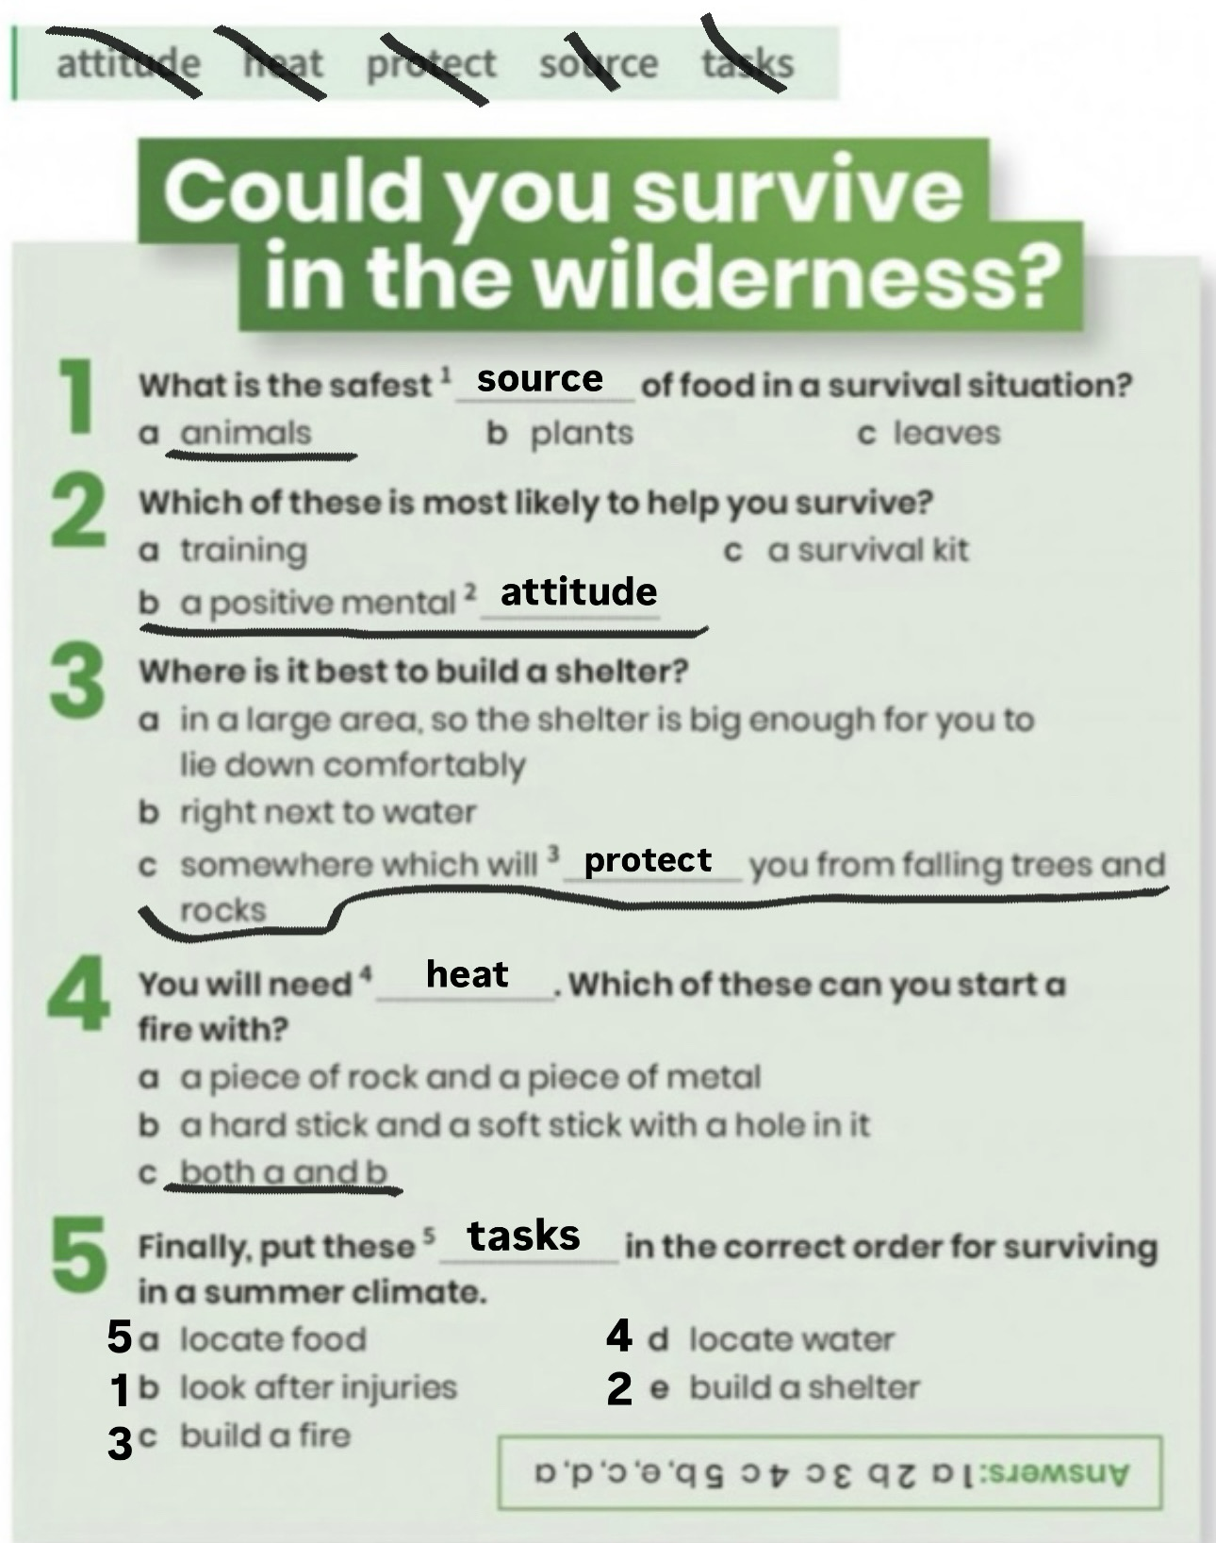

- Work on activity 2 page 58.
- Do activity 4. Then, complete the chart about conditional types that appear on activity 5.

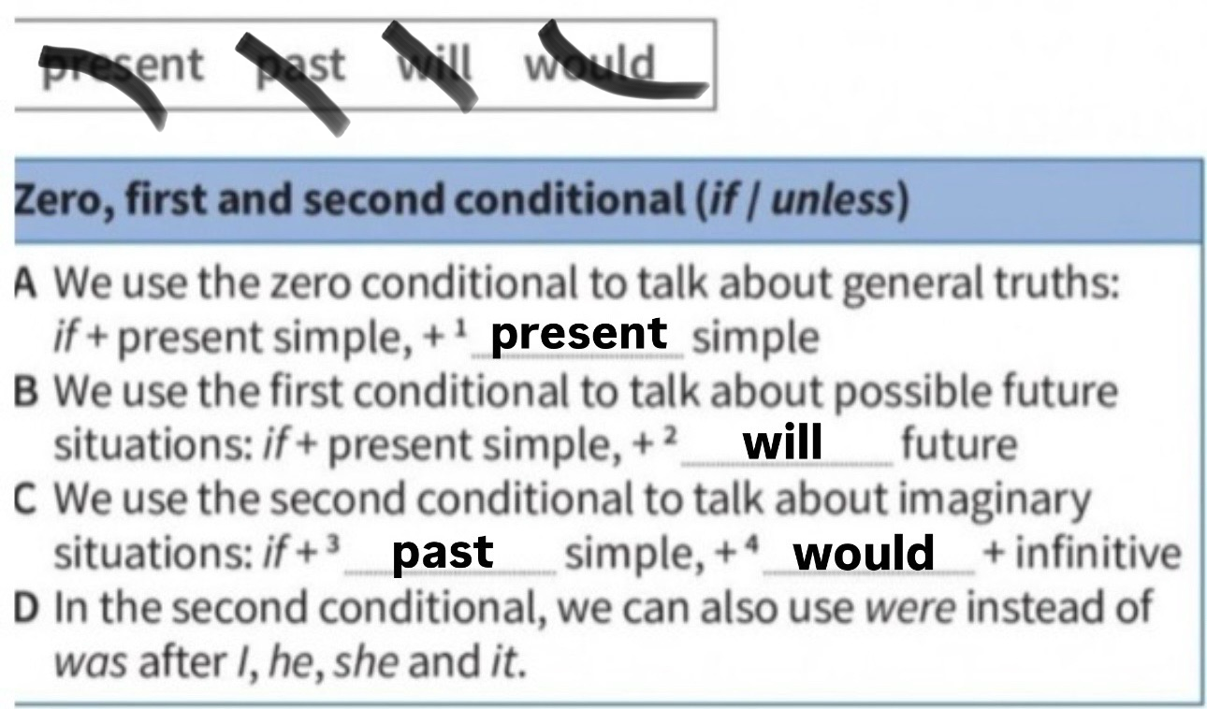

- Do activity 6 page 59 to review the different uses and forms of the different conditional types (0,1,2)

- Then, do activity 9. Complete the sentences with your own information.
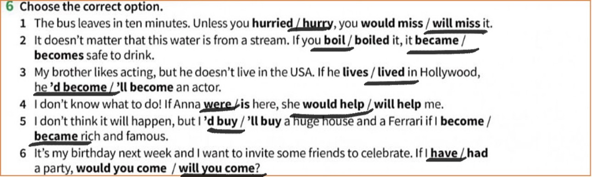

- Look at the following video about third conditional sentences (up to minute 1:57) and answer: https://youtu.be/ve4Tk78j6Nc?si=LIG2jW33nEEgmXHO
- When do we use third conditional?
we used the third conditional to talk about things that didn’t happen in the past to imagine different results
- How is it form? Which is its structure?
If+ had+ p.p > would+have+p.p
- Which examples can you provide?
if I had a studied, I would have passed the exam
if I had gone to bed earlier, I would have felt better
if it had rained, we would have stayed at home
if I had known, I would have helped you
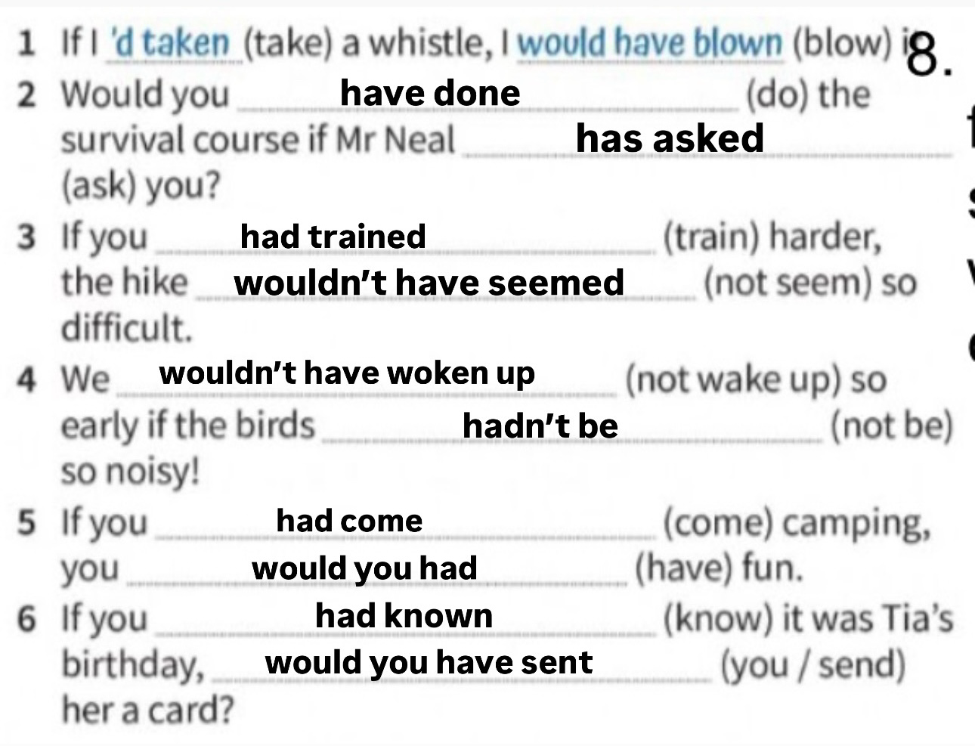
- Complete the following sentences with third conditional.



