COLEGIO SANTA ROSA DE LIMA

“Sowers of hope, artisans of fraternity"

UNIT 5: OUR VALUES

- Look at the different pictures that introduce the unit on page 56 and answer:
- Which is the first thing that comes to your mind? How each of these pictures make you feel?
Do everything that makes you happy. They make me feel cheerful and positive.

- Does any of these pictures remind you of something you experienced before? Which one?
Picture 6 reminds me of coronavirus and the time when we were in a pandemic.
- Which is your favourite one? Why?

Picture 2 is my favourite because it has a positive phrase.

- Work on activity 2 page 57.

Picture 1: courage
Picture 2: optimism
Picture 3: empathy
Picture 4: sense of fair play
Picture 5: determination
Picture 6: patience

- Do activity 3 page 58. Then, work on activity 4 page 59.

Page 58 act 3
- People like reading quotes because people feel inspired and more confident with them. They remind people of the importance of things in life.
- Yes., they are.
- I think these quotes have a deep meaning and we should learn from them.

Page 59 act4
- Kobe Bryant’s quote connects to picture 4
Leonardo Da Vinci’s quote connects to picture 6
- I think the most motivating quote is JK Rowling’s because it is about how powerful our thoughts are to create whatever we want. The least motivating quote is Michelle Obama’s because it’s too simple.
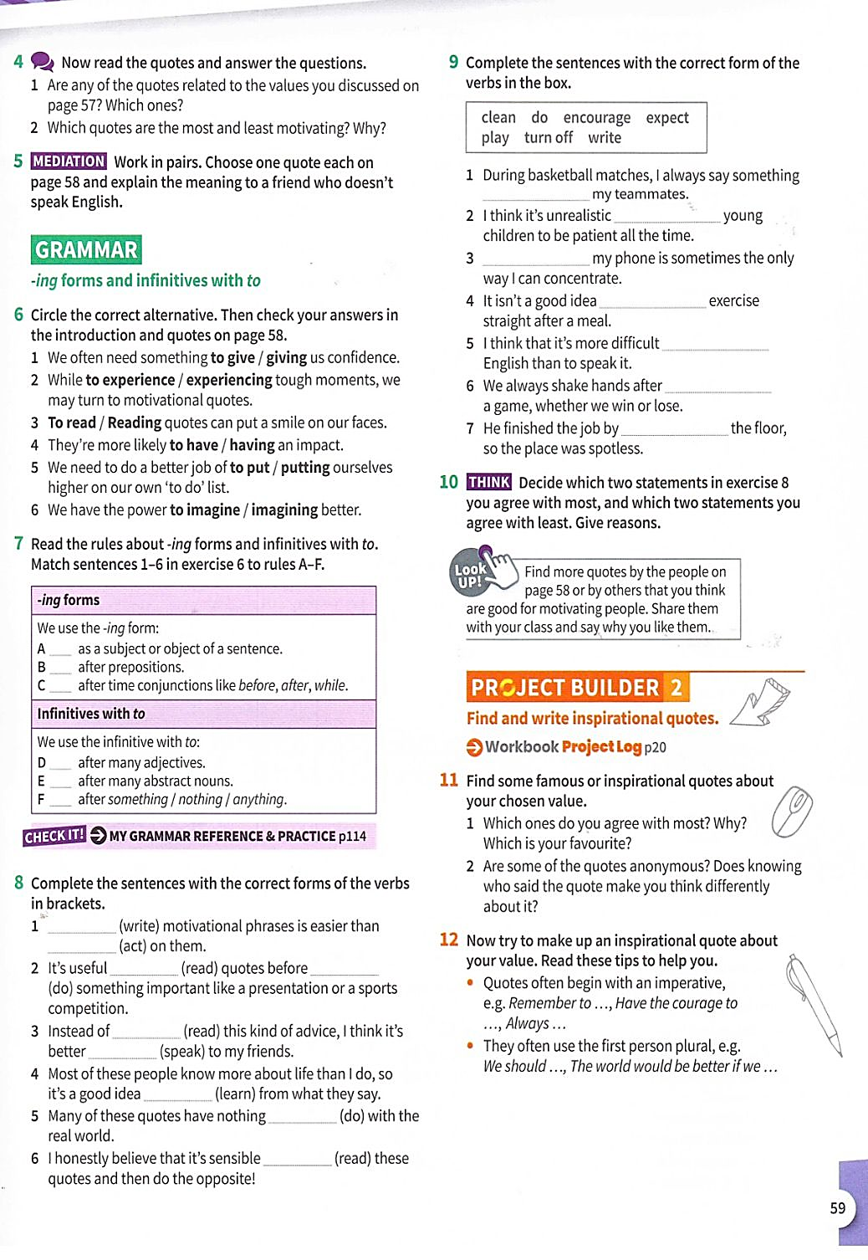
- Work on activity 6 and 7.

Answers:
6 1-to give 2-experiencing 3-Reading 4-to have 5-putting 6-to imagine

7 A-3 B-5 C-2 D-4 E-6 F-1

- Do activity 8.

Answers:
1-Writing acting
2-to read doing
3-reading to speak
4-to learn
5-to do
6-to read

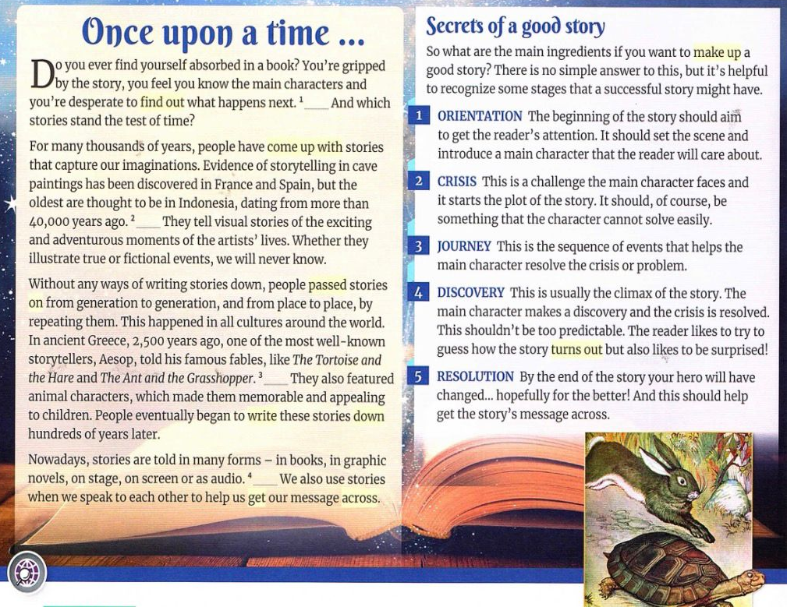
- Read the text on page 60 and answer the questions on activity 1. Then, do activity 2.

Answers:
- 1- Cinderella and Snow White
2-They are memorable because they are about love and how good people get good things in life.

- 1-D 2-A 3-E 4-C

- Do activity 4 and 9 page 61.

Act 4
absorbed in a book
the main character
sequence events
set the scene
get someone’s attention
capture our imagination

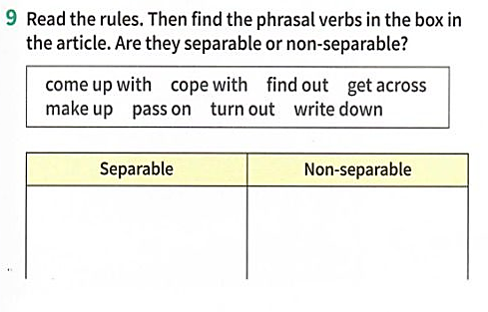

Act 9
Separable: find out, get across, make up, write down
Non-separable: come up with, cope with, pass on, turn out

- Work on activity 10.
Answers:
- Have you ever come up with a storyline for a film?
- Which family traditions have your parents passed on you?
- Has a day this week turned out to be better than you expected?
- Can you remember a time when you couldn’t get across what you meant?
- How do you cope with stress before exams?
- Have you ever made up information about yourself?

- Final project: write your own motivational quotes with all what you have learnt in this unit. Vocabulary (qualities, phrasal verbs) and grammar (to-inf/-ing verbs).

“Staying in balance and with optimism in every area of your life will help you cope with difficulties and be happy.”
“It’s important not to compare to anyone. Follow your own path, just try to be better than yesterday”

