COLEGIO SANTA ROSA DE LIMA

“Sowers of hope, artisans of fraternity"

UNIT 6: News travels fast

READING COMPREHENSION ACTIVITY
- Which headline do you think best summarizes the article?
- South Korean student goes missing in Cambodia: authorities investigate
- Teen Wins Award for Helping Communities Abroad
- South Korean Student Arrested for Online Fraud in Cambodia ✅
- Breaking News: Cambodian Students Launch Educational Program

In a significant development reported as breaking news, Ollie Holman, a 21-year-old University of Kent student, has been sentenced to seven years in prison for creating and distributing phishing kits used in fraudulent schemes amounting to £100 million globally. Initially covered by local news, the incident has now attracted attention from international news outlets due to the scale of the cyber fraud and its global implications.
According to an eyewitness, Holman developed 1,052 phishing kits that mimicked official websites of governments, banks, and charities, allowing cybercriminals to collect confidential information such as card and login details. Operating primarily through Telegram, he earned an estimated £300,000 from the activity between 2021 and 2023, laundered via cryptocurrency.
During the evening broadcast, the news presenter provided an update, reporting that authorities have seized Holman’s assets and are pursuing the recovery of his illicit earnings. A confidential source within the National Crime Agency confirmed that the investigation is ongoing, with efforts to dismantle the network of cybercriminals who utilized the phishing kits.
In her detailed report, the journalist emphasized the growing concern over cybercrime and the importance of robust cybersecurity measures to protect individuals and organizations from such fraudulent activities.
The story has rapidly appeared in the headlines of major international news outlets, underscoring the global nature of cybercrime and the need for international cooperation in combating it.

- Complete the sentences with the correct word from the box:
breaking news- eyewitness- headlines- update- journalist- source- local news- international news- news presenter- report

- The news presenter provided information about the seizure of the student’s assets.
- According to an eyewitness, the student created over 1,000 cybercrime tools.
- The story appeared first in local news before reaching global coverage.
- The journalist emphasized the importance of cybersecurity in her article.

- Work on activity 5 page 69.

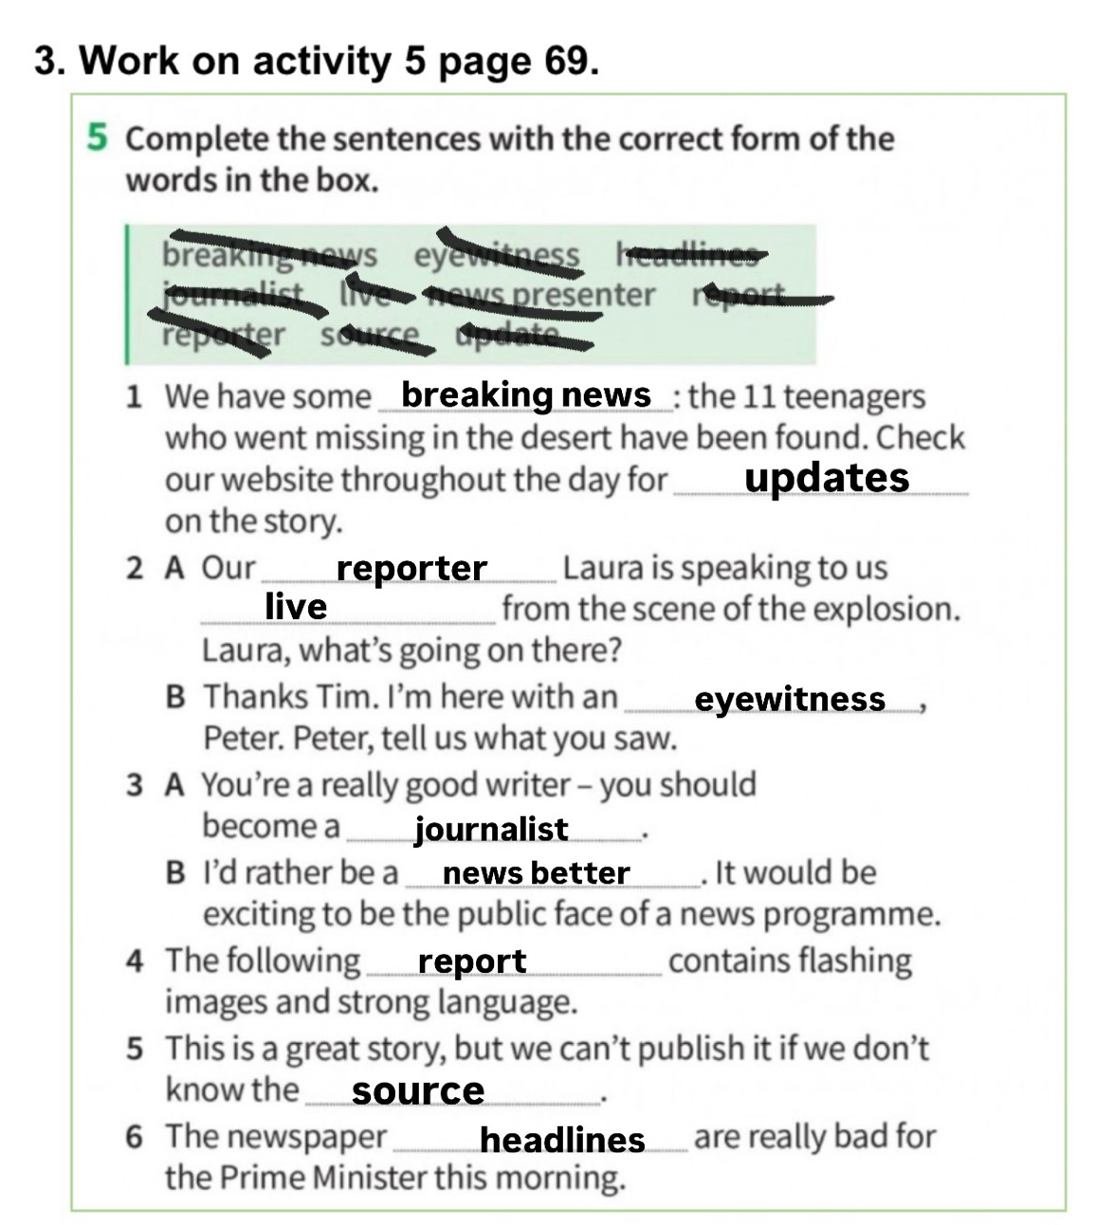

- Do activity 3 page 70.

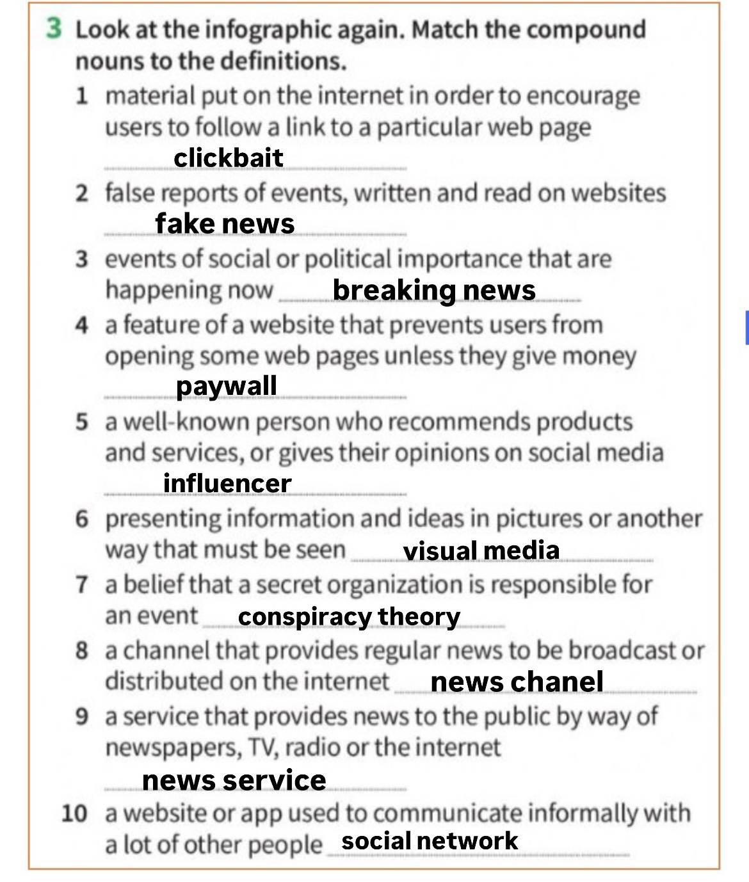

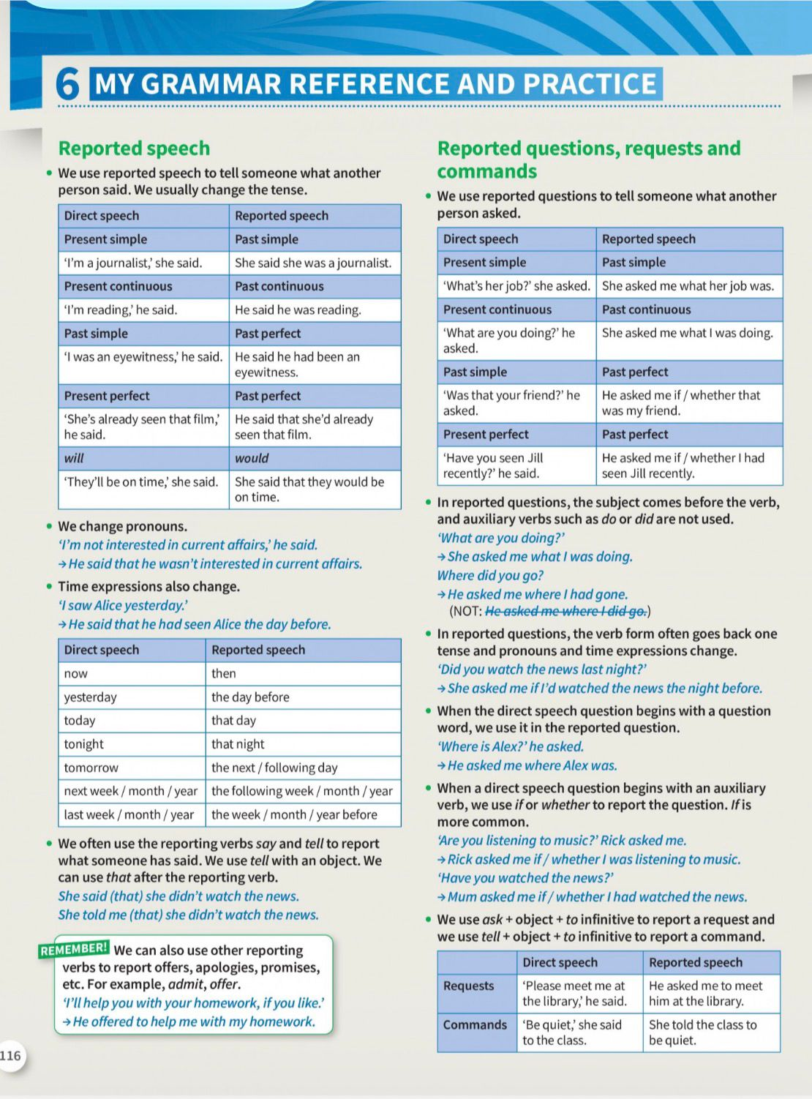
- Work on activity 6, 7 page 71. Then, Read the first part (Reported Speech) on page 116.

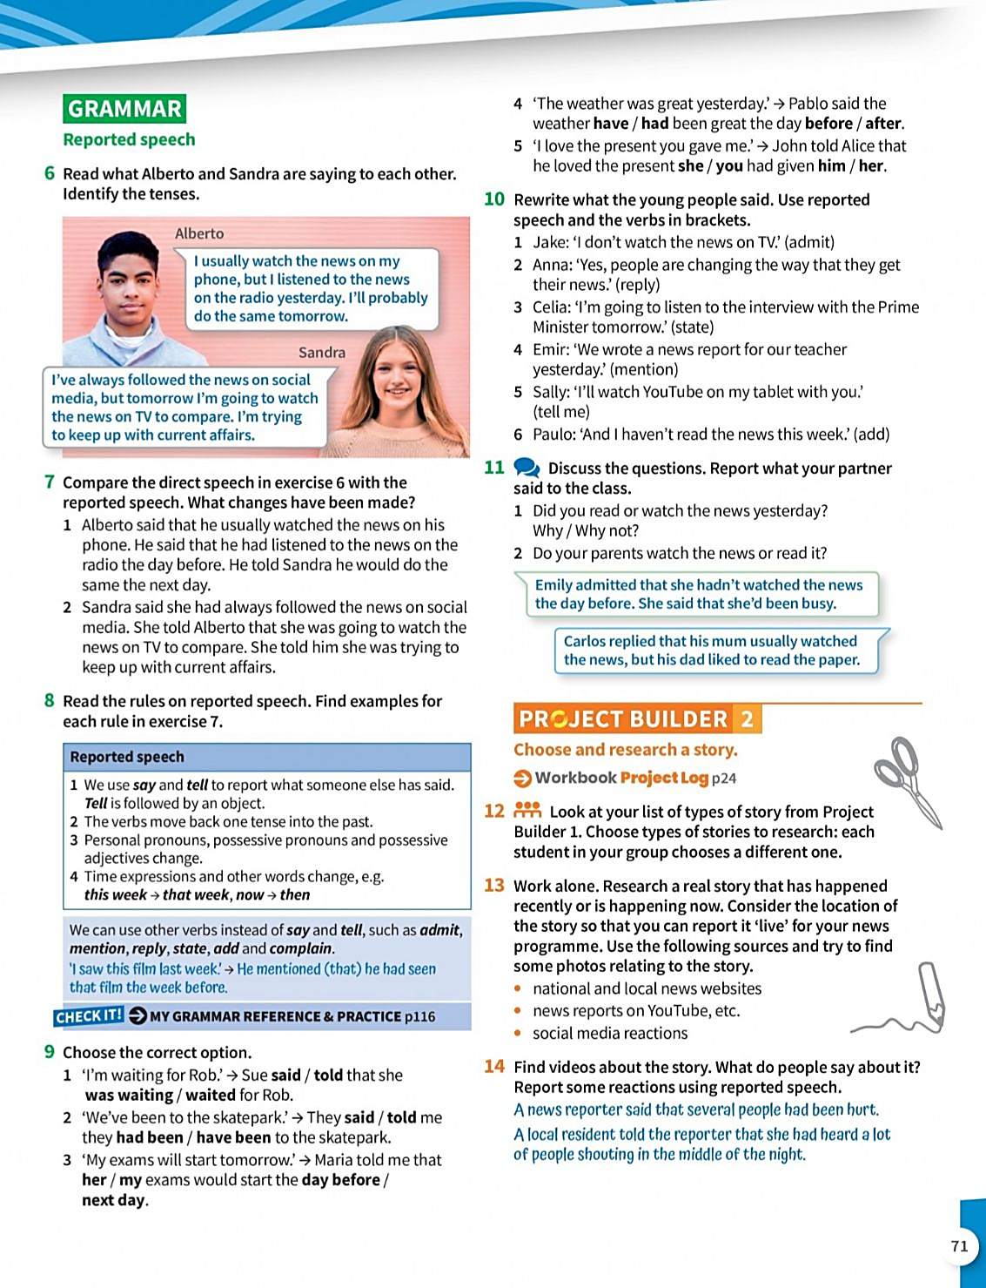
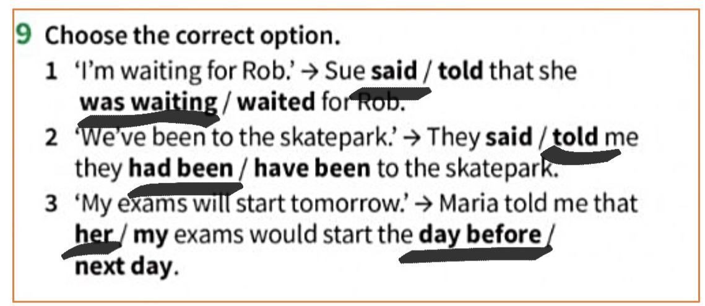
- Do activities 9 and 10 page 71.

1) Jake admitted that he didn’t watch the news on tv
2) Anna replied that people were changing the way they got their news
3) Celia stated that she was going to listen to the interview the next day
4) Emir mentioned that they had written a news report for their teacher the day before
5) Sally told me that she would watch youtube on her tablet with me
6) Paulo added that he hadn’t read the news this week

