COLEGIO MADRE MAZZARELLO – 4° año – 2025
TOPIC: PAST SIMPLE
ACTIVITIES
Writing
- Write a short paragraph about your last holiday using Simple Past tenses and expressions.
Use of English
- Each sentence contains ONE mistake. Check it.
- He spended all his money on video games.
__________________________________________
- We didn’t went to the concert because it rained.
___________________________________________
- She buyed that dress in Italy last summer.
____________________________________________
- They were arriving very early yesterday morning.
____________________________________________
- The teacher gived us extra homework after class.
_____________________________________________

- Fill in the gaps with ONE word each.
I __________ my best friend at a summer camp when I was ten.
Nobody __________ what happened after the lights went out.
The film __________ so boring that half the audience left.
They __________ to call me back, but they forgot.
I almost __________ my train because I overslept.
Reading Comprehension
- Read the short text and answer the questions in Past Simple.
Text:
Emma pushed the door open quietly. The house was darker than usual, and no music was playing; her older brother always played something loud in the afternoons. She left her bag on the sofa and walked into the kitchen. A broken glass lay on the floor next to the counter. Her brother wasn’t there.
Questions:
- Where did Emma leave her bag? _______________________________________
- What object did she find in the kitchen? _________________________________
- What was unusual about the house? ____________________________________
- Who normally played music in the afternoons? ___________________________
- Was her brother at home? ____________________________________________
Hi Caro!
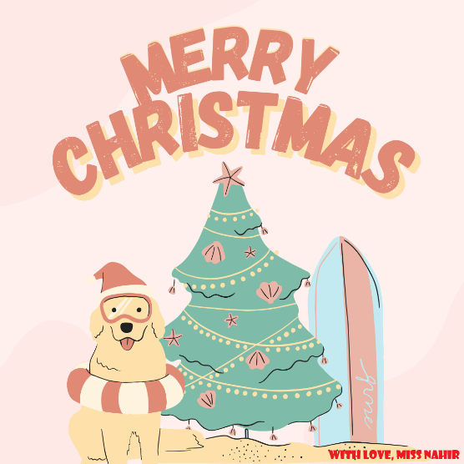
Hope you’re doing really well. I know you’re excellent at English, so you’ll solve these exercises without any problem. I wish you a lovely Christmas and an amazing start to the new year. I’m sending you a big hug, love you! Greetings to your family, too.
XOXO,
Miss Nahir.

