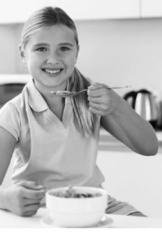

I am Patricia and I am 12 years old. I live in Spain. I get up at 7am and have a shower. Then, I have breakfast in the kitchen.
I go to school at eight am. I have lunch in the school canteen.
At 3:15pm I go home. I have a snack and I play computer games. Then, I do my homework in my bedroom. My grandmother prepares dinner. At seven pm I have dinner with mom and dad. At nine pm I watch T.V. and my grandmother reads a book. I go to bed at ten.
Dad is a doctor; he is reliable. He works in an office from 8am to 6 pm.

