

ENGLISH EXAM 4° “A”

NAME AND SURNAME:__________________________________________DATE:________________________
e
c
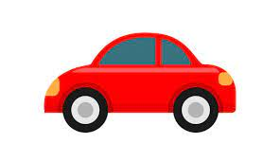

1-LOOK AND COMPLETE.
a)Ellen goes to school by ___________________
b
d
a

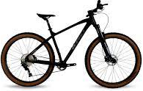
b)My dad goes to work on _____________

c)We go to the park by ______________
d)I go to the office by _____________
e)They go to school by ___________________
-HOW DO YOU GO TO SCHOOL? I go to school by _______________
-HOW DOES YOUR FATHER GO TO WORK? He goes to work by ________________
2-LOOK AT THE PICTURES AND WRITE THE CORRECT WORD.
RESTAURANT -- SUPERMARKET -- HOSPITAL -- BANK --





_________________ _________________ ___________________ ___________________
3-READ AND DRAW ( OR GLUE PICTURES)
a)The bank is next to the supermarket.
b)The pet shop is between the toy store and the clothing store.
c)The restaurant is across from bookstore.

