Repaso instancia diciembre (EXAMEN FINAL MARTES 16/12 a las 8:10 hs.)
- Answer.
- What`s your name?...............................................................................................................
- How old are you?.................................................................................................................
- Are you a student?...........................................................................................................
- Is your brother tall?.........................................................................................................
- Have you got brothers?.................................................................................................
- Do you get up at 7.00 ?......................................................................................................
- What do you do in the morning?..........................................................................................................
…………………………………………………………………………………………………………………………………………
- Does your mum work?.....................................................................................................................
- Is there a garage in your house?..........................................................................................................
- Are there two bedrooms in your house?..........................................................................................
- What`s your favourite music? …………………………………………………………………………..
- What`s your favourite food and drink?...............................................................................................
- Complete with the VERB TO BE (AM, IS, ARE)
Tim: Hi, Leo. How ₍₁₎ ___________ you? Tim:(7) ………your parents at home?
Leo: I ₍₂₎ ___________ fine, thanks. And you? Leo: No, they(8) ……………..They(9)……..
Tim: Not bad. Who ₍₃₎ ___________ your favourite actor? In the park.
Leo: Will Smith, definitely. He ₍₄₎ ___________ great!
Tim: ₍₅₎ ___________ he from Canada?
Leo: No, he ₍₆₎ ___________ . He’s American.
- Turn the sentences into.
2. Negative:…………………………………………………………………………………………………………………………..
4. Neg:…………………………………………………………………………………………………………………………………….
Int:……………………………………………………………………………………………………………………………………….
9. Neg:…………………………………………………………………………………………………………………………………….
Int:………………………………………………………………………………………………………………………………………..
- Choose the correct conectors
a.That is a very big and / but expensive TV.
b.It’s a new smartphone and / but it isn’t very fast.
c.That coloured pencils aren’t new and / but they’re very good.
5) Choose the correct demonstrative pronouns.
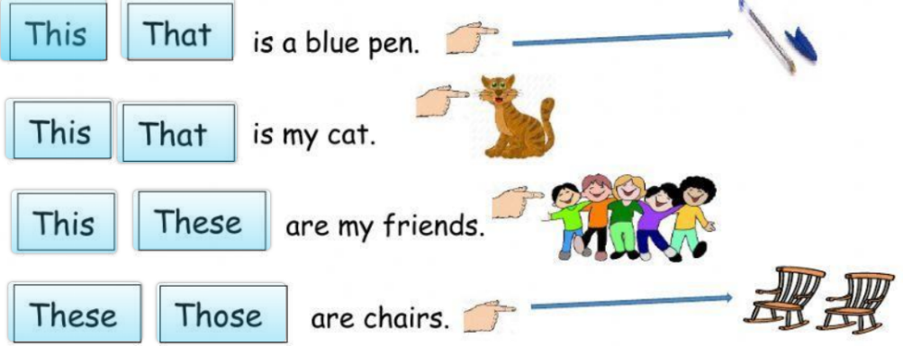

- Unscramble the questions and answer them. (5 x 0.4 = 2)

- got / grandad / have / and / your / grandma / parrot / a / ?
Q: __________________________________________?
A: __________________________________________.
- best / what / your / is / subject / friend’s / favourite / ?
Q: __________________________________________?
A: __________________________________________.
- mother’s / what / job / your / is / ?
Q: __________________________________________?
A: __________________________________________.
- colour / got / hair / what / have / you / ?
Q: __________________________________________?
A: __________________________________________.
- your / an / worker / is / dad / officer / ?
Q: __________________________________________?
A: __________________________________________.
- Complete with the simple present.
